Mr. Fitton’s Weekly LAW Learning Bulletin

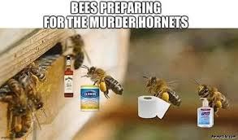

Week 6 - May 11th – May 18th

1. HOW TO START.
-Go to my website at: https://mrfitton.weebly.com/online-prison-unit.html

2. Yay – a hands on project to sink our teeth into! “Shanks A lot, Mr. Fitton.”

Checkmark  When Done | Task – Assignments, Learning Activities
 | 1. Go to: https://mrfitton.weebly.com/online-prison-unit.html (Follow Lesson 6)
2. Watch the video on the power of Questions: https://youtu.be/W1K2jdjLhbo
3. View the pictures on “The Inquiry Process.”
4. Choose whether you want to do a project on Prisons OR Forensics.
3. If you chose Prisons:
A. Read Prison Inquiry Project Assignment (Mr. Fitton explains in a youtube video: https://youtu.be/b5WNZjxY2rM)
B. Read the Inquiry Process Handout – it will help you get started.
C. You may choose to use the Inquiry Chart to help you (optional)
D. View the Slideshow on why we are doing “Inquiry Learning.” Video tutorial also available:
https://youtu.be/TgMJKz0r0cY
E. Review Student Sample projects to get inspired
F. Review difference between “Topic, Question and Thesis” on website.
G. Start your project!
4. If you chose Forensics:
A. Read Forensics Inquiry Project Assignment (Mr. Fitton explains in a youtube video:
https://youtu.be/Eov4zxgNNzY
B. Read the Inquiry Process Handout – it will help you get started.
C. Start your project!
 | Your project is due in two weeks on May 25th
 | *Please note, I am available on TEAMS /Remind / Email Every day to help students with homework/assignments or anything they need!

