Mr. Fitton Name:
/30 MARKS
Law 12 Date:

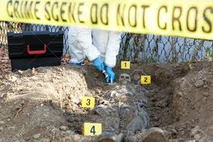
The unit on Crime Scenes has provided you with a great deal of information in a variety of forms. We have read articles, viewed videos from universities, examined a crime scene and learned about fingerprinting. This is an opportunity for you to develop an Inquiry Question on a topic of choice about Crime Scenes. After developing a question, you will have the ability to research through online journals, documentaries, films, books and other reliable sources. Finally, you will be permitted to share your findings in any way that showcase’s your talents.

DUE DATE: The completed project is due on _______________________________________.
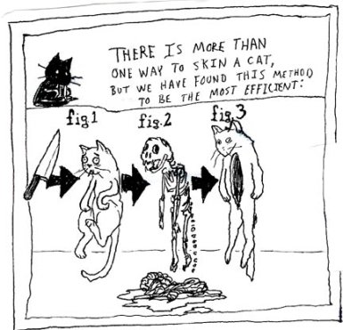
You should be half done and show Mr. Fitton on _____________
If you have not made substantial headway at this point, we will discuss what you require in order to be successful.

The Project: The project aims to provide you with freedom to learn about a topic of interest and present it in a way you want. Moreover, it aims to familiarize you with how to research and express yourself in a cogent and successful manner. As a result, we will be reviewing academic journals, learning citation and using our teacher-librarian as a resource.

Some Suggest Project Ideas (you can present in any way you want!):
PHOTO ESSAY or PODCAST
-Create a crime scene or look at historical crime scenes
-Create a photo essay with written or recorded explanations
-Create your own true Crime podcast that demonstrates an understanding of key Forensics terms (Types of Splatter, Entomology, States of Decomposition, Fingerprint types, etc)
CREATE A CRIME SCENE
- Research several articles on crime scenes
-Create crime scene; video record it; or take photos – then explain
- You my choose to bring the class through it as though you are the CSI Expert
-If done outside, please inform neighbours and possibly the police; clean up when done
-The crime scene must be grade 12 Level complex

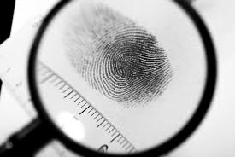

Video/Animation /Anything
- Create a video newscast, or anything using the medium of video that helps you articulate your research and viewpoints.
-Must reveal grade 12 level of research
-Must somehow include citations
-Must demonstrate a superior level of understanding.

What will help you in your Career?
-In this class we have future police officers, nurses, lawyers, army personnel, secretaries, parents, construction workers, etc.
-Create your own type of demonstration of learning where you research and present in a way that will help you gain skills / present knowledge in a way you would in your future career. (Police report, Doctors notes…. Etc)

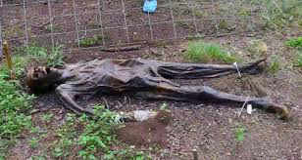

Science Fair Poster / Term Paper
- Create a crime scene or use a historical one
- Identify elements of the crime scene
--Aesthetically appealing
-Requires evidence of research/citations
-On your posters explain in detail how you are demonstrating a thorough knowledge of crime scenes.
-Term paper on an area of Forensics (ie: significance of DNA evidence / use of entomology, etc)
Documentary
-Using film or pictures gathered from the internet, create a documentary with an overdub that explains what you’ve learned about forensics.
-Post to youtube for final evaluation.
-You may download and show archival footage or re-enact key scenes yourself.
-Should include citations

These are only a few suggestions. You may show your learning in an alternate fashion (ie. police report, radio show, Crash Course style lesson, youtube tutorial, tv show or anything, but consult with me first and I will be happy to discuss the viability of your idea. Remember, you will likely have to support your creative work (if you choose to do something that is not written) with additional written analysis to ensure that you have submitted a project that demonstrates a grade 12 level of understanding.

Inquiry Assignment

Decide on what type of Forensics you are interested in (Crime scenes, blood splatters, cadaver farms, fingerprints, accounting, entomology, etc)

Select Topic (what about crime scenes intrigues you or makes you curious, what do you want to know a great deal more about?)

Select one or two aspects of Forensics you would like to investigate.

Develop your 2 or 3 inquiry questions that you want to answer or demonstrate an understanding of

Share your presentation – Be Proud of Your Work!
Decide how you will share your findings and your personal thoughts on your findings. What will be the format you will share you info in? – See options on assignment?
Research (Academic Journals, Netflix Documentaries, Online, Books, etc)
Organize your findings – You may use the inquiry chart provided. Strive to document your research in a way that works for you so you are prepared for post-secondary. Organization is key

ASSESSMENT :
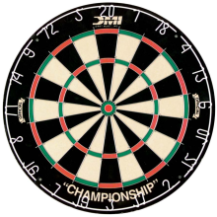
Tips to stay on target: Think of your topic Read textbook/articles/ watch youtube videos or documentaries on that topic Create a driving question Find academic sources (articles / online sources / documentaries to support highlight examples to support your points start the writing / creative process / crime scene creation Done!

Assessment: Due to the extremely personalized nature of this assignment and due to the variety of choices of expression, it is incredibly difficult to assess. As a result we will be using a 6-point generalized scale.

6
A relevant topic is evident and clearly developed throughout the project/paper
Superior use of factual content; organized in a purposeful and effective manner
Precise selection of supporting details; evaluation/analysis is exemplary; a polished and professional product
Expression is clear and fluent; errors may be present but do not interfere with meaning
Proper Bibliography in APA format; no errors

5
A relevant topic is evident and provides direction throughout the project/paper
Proficient use of factual content; organized in a clear and thoughtful manner; a very good product
Accurate selection of supporting details; evaluation/analysis is sound
Expression is generally fluent; errors may be present but do not interfere with meaning
Proper Bibliography in APA format; minor errors

4
A relevant topic is evident
Competent use of factual content; organized in a purposeful manner
Appropriate selection of supporting details; evaluation/analysis is satisfactory, but basic; product is rough/silly/amateurish
Expression is generally fluent; errors may impede meaning at times (some sections unclear due to writing)
Proper Bibliography in APA format; a few errors

3
A relevant topic is attempted, but unclear
Adequate use of factual content; organization attempted or parts organized, but parts disorganized; product is draft-like
Simplistic selection of supporting details; evaluation/analysis is weak, or at times there is a lack of evaluation/analysis
Expression is simplistic; errors impede meaning
Attempts bibliography; many errors

2
A relevant topic is absent, inaccurate or student has simply listed their topic
Limited recall of factual content; lack organization or disorganized in many places
Inappropriate selection of supporting details; Inaccurate supporting details, evaluation/analysis are absent; limited effort
Expression is flawed and errors impede meaning
Bibliography is just a list of sources in no format

1
A relevant topic is absent
Deficient recall of factual information; lacks organization
Absence of supporting details; product is far below grade expectations
Expression is unclear and makes understanding difficult
No bibliography.

0 - Writing / video / visuals are evident, but no attempt has been made to discuss/argue or create a cohesive product
Plagiarized; product is not meeting grade expectations in the least
Cut and Pasted information from the internet makes up a large portion or all of the product

