IBMYP introductory workshop:

Launching the MYP
Process Journal

Princess Margaret Secondary High
September 29th

Launching the MYP
One Day In-school Workshop
Content

Session 1: MYP Philosophy 8:00 – 9:30 am
• Reflection
• Burning questions
• What matters in a good education?
• Group discussion
• Mission statement
• IB learner profile
• Reflection: What’s on your mind?

BREAK

Session 2: MYP classroom 9:45 – 11:15 am
- One word round robin: What do you see, hear, feel?
- International mindedness: IB graffiti wall
- What to do? Two column chart
- Programme model
- Approaches to teaching and learning
- Inquiry
- Reflection: Table group discussion

LUNCH

Session 3: MYP unit planning 11:45 – 1:15 pm
- What is learning? Objectives/strands
- Differentiation
- MYP unit planner
  - Key concepts
  - Related concepts
  - Your turn!
- Conceptual understanding

BREAK

Session 4: MYP contexts to assessment 1:30 – 3:00 pm
• Global contexts/explorations
• Creating the statement of inquiry
• Assessment
• Reflection

Session 1: MYP Philosophy

One thing I know about the MYP…
Visible Thinking

Harvard Project Zero, Visible Thinking, Core Routine. Copyright © 2010 by the President and Fellows of Harvard College http://pzweb.harvard.edu/

What questions do you have???

Jot down any questions you may have about the MYP. As a table group come to a consensus on the top 3 questions and write them on the sticky notes found on your table. Stick these on the chart paper. If you have your own questions, write them here.
Thought Point

What matters in a good education? | How do our educational traditions get in our way?

Group Discussion

Insights from our discussion on what matters to an 11-16 year old student…

How has your thinking been changed and/or validated after viewing the Changing Paradigms video?

IB Mission Statement & MYP

For reference, you can find the IB mission statement at the front of your subject guide.
Jot down key phrases that align with your philosophy as an educator. Choose one phrase and complete the diagram below:
How can I do that?
How do we foster lifelong learning in our staff and students?
How can I encourage my students to be “this” way?
How might this look in my/ our school?
What tools do I need to promote this ideal in my students?

Phrase:

Extension A: Examine your school’s mission statement. Which key words from the IB mission are embedded in your own school mission statement? Now that you will be implementing a wall-to-wall MYP program, what change(s) (if any) need to be made to include the MYP?

Extension B: In what ways does the mission statement heighten our understanding of student-centered learning and also of assessment?

Connecting the Learner Profile
You can find the Learner Profile descriptors found at the front of your subject guide.
As you think about the correlation between the learner profile and the IB mission statement, use this space to examine your own journey toward international mindedness.

IB learner profile attributes: The IB mission in action

ATTRIBUTE | RESPONSIBILITIES | INDICATORS | CLASSROOM

Reflection
What’s on your mind?

Capture a thought from each of the learner profile attributes. Write them below.

Session 2: MYP classroom
Activity: One-word round robin

What do you see?

What do you hear?

What do you feel?

Group Discussion

Through whose eyes, ears, emotions?

George Walker, Director General, IBO, 2000 stated that an international education is not only:
- teaching groups of students from different nationalities
- studying the history, geography, and customs of other countries
- arranging foreign exchanges
- having a strong world languages department though each of these might help.
Workshop leaders may want to use Walker’s ideas to continue the discussion about what it means to
bring an international education to their school.

- Focus point: all these activities are a step in the right direction towards developing intercultural
awareness, but they are not enough. It is important for schools/teachers to reflect and communicate
at different levels on how to (continue to) foster this value.
- The entire school culture should attempt to reflect this by:
  - infusing instruction with examples and perspectives drawn from a variety of cultural, religious,
and national perspectives
  - celebrating cultural and other commonalities and differences
  - developing staff who share the vision and model appropriate behavior
  - implementing policies and practices which are improved through critical self reflection.

International Mindedness

What is already happening in school? | What more can be done in school?

Reflection

International-mindedness is diffused throughout the subject groups each and every year of the programme.

Connect: How is international mindedness diffused in your subject group?

Extend: How could international mindedness be enhanced within your subject group?

Challenge: What challenges might you encounter as you promote international mindedness into your subject group?

Peeling back the programme model:
How do we breathe life into our MYP classroom?
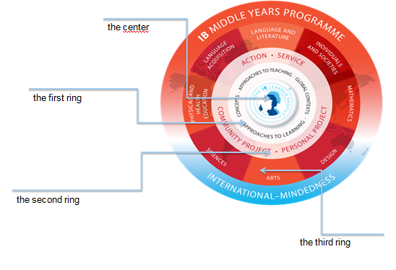

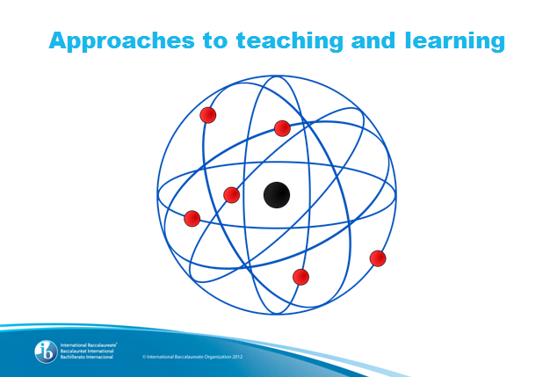
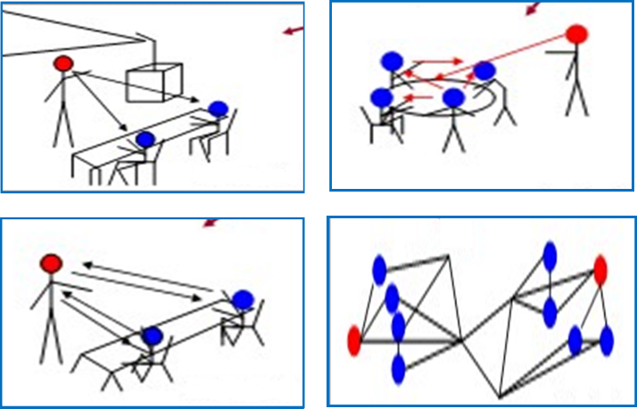

Reflection
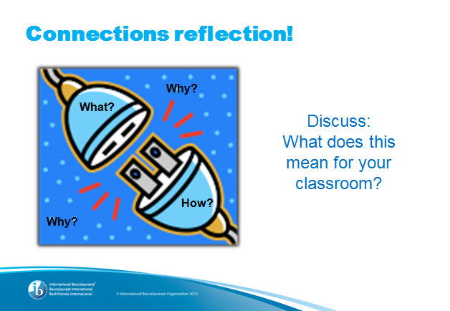
What does inquiry involve?
How does it look in my classroom now?

How might inquiry look in my classroom the same time next year?

Session 3: MYP unit planning

Investigating the subject group objectives and their strands

Find the objectives and their strands in your subject group guides. Next to each objective strand write the letters K, U, S, or A; choosing the one that you feel best identifies the strand. (You may use more than one!)

Differentiation: For those who have attended an authorized MYP training, please describe your understanding of the three phases of the unit planner by writing words or short phrases in the space provided.

Unit Planner Phase 1: Inquiry – Establishing the purpose of the unit

Unit Planner Phase 2: Action – Planning for teaching and learning through inquiry

Unit Planner Phase 3: Reflection – Considering the planning, process and impact of the inquiry

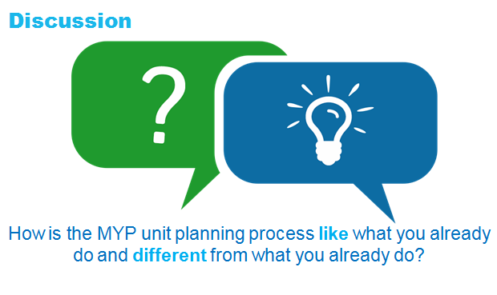

Constructing a statement of conceptual understanding
KEY Concept
Related Concept(s)
Statement of Conceptual Understanding

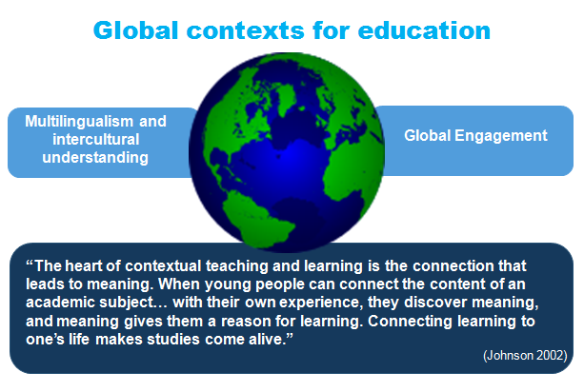
Session 4: MYP contexts to assessment

Key understandings from Marzano and Erickson’s work on the statement of inquiry:
- represents a contextualized, conceptual understanding
- describes a complex relationship that is worthy of inquiry
- explains clearly what students should understand and why that understanding is meaningful
- can be qualified (using phrases such as “often”, “may” and “can”) if it is not true in all situations, but is still an important idea
- can be formulated at different levels of specificity.
MYP: From principles into practice (2014).

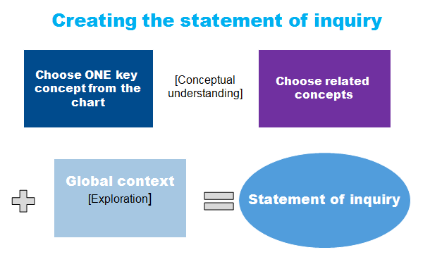
Creating the statement of inquiry
Your turn! Practice here:

Share your SoI with your colleagues as directed by your IB coordinator

Differentiation option for those who have worked with SOIs before…
Try rewriting your SOI using a different global context. Then examine the content of your unit. Create two columns and compare the learning experiences, content and possible assessments that would be included in each unit.

SOI #1 SOI#2

A focus on assessment through the subject group guide…

Find the assessment criteria.

- What does this mean for me as an MYP teacher?

- How is the MYP criterion-related assessment model student-centered?

- What do you see that is similar to something you already do?

Summative Assessment

Look back at your statement of inquiry that you developed:

- What type of summative tasks would allow your students to best show their understanding of the statement of inquiry? List these here:

- How might this be the same or different from what you’ve done in the past?

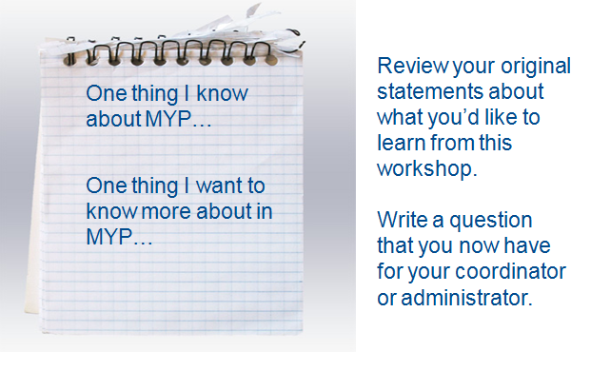
Congratulations!!!

