Communications Irony and Symbol Name: __________________
1. There are several types of irony in literature. Basically, irony refers to the development of a situation__________________________________________________________________
a. Verbal Irony = ___________________________________________________________
b. Situational Irony = _______________________________________________________
c. Dramatic Irony = _________________________________________________________
d. Understatement = ________________________________________________________
Examples of Irony
Verbal Irony: Sarcasm 101

Situational Irony: Farside Cartoon and pictures

Dramatic Irony: Anyone There? Or The Shovel

Understatement: Monty Python’s The Black Night

2. In addition to irony, writers also use _____________________ to add meaning to a story.
A symbol is _______________________________________________________________
How can symbols be recognized in a story?
- ________________________________________________________________________
- ________________________________________________________________________
- ________________________________________________________________________
- ________________________________________________________________________
Symbolism Ex: ____________________________________
“Wake Up Call” Maroon 5
I didn't hear what you were saying 1. Underline an example of each of the four
I live on raw emotion baby kinds of irony. Label them.
I answer questions never maybe
And I'm not kind if you betray me.
So who the hell are you to save me
I never would have made it babe
If you needed love
Well then ask for love 2. Explain how the music of this song is ironic.
Could have given love _____________________________________________
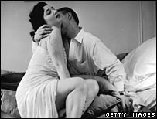
Now I’m taking love _____________________________________________
And it’s not my fault _____________________________________________
'Cause you both deserve _____________________________________________
What’s coming now _____________________________________________
So don’t say a word _____________________________________________
_____________________________________________
Chorus: Wake up call _____________________________________________
Caught you in the morning with another one in my bed
Don't you care about me anymore?
Don’t you care about me? I don't think so.
Six foot tall
Came without a warning so I had to shoot him dead
He won't come around here anymore
Come around here? I don't think so.

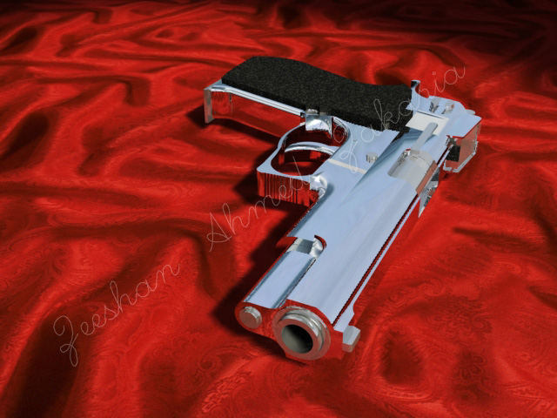
Would have bled to make you happy 3. PARAPHRASE, (retell in your own words)
You didn't need to treat me that way in 2-3 sentences, the story told in this song
And now you beat me at my own game
And now I'm finally sleeping soundly
And your lover's screaming loudly
I hear a sound and hit the ground
If you needed love
Well then ask for love
Could have given love
Now I’m taking love
And it’s not my fault
'Cause you both deserve
What’s coming now
So don’t say a word
Repeat Chorus
I'm so sorry darling
Did I do the wrong thing?
Oh, what was I thinking?
Is his heart still beating?
Repeat Chorus

"Rockin' In The Free World" Neil Young
There's colors on the street 1. Underline an example of Situational and
Red, white and blue Verbal Irony, label them.
People shufflin' their feet
People sleepin' in their shoes 2. Explain the irony of the title of this song
But there's a warnin' sign (in full sentences please). Who is the “free world”?
on the road ahead
There's a lot of people sayin'
we'd be better off dead
Don't feel like Satan,
but I am to them
So I try to forget it,
any way I can.

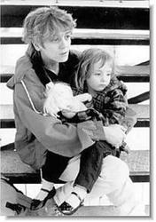
Keep on rockin' in the free world, (x4)
I see a woman in the night
With a baby in her hand
Under an old street light
Near a garbage can
Now she puts the kid away,
and she's gone to get a hit
She hates her life,
and what she's done to it
There's one more kid
that will never go to school
Never get to fall in love,
never get to be cool.
Keep on rockin' in the free world, (x4)

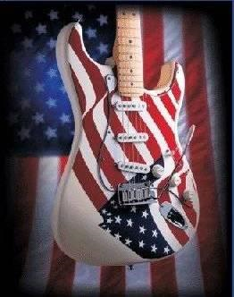
We got a thousand points of light
For the homeless man
We got a kinder, gentler,
Machine gun hand
We got department stores
and toilet paper
Got styrofoam boxes
for the ozone layer
Got a man of the people,
says keep hope alive
Got fuel to burn,
got roads to drive.
Keep on rockin' in the free world, (x4)
Communications Irony and Symbol Name: __________________
1. There are several types of irony in literature. Basically, irony refers to the development of a situation: Which is the opposite of what was expected.
a. Verbal Irony = Contrast between what is said and what is meant
b. Situational Irony = Contrast between what happens and what was expected to happen
c. Dramatic Irony = Contrast between what the character thinks to be true and what we know is true.
d. Understatement = Purposely stating something as less than it is for effect

Examples of Irony
Verbal Irony: Sarcasm 101

Situational Irony: Farside Cartoon and pictures

Dramatic Irony: Anyone There?

Understatement: Monty Python’s The Black Night

2. In addition to irony, writers also use symbolism to add meaning to a story.
A symbol is anything (character, action, setting or object) representing something else (usually abstract idea)
How can symbols be recognized in a story?
- Degree of emphasis given (mentioned frequently, at beginning or end of story
- Function in story’s development
- Included in the title
- Described in detail
- Symbolism Ex: _________________________________________________________

Communications Irony and Symbol Name: __________________
1. There are several types of irony in literature. Basically, irony refers to the development of a situation__________________________________________________________________
a. Verbal Irony = ___________________________________________________________
b. Situational Irony = _______________________________________________________
c. Dramatic Irony = _________________________________________________________
d. Understatement = ________________________________________________________
Examples of Irony
Verbal Irony: Sarcasm 101

Situational Irony: Farside Cartoon and pictures

Dramatic Irony: Anyone There? Scary Movie

Understatement: Monty Python’s The Black Night

Born in The USA
Prediction: Based on the title, what do you think the song will be about?

“Born in the USA”– Bruce Springsteen

Born down in a dead man's town
The first kick I took was when I hit the ground
You end up like a dog that's been beat too much
Until you spend half your life just covering up

Born in the U.S.A., I was born in the U.S.A.
I was born in the U.S.A., born in the U.S.A.

Got in a little hometown jam
So they put a rifle in my hand
Sent me off to a foreign land
To go and kill the yellow man

Born in the U.S.A. . . .

Come back home to the refinery
Hiring man said, "Son if it was up to me"
Went down to see my V.A. man
He said, "Son, don't you understand"

I had a brother at Khe Sahn
Fighting off the Viet Cong
They're still there, he's all gone

He had a woman he loved in Saigon
I got a picture of him in her arms now

Down in the shadow of the penitentiary
Out by the gas fires of the refinery
I'm ten years burning down the road
Nowhere to run, ain't got nowhere to go

Born in the U.S.A., I was born in the U.S.A.
Born in the U.S.A., I'm a long gone daddy in the U.S.A.
Born in the U.S.A., born in the U.S.A.
Born in the U.S.A., I'm a cool rocking daddy in the U.S.A.

Explain why this song is ironic:

