Wellness 11/12 Name:
Please discuss in groups each set of questions below. Then choose two to respond to two in writing, or video, blog or other format that you choose.
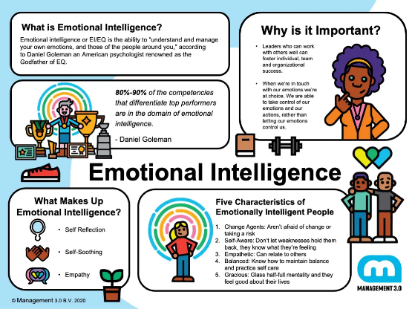
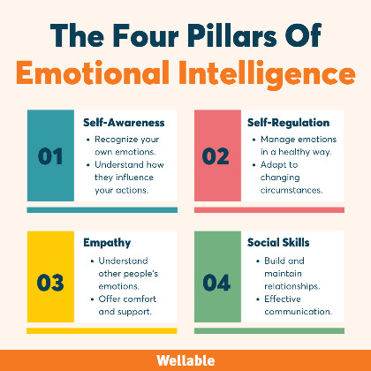
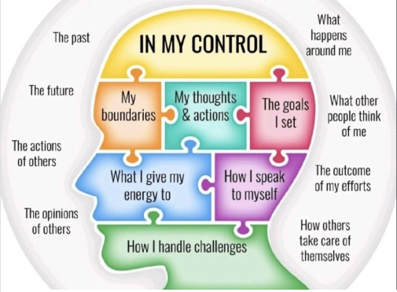

"Inside Out" is a fantastic film to explore in our wellness course, especially for students in grades 11 and 12, as it delves deeply into emotions and mental health. Thanks for recommending it, class! Here are some discussion questions that link to positive psychology, emotional intelligence, and emotions in general. Remember, we have examined that they are many types of emotions:
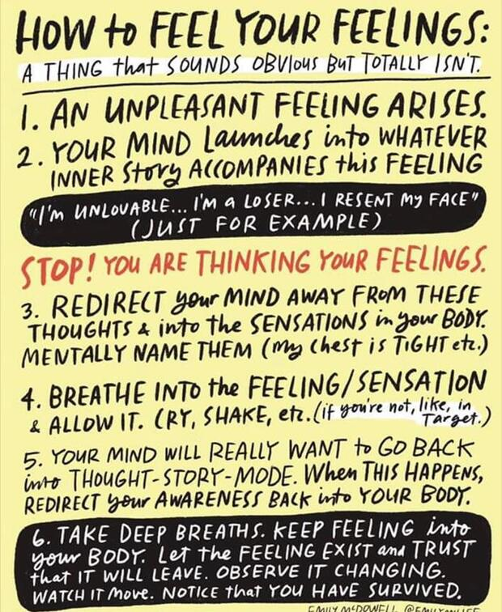
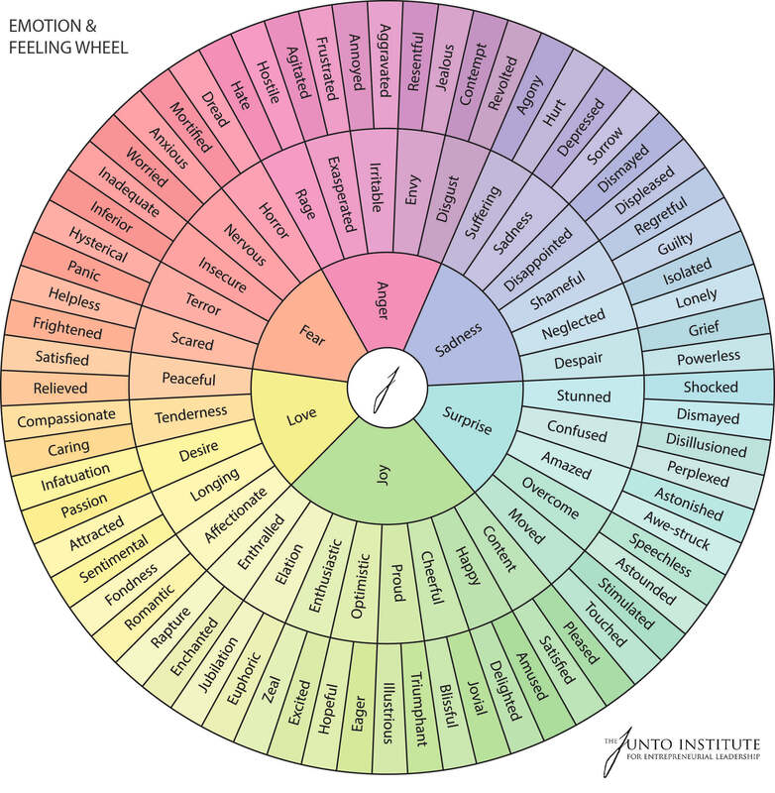

Assignment: Please discuss the following and then respond to two in your journal or on a piece of paper to be submitted

1. Understanding Emotions: How does "Inside Out" personify the different emotions (Joy, Sadness, Anger, Fear, and Disgust)? How do these representations help us understand our own emotional responses?

2.Emotional Intelligence: Emotional intelligence refers to the ability to understand, use, and manage our own emotions in positive ways to relieve stress, communicate effectively, empathize with others, overcome challenges, and defuse conflict. In what ways does the character Riley demonstrate emotional intelligence throughout the movie? How does her emotional intelligence evolve?

3. The Role of Sadness: The film portrays Sadness as a crucial emotion. Why is Sadness important in our lives, according to the movie? Can you relate this to real-life experiences where sadness played a positive role?

4. Balance of Emotions: How does the film illustrate the need for a balance of different emotions? Why is it unhealthy to focus only on being happy?

5. Coping with Change: Riley faces significant changes in her life. How do her emotions react to these changes? Discuss the strategies that individuals can use to cope with similar changes in their lives.

6. Memory and Emotions: How does the film depict the relationship between emotions and memories? Discuss how our emotional state can influence how we remember events.

7. Family Dynamics and Emotional Support: How does Riley's relationship with her parents influence her emotional well-being? Discuss the importance of family and social support in maintaining mental health.

8. Positive Psychology in Action: Positive psychology is a branch of psychology that focuses on the study of positive emotions, strengths-based character, and healthy institutions. It aims to improve quality of life and prevent the pathologies that arise when life is barren and meaningless. Identify instances in the movie where characters use principles of positive psychology (like gratitude, resilience, or optimism). How do these moments impact the characters' emotional journeys?

9. Emotional Growth and Maturity: How does Riley's understanding of her emotions change by the end of the movie? Discuss how emotional maturity can affect our mental health and well-being.

10. Stigma and Emotional Expression: Do you think "Inside Out" helps reduce the stigma around expressing emotions, particularly those considered negative? How can society benefit from a more open discussion about emotions?

11. Emotions and Decision Making: How do the different emotions influence Riley's decision-making process? Discuss the role emotions play in our own decision-making in real life.

12. Empathy and Understanding Others: How can understanding our own emotions help us empathize with others? Provide examples from the movie and real life.

13. Resilience in Adverse Situations: Discuss how the concept of resilience is portrayed in the movie. How do the characters bounce back from challenging situations?

14. Mindfulness and Emotional Regulation: Are there moments in the film where mindfulness or emotional regulation could have been beneficial? Discuss techniques that can help in managing intense emotions.

15. Future Implications: Based on the movie, how do you think Riley's emotional development will continue as she grows older? What lessons can we take from the film for our own emotional development and mental wellness?

16. Develop your own question and respond to it.

GRADING RUBRIC!

Criteria \ Proficiency Levels | Emerging | Developing | Proficient | Extending
Understanding of Content | Demonstrates minimal understanding of the themes and concepts presented in "Inside Out." Responses may lack detail or relevance to the chosen questions. | Demonstrates basic understanding of the themes and concepts. Responses are somewhat relevant but may lack depth. | Demonstrates clear understanding of the themes and concepts. Responses are relevant and well-explained. | Demonstrates in-depth understanding of the themes and concepts. Responses show insight and a high level of engagement with the material.
Quality of Analysis | Analysis is very basic or superficial. Little to no connection is made between the movie and the discussion questions. | Analysis shows some thought but remains on a basic level. Few connections are made between the movie and the discussion questions. | Analysis is thorough and thoughtful. Good connections are made between the movie and the discussion questions. | Analysis is insightful and deep. Offers new perspectives and makes sophisticated connections between the movie and the discussion questions.
Expression and Clarity | Responses are unclear or poorly structured. Language and vocabulary are very basic. | Responses are somewhat clear but may lack organization. Language and vocabulary are adequate. | Responses are clear and well-organized. Language and vocabulary are appropriate to the task. | Responses are exceptionally clear, well-organized, and eloquently expressed. Language and vocabulary are sophisticated and precise.
Engagement with the Questions | Engages with only one question or responds to two questions but with minimal effort and reflection. | Responds to two questions but the engagement is surface-level. Shows a basic level of reflection. | Effectively engages with two questions, showing a good level of reflection and understanding. | Deeply engages with two questions, demonstrating high-level critical thinking and reflection.

TEACHER COMMENTS:

/20

