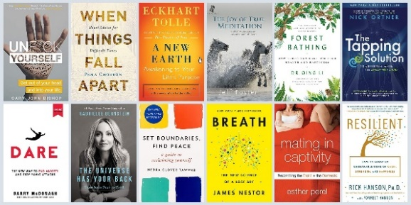
Independent Novel/Book Study on Mental Health and Wellness
Welcome to an engaging journey through literature that delves into the intricate world of mental health and wellness. This assignment is designed to deepen your understanding of the themes, tools, and narratives that shape mental health. By exploring these topics through the experts that have written them you will gain insight into various mental health issues Engaging with your chosen book on multiple levels ensures that you don't just read the words but truly comprehend and reflect on their significance. This deeper understanding can foster personal growth and a greater awareness of mental health in our society.
Assignment Options:

1. Book Review – Make it authentic by writing it for Amazon or Google:

Write a comprehensive review of your chosen book.
Include your personal opinion, how the book addresses mental health topics, and its impact on readers. What did you find powerful? Useful? What changes would you make?
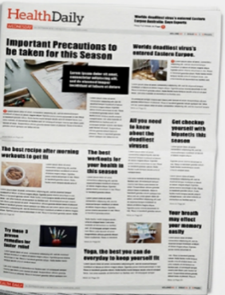
Aim for 300-500 words. Check online for how to write a book review.

2. Create a Newspaper with Mini Articles:
Design a newspaper that includes various articles on key findings from the novel.
Each article can focus on different aspects like tips, research, key takeaways, real-life connections, advice columns – whatever you think would best showcase your learning.
Include images or illustrations to enhance visual appeal.
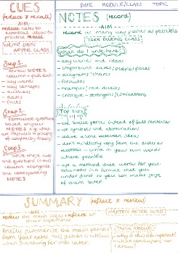
3. Reflection Style Assignment:

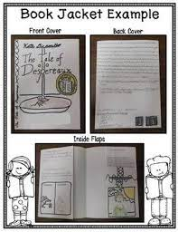
Write a reflection on how the book has influenced your understanding of mental health. Discuss specific moments in the book that resonated with you and why. Aim for 250-500 words.

4. Detailed Note-Taking with Quotes and References: Create detailed notes on key takeaways from the book. Include direct quotes and specific references to the text. Analyze these excerpts and their relevance to the overall theme of mental health. Make connections!
5. Book Jacket Style Summary and Reflection:
Design a book jacket for your novel. Include a summary, author bio, and a personal reflection on the back cover. Reflect on how the book's portrayal of mental health issues has affected your perspective.

6. Student-Created Assignment: Design an assignment that inspires you and explores the book in a unique way. This could be a creative project, a video essay, poster project, a series of blog posts, key vocabulary definer or any other format that engages you deeply with the book.

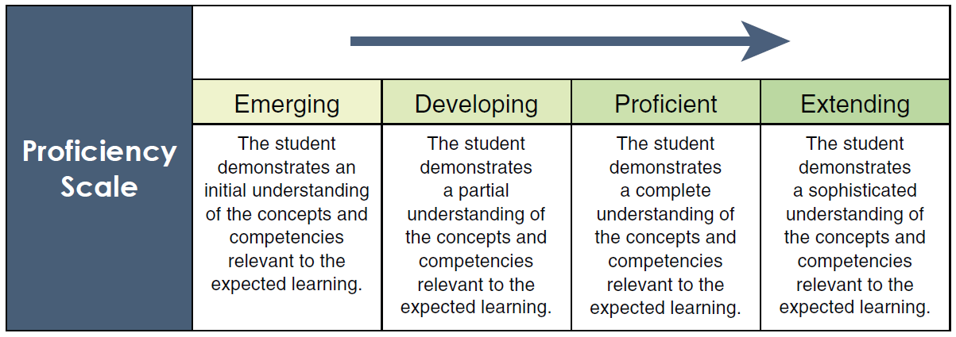
Marking Rubric

Criteria | Emerging | Developing | Proficient | Extending
Understanding of Content | Shows minimal understanding of the mental health themes in the book. | Shows basic understanding of the themes but may miss deeper connections. | Demonstrates a solid understanding of the mental health themes and their relevance. | Exhibits exceptional understanding, making insightful connections beyond the book.
Analysis and Critical Thinking | Analysis is basic and surface-level, with few or no original thoughts. | Analysis shows some original thought but lacks depth or detail. | Provides a thorough and detailed analysis with clear original thought. | Offers deep, insightful analysis that demonstrates sophisticated critical thinking.
Clarity and Organization | Work is disorganized and unclear, making it difficult to understand. | Work is somewhat organized, but clarity is inconsistent. | Work is well-organized and clear, with thoughts expressed coherently. | Work is exceptionally well-organized and presented with outstanding clarity.
Use of Evidence | Uses minimal or irrelevant evidence; quotes and references are scarce or improperly used. | Uses some appropriate evidence, but it may not be integrated well or fully relevant. | Uses relevant and effective evidence to support analysis; quotes and references are well-integrated. | Uses a wide range of highly relevant evidence in a sophisticated manner, enhancing the analysis.
Teacher Comments

/20

