Name: __________________ Date: ___________________
Imagery

Poets use effective Imagery, language that appeals to the sense, as a tool in achieving intensity in their work. It also allows the poet to convey a lot in few words. An image communicated a sight, sound, taste, or touch sensation.

For example, the following image might be used to describe a stroll on a summer night:

Sight –a full moon, partially obscured by a bank of clouds
Sound – the chirp of a cricket
Taste –Sipping lemonade as I walk
Touch –dew on the grass soaking through my tennis shoes
Smell –clean smell of pine trees mixed with the sweetness of lilac

Exercise A: Fill in the chart with images you might use to describe each of the listed experiences. Remember, use lots of vivid images and details, one or two words answers are not enough. (5)

Sense | Object: _______________ | “The Shark” E.J.Pratt
Sight
Touch
Smell
Taste
Sound

“The Shark” E.J. Pratt
He seemed to know the harbour,
So leisurely* he swam; *relaxed
His fin,
Like a piece of sheet-iron,
Three-cornered,
And with knife-edge,
Stirred not a bubble
As it moved
With its base-line on the water.

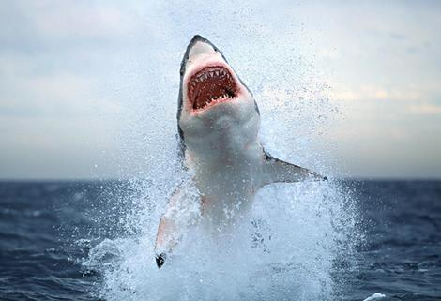
His body was tubular
And tapered
And smoke-blue,
And as he passed the wharf
He turned,
And snapped at a flat-fish
That was dead and floating.
And I saw the flash of a white throat,
And a double row of white teeth,
And eyes of metallic grey,
Hard and narrow and slit.

Then out of the harbour,
With that three-cornered fin
Shearing without a bubble the water
Lithely*, *Flexible
Leisurely,
He swam--
That strange fish,
Tubular, tapered*, smoke-blue, *gradually become narrow
Part vulture, part wolf,
Part neither-- for his blood was cold.
Questions:
1. Pick an image from the poem that appeals to each sense and record it in the chart on the backside of this sheet.

2. “His fin like a piece of sheet iron” is an example of
a. personification b. simile c. metaphor d. alliteration

3. “Snapped” is an example of
a. hyperbole b. simile c. onomatopoeia d. personification

4. “Flat fish that was dead and floating” is an example of
a. metaphor b. alliteration c. hyperbole d. simile

5. “Eyes of metallic grey” and “part vulture, part wolf, part neither for his blood was cold” emphasis what about the shark’s nature?
a. he is ruthless and cold b. he is sad c. he is loving d. he is a killer

6. What is the author’s tone in this poem?
a. cold and indifferent b. bitter c. humorous d. compassionate

7. In the poem as a whole, what is the shark being compared to?
a. a wolf b. a machine c. nothing d. dead fish

