Mr. Fitton HUMANS OF PENTICTON ADVENTURE English

Background: Humans of New York (HONY) is a famous blog and instagram account. Amateur photographer Brandon Stanton lost his job as a bond trader and had two camera’s which he didn’t even know how to use. He moved to New York and simply began to take pictures of people.

Premise: Stanton typically asks the subject one question and uses the response as a caption beneath the photograph. At times he writes what the person says when he asked permission to photograph them. Sometimes he chose a person because they were close to a backdrop that he wanted. Sometimes he chose them because they appeared interesting. Other times, what they were doing intrigued him.
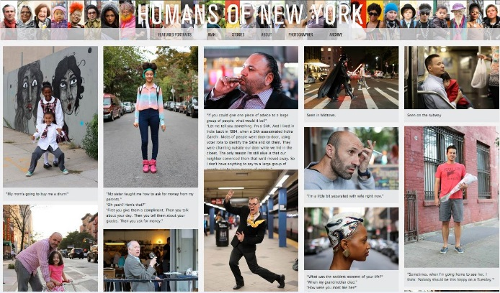
In this sense, it is not his photographic skills which are noteworthy or have brought him fame, it is merely capturing the humanity in the person, and thus the humanity of each of us that makes his work compelling.
Purpose: To show you the many types of effective communication in the world (not just writing); to celebrate creativity; to reveal the variety of jobs/opportunities available; to celebrate humanity; to build empathy; a reminder not to judge someone based on a first impression.
Assignment: To take 3 “Humans of…..” photographs with captions and then present your work as a photographer. (we will learn some photography skills in class).
1. Get your phone ready to take photos. Embark looking with a photographer’s eye for people, for locations. See the world from a child’s eyes – everything is new and interesting. Everyone has a cool story to tell.
2. Ask a big life question – write response down. (see examples of his questions below.)
3. OR Just what they say when you ask to take their photo
4. OR Record their dialogue with you
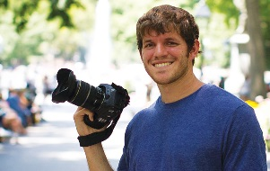
Your goal is to get them to tell a story
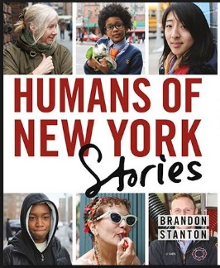
Example questions: What is your biggest regret? What is your greatest struggle? Do you remember the happiest moment of your life? What’s the biggest obstacle stopping your from achieving what you want? What’s your biggest struggle right now? Tell me about a time you had trouble being optimistic? Who in your life have you had the hardest time forgiving? Tell me about a time you didn’t take a risk and you regretted it?
“The unexamined life is not worth living.”
Lesson
1. Look at a youtube video of famous photographs and discuss the importance of photography. https://www.youtube.com/watch?v=ssgjF3yp8mE
2. Examples from HONY of how you can approach you assignment. http://thoughtcatalog.com/kim-quindlen/2015/06/15-beautiful-heartening-inspiring-humans-of-new-york-posts/
3. The Man Behind Hony: https://www.youtube.com/watch?v=Bcm6kwWv09o (3:11 long) – What questions do students have?
4. Watch a youtube clip about Humans of New York and how he asks questions https://www.youtube.com/watch?v=KPxzlGPrM3A (3:28-5:45; 11:09-14:44)
5. Assignment instructions; photography mini-lesson. We will watch a youtube video on iphone photography: https://www.youtube.com/watch?v=PhGsFzAZ71Y At this point, students will go out and take 5 photos using some of the techniques from the tutorial. We will then share our photos as a class.
6. Take photographs and interview our subjects. (Have some in mind)
7. Create a photo essay on computer, slideshow, paper, imovie, Instagram, blog or any app that allows you to create your masterpiece. Share out (in small groups or large groups).
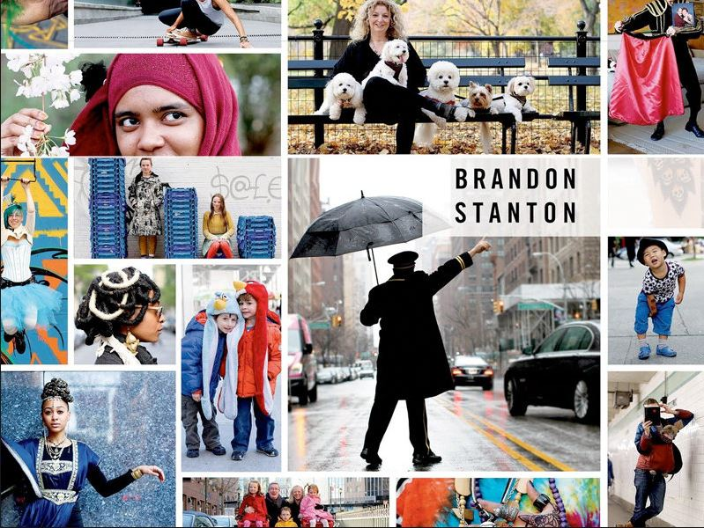
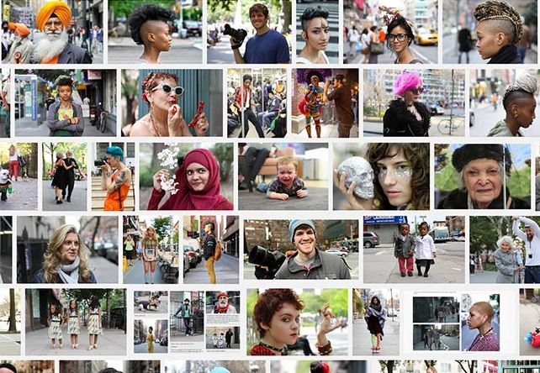

For Further Inspiration, here are examples of his work to check out.
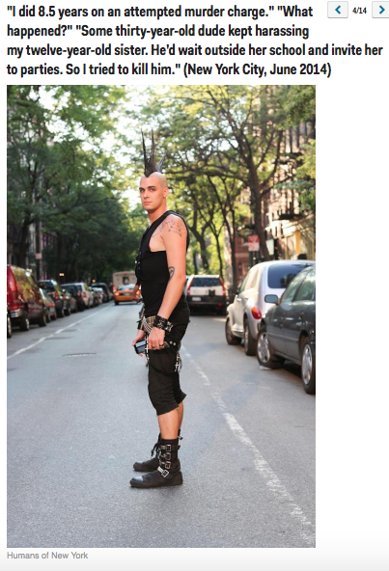
http://www.businessinsider.com/humans-of-new-yorks-most-popular-2014-9?op=1/#ats-your-biggest-dream-for-your-child-well-let-him-dream-for-himself-new-delhi-india-september-2014-1
http://www.melyssagriffin.com/best-humans-of-new-york/
