Mr. Fitton HUMANS OF OUR CLASSROOM CONNECTION ADVENTURE WELLNESS 11/12

Background: Humans of New York (HONY) is a famous blog and instagram account. Amateur photographer Brandon Stanton quit his job as a bond trader and had two camera’s which he didn’t even know how to use. He moved to New York and simply began to take pictures of people.

Premise: Stanton typically asks the subject one question and uses the response as a caption beneath the photograph. At times he writes what the person says when he asked permission to photograph them. Sometimes he chose a person because they were close to a backdrop that he wanted. Sometimes he chose them because they appeared interesting. Other times, what they were doing intrigued him.
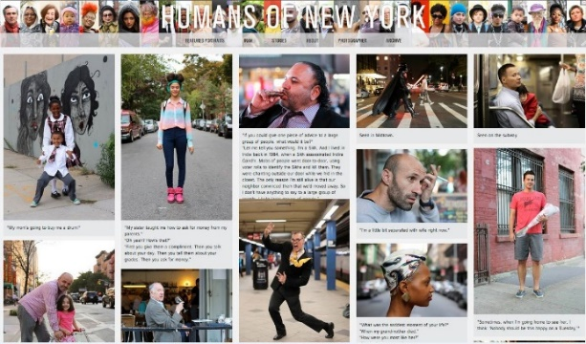
In this sense, it is not his photographic skills which are noteworthy or have brought him fame, it is merely capturing the humanity in the person, and thus the humanity of each of us that makes his work compelling.
Purpose: To show you the many types of effective communication in the world (not just writing); to celebrate creativity; to reveal the variety of jobs/opportunities available; to celebrate humanity; to build empathy; a reminder not to judge someone based on a first impression.
ASSIGNMENT: To meet with a classmate and have a deep and meaningful conversation in the style of Brandon Stanton. Choose one story and write it out. Take a photo of the subject to include with the story.
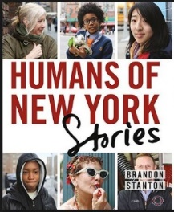
1. Get your phone ready to take photos. Embark looking with a photographer’s eye for locations and shots the represent the person you are writing about.
2. Ask a series of big life questions – write responses down. (See examples of his questions below.)
3. OR Just write what they say when you ask to take their photo.
4. OR Record their conversation with you. You may not get it perfect – capture the spirit of what they say.
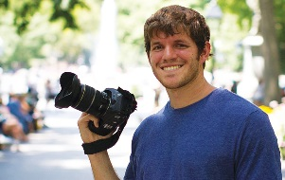
Your goal is to get them to tell a story
Example questions: What is your biggest regret? What is your greatest struggle? Do you remember the happiest moment of your life? What’s the biggest obstacle stopping your from achieving what you want? What’s your biggest struggle right now? Tell me about a time you had trouble being optimistic? Who in your life have you had the hardest time forgiving? Tell me about a time you didn’t take a risk and you regretted it?
“The unexamined life is not worth living.”
Lesson
1. Look at a youtube video of famous photographs and discuss the importance of photography. A. https://www.youtube.com/watch?v=RMEOzOBHqDw B. https://youtu.be/NRvWy-6JzNc
2. Examples from HONY of how you can approach you assignment. http://thoughtcatalog.com/kim-quindlen/2015/06/15-beautiful-heartening-inspiring-humans-of-new-york-posts/
3. The Man Behind Hony: https://www.youtube.com/watch?v=Bcm6kwWv09o (3:11 long) – What questions do students have?
4. Watch a youtube clip about Humans of New York and how he asks questions https://www.youtube.com/watch?v=KPxzlGPrM3A (3:28-5:45; 11:09-14:44)
5. Assignment instructions; photography mini-lesson. We will watch a youtube video on iphone photography: https://www.youtube.com/watch?v=PhGsFzAZ71Y At this point, students will go out and take 5 photos using some of the techniques from the tutorial. We will then share our photos as a class. To prep up for our HONY photos.
6. Take photographs and interview our classmate. (Have some in mind)
7. Write out your text of their powerful story and add your photo. Put a key quote from the story at the top.
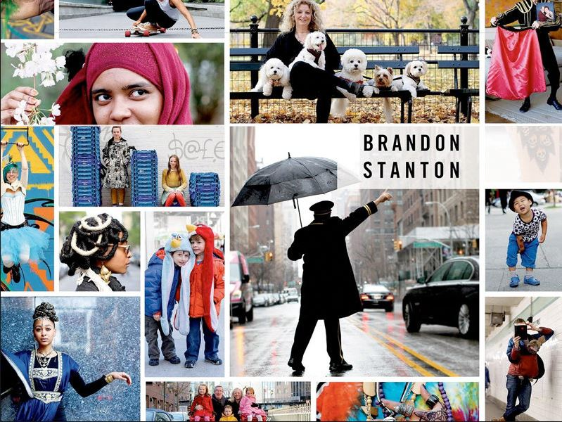
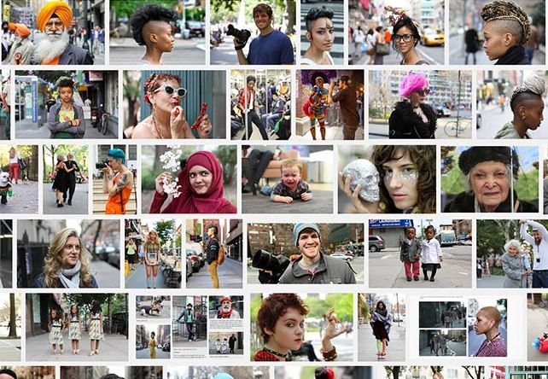

For Further Inspiration, here are examples of Humans of New York to check out.
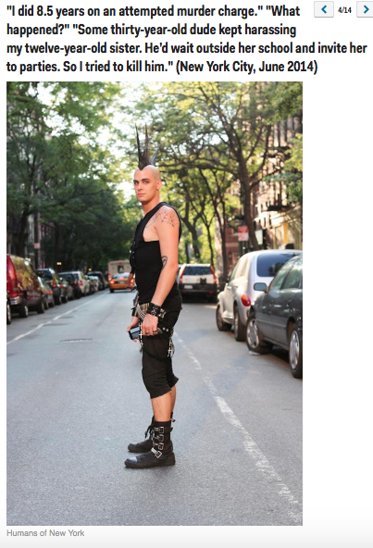
http://www.businessinsider.com/humans-of-new-yorks-most-popular-2014-9?op=1/#ats-your-biggest-dream-for-your-child-well-let-him-dream-for-himself-new-delhi-india-september-2014-1
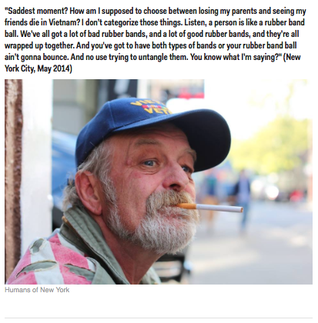
http://www.melyssagriffin.com/best-humans-of-new-york/
