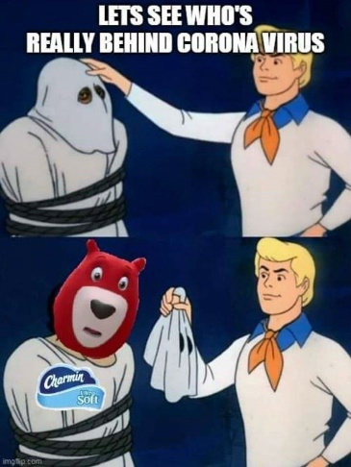
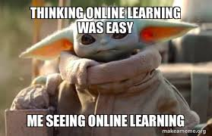
Mr. Fitton’s Weekly History Through Film Learning Bulletin

Week 2 – April 13th – April 20th

1. HOW TO START.
-Check your student email; our school communication is through there. .
-Most material is currently up on my website at:
https://mrfitton.weebly.com/online---ww2.html
Please click the link above or go to the website to start learning.

2. GO TO: LESSON 2 “TO BE DONE BETWEEN APRIL 13th-20th”
- Don’t work too far ahead, as things will change.

Checkmark  When Done | Task – Assignments, Learning Activities
1. Download Remind App if you haven’t yet.
-Our course code is: https://www.remind.com/join/jfitto?utm_source=email&utm_medium=ios&utm_campaign=join_invite

 | 2. Go to: https://mrfitton.weebly.com/online---ww2.html
 | 3. Do “Lesson 2” – Follow the website
 | 4. Watch the Biography of Churchill. https://youtu.be/cFUSLK2z6qI
 | 5. Watch Fitton’s video on Webbs DOK: https://youtu.be/cV6eLSQ2LPE
 | 6. Go to Netflix and watch “The Darkest Hour” a film about WW2
7. Develop 6 discussion questions; Post on your Blog; Answer two of your questions;
Have a discussion in the discussion forum on the blog site.
8. Explore the additional content on my website about “Darkest Hour” if you want.

*If you can’t access your blog, please email me your 6 questions and your two detailed responses.

