Mr. Fitton Name:
(Capitalist Pig)

History 12 Date:
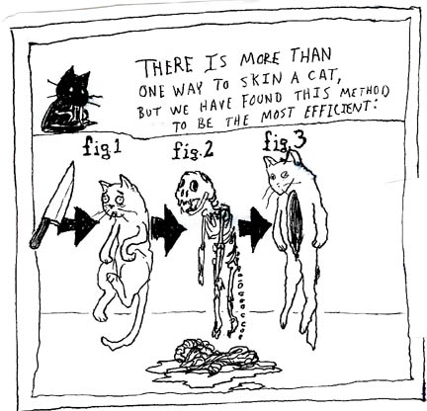
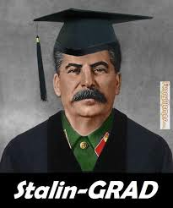
During our enriched learning session, we will conduct a science fair as a class. You will be given the opportunity to share your research, passion for subject matter and your thesis with your colleagues.

During the science fair, please visit three different colleagues and answer the questions below.

Name of person:

What is their thesis?

What are three pieces of evidence they use to prove their thesis?

What is a neat thing they learned?

What did they enjoy about this project/the research/the learning process?

Name of person:

What is their thesis?

What are three pieces of evidence they use to prove their thesis?

What is a neat thing they learned?

What did they enjoy about this project/the research/the learning process?

Name of person:

What is their thesis?

What are three pieces of evidence they use to prove their thesis?

What is a neat thing they learned?

What did they enjoy about this project/the research/the learning process?

