Paragraph: The Hamburger Model

**Name:**

**Date:**

Mr. Fitton

LAW

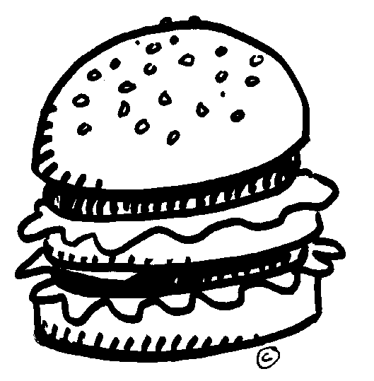Topic Sentence / Thesis Statement

(Your Argument: What you are going to prove)

+ Blueprint

The Meat: The points that will prove your thesis.

(It includes: examples, **quotations**, insights and analysis.)

Hamburger

The Concluding Sentence!

(Sum up your points & make an insightful comment.)

**A) Topic Sentence / Thesis statement**

# Jay: A Domineering Character

Jay, the patriarch on the television show, “Modern Family” is a domineering character. His **actions**, **relationships with others** and **his concluding statements** demonstrate his **oppressive nature**. Jay’s actions, such as telling Manny not to pursue his love make him an **authoritative** character. He tells Manny that if he puts on a puffy white shirt and proposes his love, he will “swing on a flagpole by his puffy white underpants.” The fact that he will not support his stepson and even goes so far to insult him shows that he is authoritative. Jay’s **relationships with others** also demonstrates his oppressive character. For example, exclaims to Cam and Mitchell that having a baby is a bad idea and he also calls Mitchell’s husband a drama queen. This outward display of contempt for his own families shows that he is domineering and unsupportive. Finally, Jay’s concluding statements further prove that he is domineering. Indeed, while most individuals would learn from treating their stepson’s and biological son’s meanly, Jay does not. In the very end of the show, he is shown reading Manny’s love letter. Instead of supporting Manny, he reads the letter, laughs derisively and says “I mean seriously” when he reads the poem. In conclusion, Jay is symbolic of the male dominated world that existed in his era. Indeed, Jay’s actions, relationships with others and the fact that he is a static character even at the end of the episode prove that he is domineering.

E) Point 3 stated and

Developed

D) Point 2 stated and

Developed

C) Point 1 stated and developed

B)Blueprint: The points that prove my thesis briefly stated

F) **Conclusion**. Sums up information, sums up the main idea (Oberon is a domineering character) and makes an *interesting statement* about what kind of character there are (Round, Flat, Static, Dynamic).

*Remember the S.E.X Formula for effective formal essay writing:*

**S**tatement (Make a **statement**)

**E**xample (Provide a quote, **example** or describe an event – be detailed and specific)

e**X**planation (**Explain** how your point proves your thesis or topic sentence)

**Thesis:** A thesis is another word for “Argument.” Outline what you will argue below. Include the Author’s name and the name of the work(s) you are discussing. (If Dr. Zimbardo from “The Psychology of Evil” were to view “The 7-5” by

________________________________________________________________________________________

**Blueprint:** (What are the 3 things you plan to discuss) (Three events Dr. Zimbardo would comment on)

________________________________________________________________________________________________________________________________________________________________________________

**Main Body (what come after the thesis and blueprint)**

(Main body of the Paragraph)

. First,(state what he would comment on) __________________________________________

___________________________________________________________________________________

(What would he say, and what evidence do you have to support that)____________________________

___________________________________________________________________________________

___________________________________________________________________________________

Second ,(state what he would comment on) __________________________________________

___________________________________________________________________________________

(What would he say, and what evidence do you have to support that)____________________________

___________________________________________________________________________________

___________________________________________________________________________________

Third,(state what he would comment on) __________________________________________

___________________________________________________________________________________

(What would he say, and what evidence do you have to support that)____________________________

___________________________________________________________________________________

___________________________________________________________________________________

Concluding sentence (summarize key points and end with insightful comment):__________________

__________________________________________________________________________________

__________________________________________________________________________________

__________________________________________________________________________________