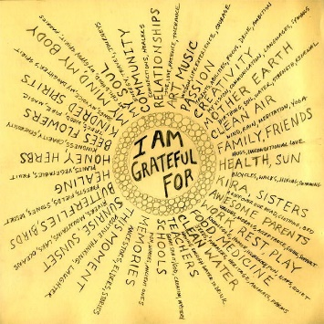
Assignment: Cultivating Happiness Through Gratitude
In this assignment, you will engage with the concept of gratitude based on the research and teachings of Dr. Laurie Santos, a renowned psychologist specializing in happiness and well-being. One powerful exercise Dr. Santos often discusses is the practice of writing a gratitude letter. Gratitude has been shown to enhance well-being, increase happiness, and foster positive relationships. By expressing gratitude, we acknowledge the kindness and support we receive from others, leading to a greater sense of happiness and fulfillment.
Instructions:
- Select a Recipient: Think of someone in your life who has had a significant positive impact on you. This could be a friend, family member, teacher, mentor, or anyone else who has shown you kindness, support, or guidance.
- Reflect on the Impact: Take a few moments to reflect on the specific actions, qualities, or gestures of this person that have influenced you positively. Consider how their kindness or support has made a difference in your life and why you appreciate them. Brainstorm below.

- Write the Gratitude Letter: In your letter, express your gratitude sincerely and specifically. Be specific about what they did, how it made you feel, and the lasting impact it had on you. You can include personal anecdotes or examples to illustrate your gratitude effectively. Include a warm greeting at the start!
- Be Genuine and Heartfelt: Write from the heart. Your letter should convey genuine appreciation and gratitude. Be sincere in your words, expressing your feelings openly and honestly. Don’t worry about super formal language.
- Revise and Review: After writing your letter, take some time to revise and review it. Ensure that your message is clear, heartfelt, and respectful. Check for spelling and grammatical errors to present a polished and thoughtful letter.
- Consider Sending or Reading Aloud: Consider either sending the letter to the recipient or reading it aloud to them in person. Sharing your gratitude can deepen your connection and bring mutual happiness. There will be lots of tears, but it is worth it!
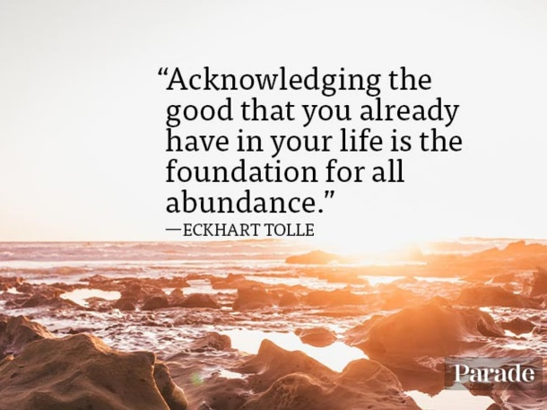
- Reflect on Your Experience: After completing the letter, take a moment to reflect on how the process made you feel. Consider the emotions and thoughts that arose during and after writing the letter. Reflecting on your own gratitude can enhance the positive effects of the exercise.
Benefits of Writing a Gratitude Letter:
- Increased Happiness: Expressing gratitude has been linked to increased happiness and life satisfaction.
- Strengthened Relationships: Sharing your gratitude can strengthen your bond with the recipient and foster a sense of connection.
- Positive Impact: Acknowledging the kindness of others can lead to a positive impact on both the writer and the recipient.
*Remember, this assignment is not just an academic task; it's a chance to cultivate happiness, foster gratitude, and strengthen your connections with others. Enjoy the process, and feel free to let your feelings of gratitude guide your words.
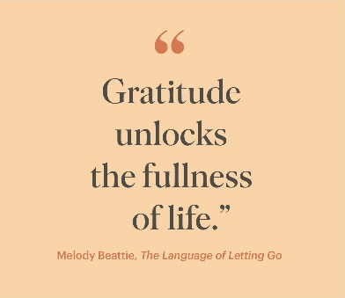
How-To Guide

Time Required
Budget about 30 minutes for writing the letter and at least 30 minutes for the visit if you choose to deliver your letter in person.

How to Do It
Call to mind someone who did something for you for which you are extremely grateful but to whom you never expressed your deep gratitude. This could be a relative, friend, teacher, or colleague. Try to pick someone who is still alive and could meet you face-to-face in the next week. It may be most helpful to select a person or act that you haven’t thought about for a while—something that isn’t always on your mind.
1. Summarize why you're grateful for your recipient
Your first paragraph can tell your recipient why you are grateful for them. You may summarize why you feel grateful and thank your recipient for their contribution to your life. It's natural to mention your connection or relationship in your introductory paragraph.
2. Mention specific details about the recipient and their impact
The second paragraph can expand on your first paragraph and note specific behaviors or moments you shared with the recipient that mattered to you. Note the impact that the recipient had on you and your life. You may use more emotive language if you're closer to the receiver.
3. Conclude with an expression of gratitude
The last paragraph of a letter of gratitude usually highlights your feelings of gratitude and expresses your thanks to conclude positively. You may explain how your recipient's contribution helped you become the person you are today. If it's been a while since you communicated with your recipient, you might mention what you're doing in your career now and how their impact still resonates with you today. Add a professional sign-off and your signature above your printed name.
Letter of gratitude example
Here is an example of a letter of gratitude you could use to inspire your own letters:
Dear Ms. Kim,
I would like to express my gratitude for the love of writing you instilled in me as a high school student. I always enjoyed writing short stories, but it took your senior English classes to understand the potential I had. Your praise gave me the confidence to pursue a career in this field.
I was so moved when you read my story about the loss of my grandfather out to the class and told the other students it was a prime example of the way the right words can make the audience feel emotions. I was unaware I had that power before, and it made me want to move people even more with my stories. I really appreciated you reading each story I'd give you in your own time and offering such constructive critiques. I know your insights made me a better writer.
I recently secured my first job at a local newspaper writing human interest stories. I'm enjoying sharing stories of the residents with people in the local area and hopefully moving them with my words. Your advice plays in my mind whenever I proofread my articles. I could always count on you for honesty and advice. Ms. Kim, I am so grateful for you seeing the potential in me and giving me the confidence to pursue my career. Thank you for your guidance and belief.
Kind regards,
Dale Underwood
The model shown is for illustration purposes only, and may require additional formatting to meet accepted standards.
FROM How to Write a Letter of Gratitude (With Tips and Example) | Indeed.com Australia

Rubric Scale
Criteria | Emerging | Developing | Proficient | Extending
Content and Clarity | Gratitude is expressed, but details and specifics are limited. The impact of the person/thing is vaguely addressed. | Gratitude is communicated with some specific examples. The impact is acknowledged but not deeply explored. | Gratitude is clearly and specifically expressed. The impact is reflected upon with insight and depth. | Gratitude is expressed with exceptional specificity and detail. Deep and thoughtful reflection on impact is evident throughout.
Organization and Structure | The structure of the letter is attempted but not fully coherent. Transitions may be abrupt or confusing. | The structure is apparent, with a basic introduction, body, and conclusion. Some lapses in logic or flow may be present. | The letter has a clear and effective structure with logical progression and smooth transitions. | The structure is exemplary, enhancing the clarity and emotional power of the letter. The organization is creative and engaging.
Language and Tone | Language is simplistic and may not be entirely appropriate for the context. Multiple errors in grammar, punctuation, and spelling. | Language and tone are generally appropriate. Minor errors in grammar, punctuation, and spelling. | Language and tone are appropriate and effective for expressing gratitude. Grammar, punctuation, and spelling are mostly accurate. | Language and tone are exemplary, with sophisticated vocabulary and flawless grammar, punctuation, and spelling.
Personal Voice and Creativity | The student’s voice is not evident. The letter lacks originality and relies on generic expressions. | The student's voice is present but not pronounced. Some creativity is evident, but clichés may be present. | The student’s voice is clear, and the letter shows originality in thought and expression. | The letter exudes a strong personal voice and high creativity, providing a memorable and unique expression of gratitude.
Impact and Persuasiveness | The significance of the gratitude is not compellingly conveyed, and the emotional impact is minimal. | The letter is somewhat persuasive, but the expression of gratitude may not fully resonate with the recipient. | The letter is persuasive, showing genuine appreciation that is likely to elicit an emotional response from the recipient. | The letter has a powerful impact, with compelling persuasiveness that will deeply touch the recipient and evoke a strong emotional response.

Teacher Comments:

/20

