English 11 Name:____________________
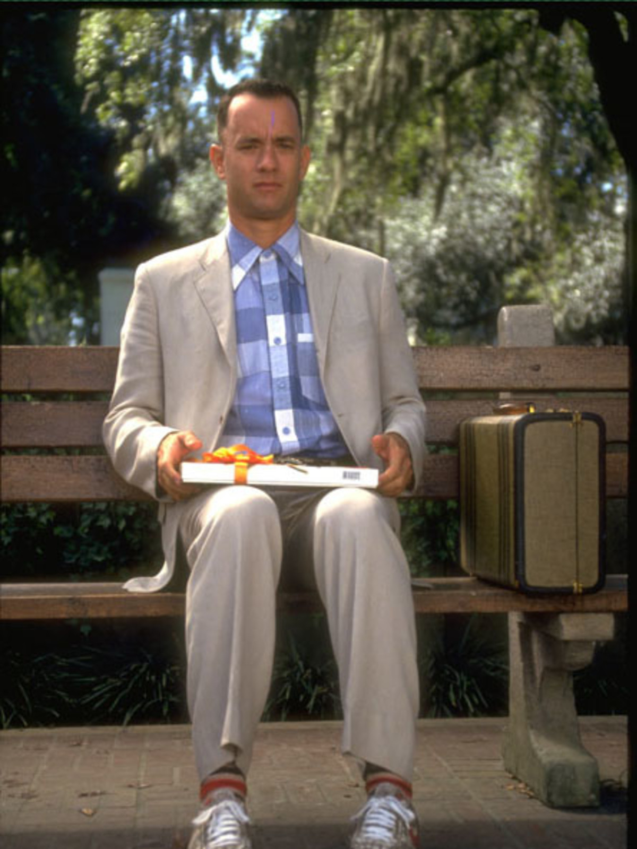
The Assignment: You get the amazing opportunity to write a personal narrative. The ability to write or tell an engaging story is an essential skill to help you communicate ideas with others. A personal narrative is when a person describes a single event from their life in dramatic or interesting detail. 300-500 words.

The Process: We will start with a walk as a class. Partner with someone you feel comfortable talking with and discuss the following questions, which will scaffold the assignment for you.

PART ONE: On your walk, have a discussion guided by these questions:

1. What is an experience / event from your past that has an emotional response attached to it (Happiest Moment, Saddest Moment, Moment you were most scared; Moment you felt whole)

2. Describe the event/experience in as much detail as possible.

3. What did you learn from the experience?

4. Why was the experience important to you?

5. How do you think or act differently as a result of that experience?

6. Come up with follow-up questions like we learned from Brandon Stanton in “Humans of New York.”

7. What will the first line of your story be?

PART TWO: Start writing a draft based on an event in your life. Remember, the event doesn’t have to be huge or incredibly dramatic, but should be memorable. Some helpful hints:

- Choose the event you want to describe
- Jot down the basic details in the order they happened
- Decide the basic order you want to tell your story (for example you could start in the middle and flash back)
- Create an engaging beginning that will hook your reader.
- Write out your story (write in 1st person because this is your story!)
- Add sensory details and imagery to create pictures in your reader’s mind
- Revise your work (make sure you have added the right balance of description and action; remember our checklist; include dialogue to show sophistication)
- Proofread for spelling and grammar and Peer Edit

STUDENT SAMPLE:

Please note the following example is from a Grade 10 student and is shorter than required. It contains many of the elements required, but yours should be longer.

I woke up surrounded by an oppressive fog. It obscured my vision and hindered my breathing. I couldn’t remember where I was or how I had gotten there. It was eerily quiet…

Until it wasn’t.

The silence shattered. All around me, I could hear mechanical screeches and squeals. The echoes and shadows of voices broke through my muted musings. My brain was having trouble processing. I felt blinded by the sudden onslaught of sensory overload and was lost in a hazy version of my own reality.
Then, suddenly, the fog started to lift, and my vision cleared. I was in a room, attached by long strings of wire to more beeping, sputtering machines than I had ever seen in my life. People dressed in white and blue and green and pink danced around the corners of my eyes. They were talking calmly to one another, though I could feel the urgency of their practiced movements.

I remembered.

Reaching down to turn on the radio. Looking up at Paul. Then headlights streaming through the passenger-side window. Screaming brakes. Crunching metal. And nothing.
“Paul,” I managed to breathe through parched lips. The unexpected sound forced the dancers to a halt.

“Paul,” I said even louder, though it still couldn’t have been more than a whisper.

“He’s fine, son. Your friend will be fine,” someone responded.

He was alive. And I was alive. And neither of us would ever be the same.

