Socials 9 Name _________________
Aboriginals in Early Canada
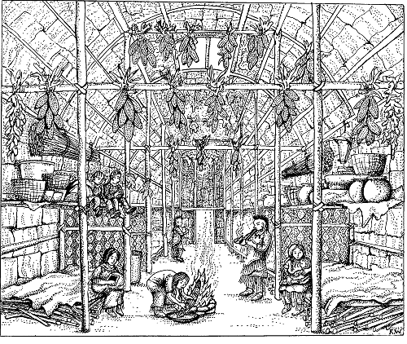
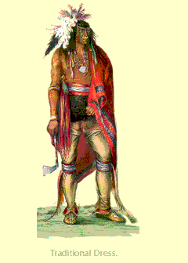
The Iroquois

Geography

-Lived in the fertile country of the ______________ __________________.

Housing
Built large towns guarded by ______________ of logs (defensive fences).
Lived in ________________ with extended family, however, the longhouse was divided into nuclear families

Agriculture/ Hunting
Used to lead ________________ lives traveling to find food until they discovered ____________________ in about 500 CE.
The towns were surrounded by fields of _______, beans, squash, and sunflowers.
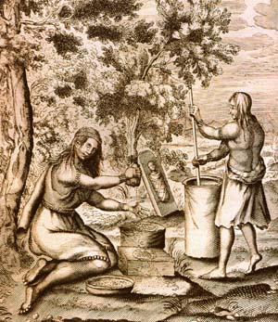
Their diet consisted of berries, nuts, vegetables, and meat.
Also grew such plants as ________________, which made a valuable trade item.

Community life
Matrilineal and _______________________.
Women took care of the ________________. They were responsible for growing the crops.
When a couple __________ they lived with the bride’s family.

Government
- The town was run by the town _______________, which consisted of the _____________ of each family.
- Several towns banded together and sent a representative from the council when a decision needed to be made. The decision would be made ______________________.
- Chiefs were chosen by the ____________ elders of the clan, who could remove him if he was a poor leader.
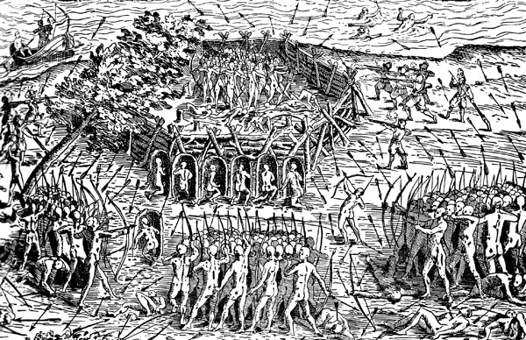
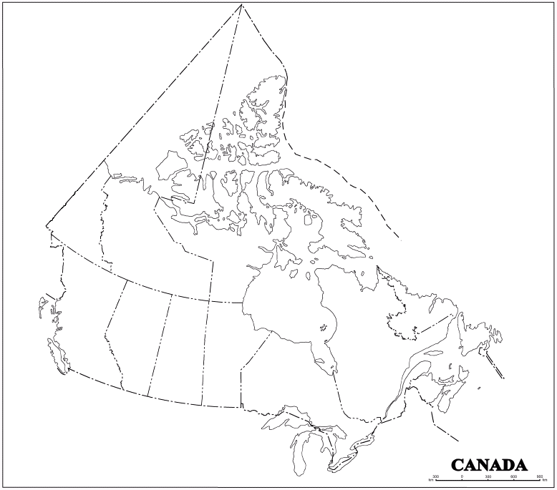

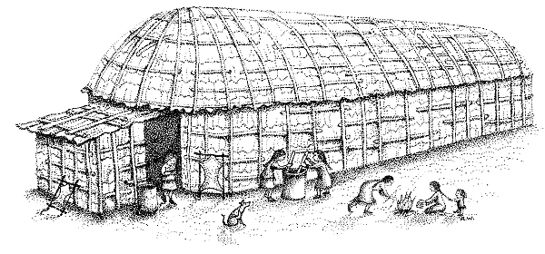

The Inuit
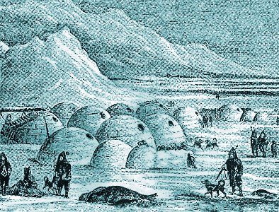
Geography
___________________ Canada, most of Alaska, and Greenland (outer edges). Snow covered most of the year.

Housing
Lived in ________________, made up of blocks of ________________.
In the ________________ they lived in tents made from animal __________________.
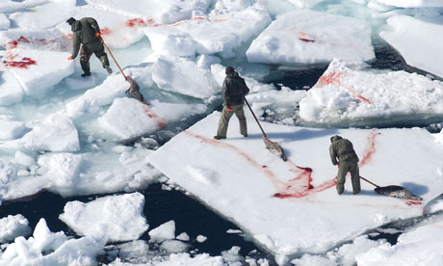
Agriculture/ Hunting
Hunted ______________ for fur for _______________.
- Hunted caribou, musk-ox, walrus, whales and fish.
- Used _____________ _________________ of the animal including the fat.
- Fat was used for protein and for fuel for lamps.
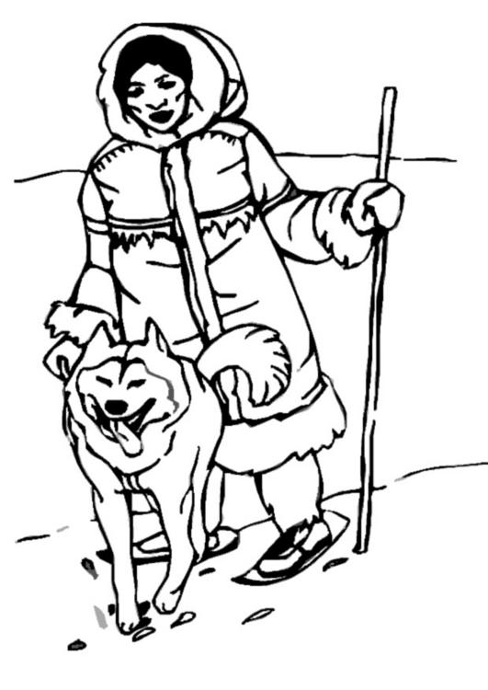
- Meat was eaten _____________________ because cooking with lamp light is difficult.
- _____________________ was used as a source of drinking ___________________.
- In winter relied on __________ ______________ of meat that were stored outside (too difficult to hunt in winter).

Community Life
- ______________ partnerships were expected to last a lifetime.
- Child _______________ would come from family tree.
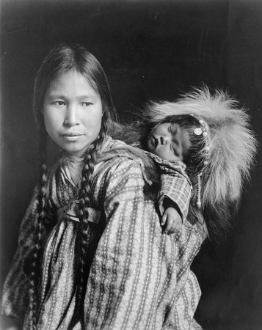
- Marriages were emphasized __________________ (descend from generation is reckoned through the male line only) but couples would spend a year living with the bride’s family so the husband could work with the father.

Government
- The ______________ of the ________________ line of the family always directed the other members of the community in proper behavior and ____________________.

Religion
- Illness and misfortune were a signal to the members of the community that they had not ________________ themselves properly.
- Believed in the spirit force in the universe and the need to behave in a certain way to ensure existence with ___________________.

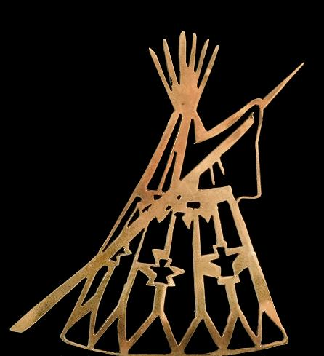
Plains

Geography
-The interior plains, Southern _______________ and Southern ___________________.
Housing
- Used _______________ as shelter made with tanned buffalo __________________.
Agriculture/ Hunting
-Lived on ___________________.
-Used two forms of buffalo hunting
-Run buffalos off a _________________where hunters waited to slaughter them.
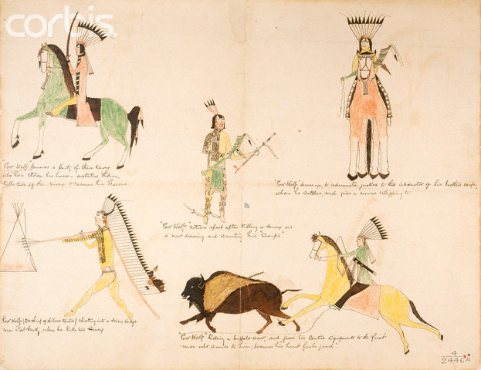
-____________________ them into a ___________________.
Community Life
-Social organization was completely organized around the buffalo ___________________.
-50-100 people lived in each community.
-Men would ________________ buffalos towards a run.
-Women, children and old people were set up along the buffalo run to _________________ at the bison which kept them running into a trap they set up called corrals.
-Here the bison would be trapped and killed.
Government
-Most tribes consisted of loosely organized and independent bands.
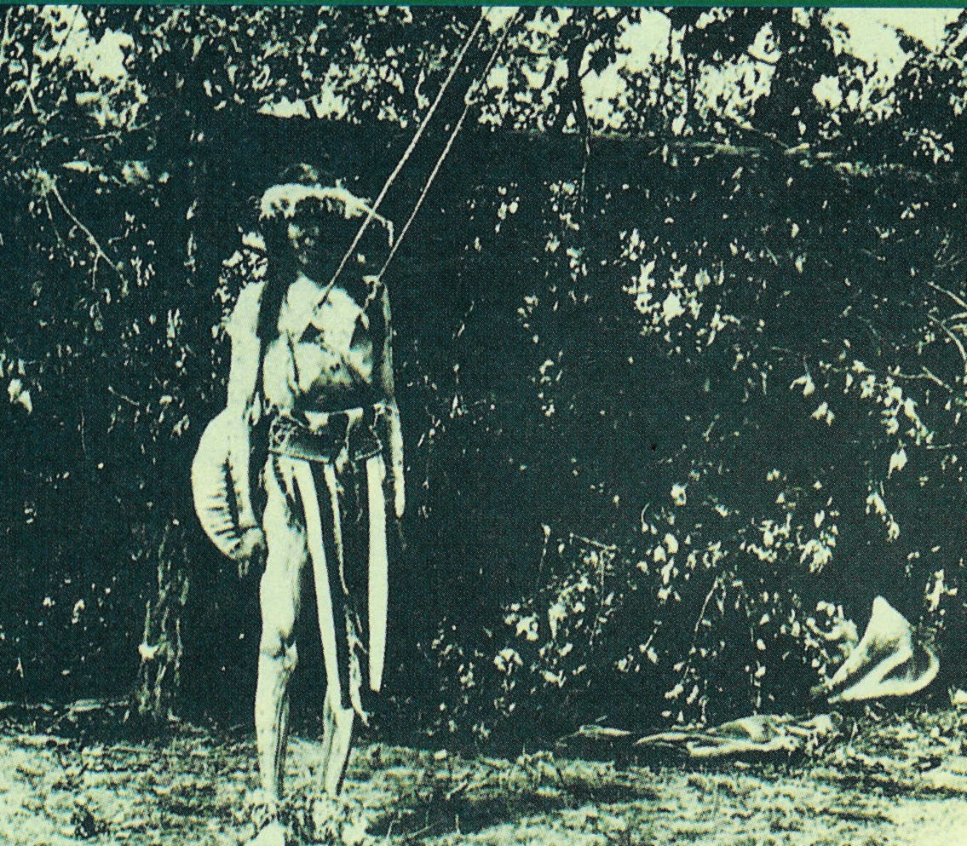
-Band chiefs had the ________________ and support of their followers as long as they were ________________ in the quest for __________________ and in ____________________ against enemy attacks.
-Chiefs were ___________________ rather than rulers; their decisions were based on unanimous approval reached in the council of elders.
-Public _____________________ and ridicule were the principal means of social ___________________.
Religion
- ____________________ Dance or the “Thirsting Dance” that was held in the summer.
- Would ________________, not drink and subject themselves to ________________ (pierce skin with skewers of bones attached to rope tied to a pole where they would lean back to create tension) while dancing without a rest for days.
- Sun Dance seen as an ____________for warriors in badge of honor.
- Other purpose is to see visions and to pray for safety in ___________________.

Plateau

Geography
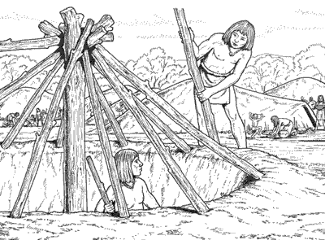
-These native peoples would have been found in such areas like the _____________________, Shuswap, Chilcotin, Lillooet, Nlaka Pamux, Nicola, and Ktunaya.

Housing
-Lived in __________________ houses (house dug into ground to protect them from the elements) in the winter that ranged from 6-8m long. Reused several winters.
-Had indoor ___________________ from a fire, which made it dark and smoky.
-Lived in _________________ in the ____________________.

Agriculture/ Hunting
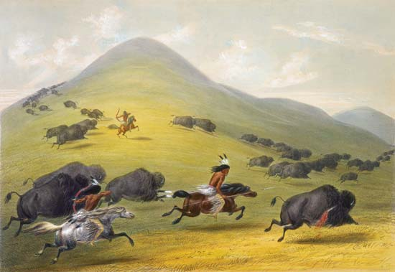
-Fished for __________________.
-Planted foods such as berries.
-Collected edible __________________ like wild onion, wild lily bulbs, balsam root which they preserved for the winter.
-Hunted ______________________ such as bison, deer, and birds.
-Hides of animals used to make ________________________.
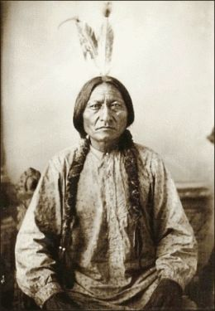
Community Life
-These people lived around hunting bison and deer.
-They did lots of ________________ with Coast Salish with shells and soapstone.
-Style of moccasins indicated ____________________ (deer skin= high status and Salmon skin= low status).

Religion
-Participated in the _________________ _____________________.
-Ceremony where men subjected themselves to pain and suffering in order to have visions, while Women prayed for their safety in war.
-Hunted bison.

Northwest Coast

Geography
-Along _______________ coast of BC.

Housing
-Lived in _______________ long houses, which lasted for many years.

Agriculture/ Hunting
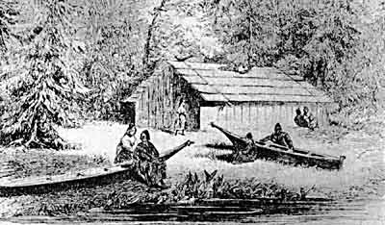
-Collected food by ______________________ and stored it.
-In winter lived in permanent villages and ate _______________food and collected shellfish.
-Spring: began to break up as families and start __________________ food.
-Summer: gathered salmon, _________________, shellfish.
-Fall: gathered ___________________ (enough to last the whole winter) and potatoes.

Community Life
-Deeply concerned with concepts of inherited ______________ and ____________________.
-Possible to __________________ outside of the tribe.
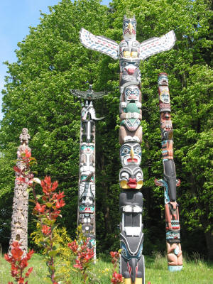
-Potlatch was a sign of noble status.
-Built ___________________ for hunting whales and for fishing.
-____________________ were used for labor.

Government
-Villages had _____________________ and nobles
-High-ranking clans (groups) controlled ____________________ areas (salmon fishing, berry patches, and cedar stands).
-Each clan had a _________________________ with an animal that represented the clan.

Religion
-Believed in the ceremony called the __________________. Potlatches were _________________ given to people that witnessed a family ____________ e.g., a marriage.
-__________________ poles (30 meters) tells a story of its origins and deeds.
-Ritual ______________________ communicated legends of each clan.
-Dancers wore elaborate costumes and masks.

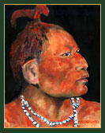
Beothuk

Geography
-The Beothuk people originally inhabited _____________________ until they were driven from their homes by ___________________________.

Housing
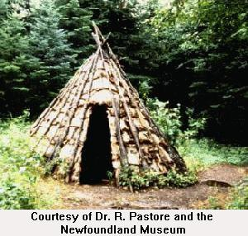
- Lived in a _________________ (like a wigwam- dome shaped).
-The Mamateek could hold up to ___________________ people in a room.
-It could be completed in less than an hour with a group of people working.
-In the wintertime families moved away from the _______________ and into multi-family dwellings.

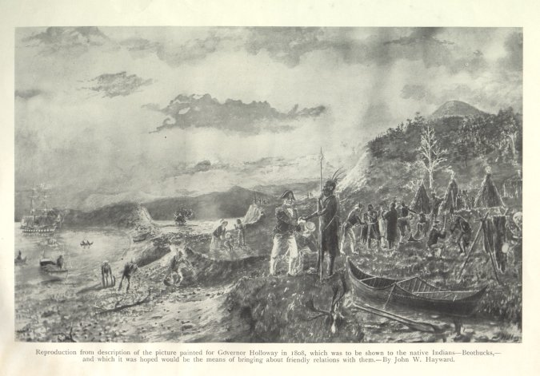
Agriculture
- They were both ______________ and ___________________.
-The Beothuk mainly hunted ________________________.
-They also fished, killed _______________, ate different types of _____________ and their eggs, as well as ___________.
-The growing season in Newfoundland was very short which meant that the Beothuk people ____________________ farm.

Community Life
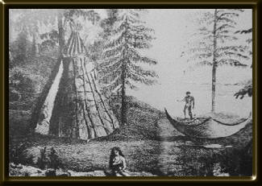
-They lived in self-efficient, independent, and ____________________ family groups between 30-50 people.

Government
-They had band leaders but not formal ___________________.

Religion
-The Beothuk followed elaborate _____________________ practices.
-After wrapping the bodies in birch ____________________, they buried their dead in ___________________ locations.
-Shanawdithit, the last known Beothuk, said that the spirit world of her people included a "Great _______________," a "Powerful ___________________" from the _______________________and Aich-mud-yim, or "Black Man."

