Social Studies 9 Name: KEY

The Revolution Begins (pg. 72-77 in Crossroads)

The disparity of the poor, extravagance of the nobles and the new ideas of the philosophes collided together in the in the 1780s, when a series of famines exacerbated the situation. France was now ripe for a radical and bloody revolution.

Directions: In your groups, read the section of the textbook you were assigned aloud (each person should read a paragraph until the section is complete). Then, fill in the blanks for your section. Afterwards, you will be assigned a new group where you be the expert on your section and will teach the information to your group.

A Crisis pg. 72
-By 1780s France was almost Bankrupt
-Lead by Philosophes, unhappy French people rioted for a limited democracy (like England)
-French soldiers participated in American Revolution and to them France was embarrassingly backward
-Problems made worse by a series of famines
-people were starving and 40 000 children were abandoned a year
-Industrial Revolution in England put French people out of work because new machines could make many products cheaper and quicker
-people wanted change immediately; formed violent and unpredictable mobs
-Louis responded to critics by killing them or imprisoning them. At a bread protest, he shot at people
-King’s popularity fell even lower
-forced to call the Estates General

Estates General pg. 73-74
-Parliament that met on royal command
-Included representatives from the three sections of society
-First Estate = clergy, Second Estate = aristocrats, Third Estate = middle class
-Seldom called (last time in 1614)
-every group had one vote (voted as a bloc), but third estate twice as big as the rest and the 1st and 2nd always voted the same way to protect their privileges.
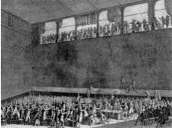-Louis hoped the meeting would help raise money to put an end to the rioting, but he was not prepared to give them a say in government
Tennis Court Oath

The Spirit of the Revolution Grows pg. 74
-Ordinary people wanted change in France, had great expectations of the delegates at the Estates General
-After 6 weeks of little progress, the third estate, led by Count Mirabeau, broke from the others and formed a new government called the National Assembly
-Wanted a new constitution for France
-Louis locked them out of their meeting so they retreated to the royal tennis courts and swore the “Tennis Court Oath”: that they would continue to meet until France had a new government
-Louis tried to give some democratic reforms, but his offer was rejected and eventually he had to force the other 2 estates to join the National Assembly, many believed the revolution was over and a success.

The Fall of the Bastille pg. 75

-Riots soon broke out again over the high price of bread
-Started attacking city prisons to free political prisoners
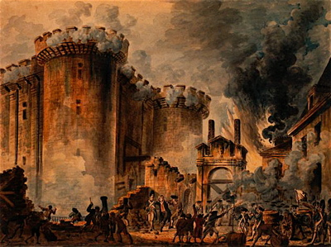
-Louis responded by sending foreign mercenary troops, which citizens thought he would use on them so they began to arm themselves
-July 14, 1789 a mob attacked a royal prison called the Bastille, released the seven prisoners, cut off the governor’s head and paraded through the streets
-Louis was frightened and agreed to send away his troops. National Guard was formed to keep order in Paris
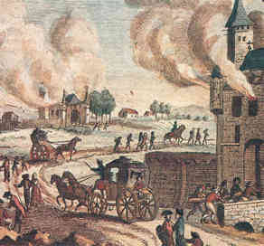
The Great Fear pg. 76
-Revolution mostly occurred in Paris and Versailles, but it began to spread to the country
-Peasants were afraid that the King would stop the revolution, resulted in a panic called the Great Fear.
-Peasants stormed rural aristocratic chateaux, burned them to the ground and killed 100s of people
-Stormed into offices and burned feudal certificates and papers that recorded their obligations to the lords.

Paris and The King pg. 76
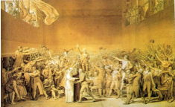-August 4, 1789, The National Assembly met in Versailles and abolished all feudal rights and privileges and ended serfdom. Then, they declared all people equal before the law.
The National Assembly
-Huge change in a short period of time
-People worried king out of touch of conditions in cities, felt government should be in Paris.
-National Assembly could not solve food shortages
-In October, starving people decided to march 50 km to Versailles to meet the king
-They attacked Versailles and Louis agreed to go to Paris

Declaration of the Rights of Man and the Citizen pg. 76
-Document passed by the National Assembly, which established basic human rights for France
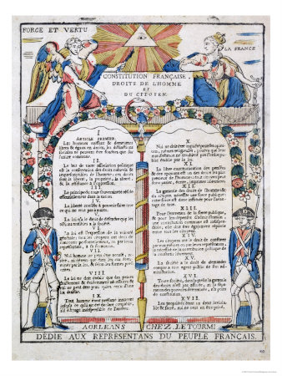
-Ideas taken from the philosophes
-Guaranteed freedom of thought, speech, religion, security, property and put limits on government power.
-Titles were abolished; everyone called “citizen” now (even King is now Citizen Louis Capet)
-Government seized control of church, sold its lands to get money to help with the food shortages
-Many aristocrats fled France to try to figure out how to restore the old system (called émigrés)
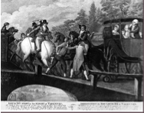-In 1791 Louis tried to flee to get help from other European monarchs to restore his monarchy
Flight To Varennes
-Worst thing he could do, proved he could not be trusted
-Royal family recognized at Varennes, arrested and imprisoned
-In the National Assembly, three groups fought between whether France should be a republic (no king), Constitutional Monarchy (like England), or Monarchy.

Summing it all up:

In the table below, please record or draw the 2 most important things that happened in each section.

A Crisis | France is bankrupt
The Estates General
The Spirit of the Revolution
Grows
The Fall of the Bastille
The Great Fear
Paris and the King
Declaration of the Rights of
Man and the Citizen

Social Studies 9 Name: ________________________________

The Revolution Begins (pg. 72-77 in Crossroads)
The disparity of the poor, extravagance of the nobles and the new ideas of the philosophes collided together in the in the 1780s, when a series of famines exacerbated the situation. France was now ripe for a radical and bloody revolution.

Directions: In your groups, read the section of the textbook you were assigned aloud (each person should read a paragraph until the section is complete). Then, fill in the blanks for your section. Afterwards, you will be assigned a new group where you be the expert on your section and will teach the information to your group.

A Crisis pg. 72
-By 1780s France was almost ________________________
-Lead by ____________________, unhappy French people ___________________ for a limited democracy (like England)
-French soldiers participated in ______________________ Revolution and to them France was embarrassingly __________________________
-Problems made worse by a series of ___________________________.
-people were starving and 40 000 children were abandoned a year
-Industrial Revolution in England put French people out of _______________________because new ___________________could make many products cheaper and quicker
-people wanted change immediately; formed violent and unpredictable ___________________.
-Louis responded to critics by killing them or imprisoning them. At a bread protest, he shot at people
-King’s popularity fell even _________________________.
-forced to call the __________________________ _________________________________.

Estates General pg. 73-74
-_________________________ that met on royal command
-Included representatives from the three sections of society
-_____________Estate = _____________, _______________ Estate = aristocrats, Third Estate = _________________________ class
-Estates General seldom called (last time in _____________________)
-every group had _______________ vote (voted as a bloc), but third estate twice as big as the rest and the 1st and 2nd always voted the same way to protect their privileges.
-Louis hoped the meeting would help _______________ money to put an end to the __________________, but he was not prepared to give them a ____________________in government

The Spirit of the Revolution Grows pg. 74-75
Tennis Court Oath
-Ordinary people wanted change in France, had great _____________________ of the delegates at the Estates General
-After 6 weeks of little progress, the third estate, led by _________________ ________________, broke from the others and formed a new government called the ___________________ ___________________________.
-Wanted a new ___________________________ for France
-Louis locked them out of their meeting so they retreated to the royal tennis courts and swore the “___________________ ___________________ ____________________”: that they would continue to __________________ until France had a new ___________________________.
-Louis tried to give some democratic reforms, but his offer was rejected and eventually he had to force the other 2 estates to join the National Assembly, many believed the revolution was over and a success.

The Fall of the Bastille pg. 75
-Riots soon broke out again over the high price of ______________________.
-Started attacking city prisons to free political prisoners
-Louis responded by sending foreign mercenary _________________, which citizens thought he would use on them so they began to arm themselves
-July 14, 1789 a mob attacked a royal prison called the ________________________, released the ________________(#) prisoners, ________________ _________________ the governor’s head and paraded through the streets
-Louis was ____________________ and agreed to send away his troops. National Guard was formed to keep order in Paris.
The Great Fear pg. 76
-Revolution mostly occurred in Paris and Versailles, but it began to spread to the country
-Peasants were afraid that the King would ________________ the revolution, resulted in a panic called the __________________________Fear.
-Peasants stormed rural aristocratic chateaux, ____________________ them to the ground and killed 100s of people
-Stormed into offices and burned ___________________ certificates and papers that recorded their obligations to the lords.
Paris and The King pg. 76
-August 4, 1789, The National Assembly met in Versailles and abolished all ____________ rights and privileges and ended serfdom. Then, they declared all people equal before the law.
The National Assembly
-Huge change in a short period of time
-People worried king out of touch of conditions in cities, felt government should be in ______________________________.
-National Assembly could not solve food shortages
-In October, starving people decided to march 50 km to ________________________to meet the king
-They ______________________ Versailles and Louis agreed to go to Paris

Declaration of the Rights of Man and the Citizen pg. 76-77
-Document passed by the National Assembly, which established Basic ________________ __________________ for France
-Ideas taken from the _________________________
-Guaranteed freedom of thought,__________________, religion, security, ___________________ and put limits on government _________________________.
-Titles were abolished; everyone called “____________________” now (even King is now Citizen Louis Capet)
-Government seized control of _______________________, sold its lands to get money to help with the food shortages
-Many ______________________ fled France to try to figure out how to restore the old system (called émigrés)
-In __________________ Louis tried to flee to get help from other European _________________ to restore his monarchy
-Worst thing he could do, proved he could not be ___________________________
Flight To Varennes
-Royal family recognized at Varennes, arrested and __________________________
-In the National Assembly, three groups fought between whether France should be a ___________________ (no king), _______________________ Monarchy, or _________________________.

Summing it all up:

In the table below, please record or draw the 2 most important things that happened in each section.

A Crisis (p.72) | France is bankrupt
The Estates General (p.73-74)
The Spirit of the Revolution
Grows (p.74-75)
The Fall of the Bastille (p.75)
The Great Fear (p.76)
Paris and the King (p.76)
Declaration of the Rights of
Man and the Citizen (p. 76-77)

