English 9 Final Exam Review
Mr. Fitton
English Nine
NAME:
EXAM TAKES PLACE ON: __________________________________________________

Your Final Exam Has 4 Parts. There are 83 Marks in total and it is worth 20 % of your final mark for the course. The test measures the following skills:
1. Extracting Information from texts.
2. Using poetic/short story vocabulary.
3. Analyzing information.
4. The ability to write literary and creative compositions.

5. The ability to apply your semester’s accumulation of knowledge

The Road to success: Some Helpful Hints and a map of details.

Know Poetic Devices/ short story terms and how to pick them out of a poem.
The items in bold are the most crucial.

Alliteration Allusion Setting Plot Atmosphere Protagonist
Mood Cliché Imagery Narrator Personification Free-Verse
Hyperbole Imagery Irony (3 types) Lyric Metaphor Mood
Onomatopoeia Oxymoron Flashback Personification Rhyme (Scheme)
Climax Repetition Simile Speaker Stanza Symbol
Theme Tone Assonance Metaphor Allusion

Advice from James Bond:
The key to killing any exam is to know the enemy. Study those
words and then annihilate them!
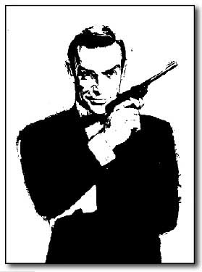

Know Short Story Terms and how to pick each out of a text.
The items in bold are the most crucial.

Hints for preparing for the non-fiction texts: You will have two text to read:
1. Read the questions first 3. Put the answer booklet next to the readings
2. Circle answers as you read 4. Go with you first gut instinct answer.

How to prepare for the Essays:
1. Learn from your mistakes. Look at corrections on previous compositions so that you do not duplicate errors. (Transition words? More descriptions? Avoid common spelling errors?)
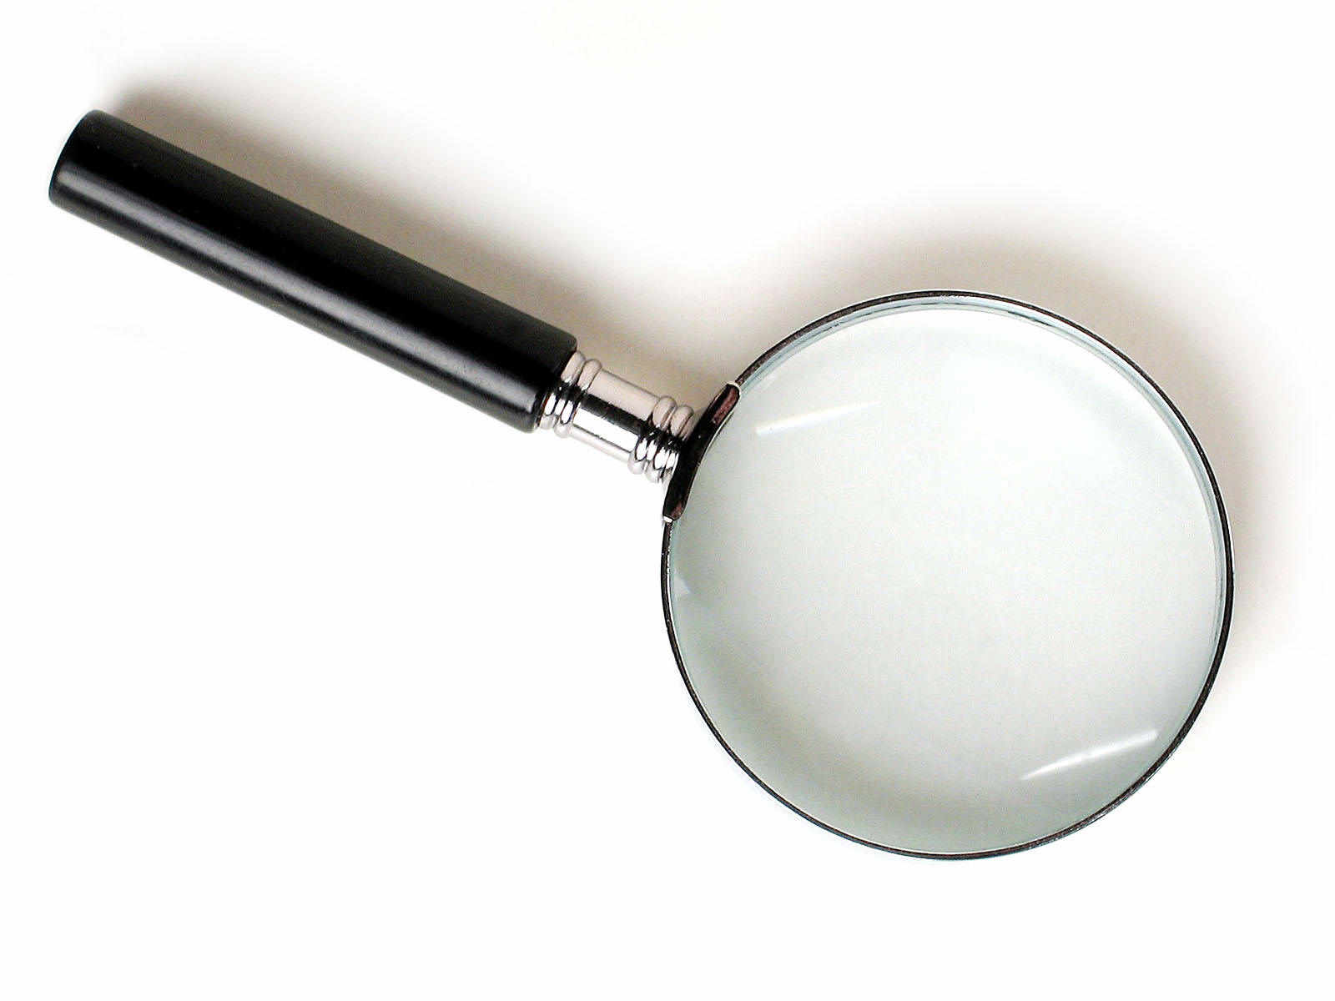
2.Remember the formula for how to write an analytical essay.
A. Introduction B. Thesis (what I will argue) C. Blueprint (3 items I will discuss)
C. Use quotes to back up your points. D. Discuss your points. E. Conclusions

HELPFUL SHEETS from this semester:
1. Creative Thoughts you have 5. Poetic Terms cut/paste sheet
2. How to write a paragraph Rubrics 6. Poems we’ve studied
3. All of the Compositions you wrote 7. Short Story Terms (Simpsons) Sheet

4. Creative Writing assignments 8. Plan For Success Sheets (how to organize)

Hasta la vista, Baby!
ENGLISH NINE EXAM FORMAT

Part A: Short Story and Poetry Terms
Total Value: 15 marks Suggested Time: 20 minutes
Instructions: Answer the multiple choice questions related to each selection. Select the best answer for each question and record your choice on the bubble sheet provided.

Part B: Poetry with Multiple Choice and Paragraph
Total Value: 24 marks Suggested Time: 35 minutes
Instructions: Read the poem “_____________” by _________ from the Readings Booklet and answer the multiple choice questions on the bubble sheet provided. Then, read and answer the paragraph question on the poem on the fullscap paper provided.

This question will ask you to write about the theme of the poem. Remember to include a topic sentence (with the authors name and the poem name), at least three examples (quotes are good – make sure to explain them) to suggest the theme (message) of the poem, and a concluding sentence. Write formally using precise language.

Part C: Prose with Multiple Choice Questions
Total Value: 14 marks Suggested Time: 25 minutes
Instructions: Read each of the two selections from the Readings Booklet and answer the multiple choice questions related to each selection. Select the best answer for each question and record your choice on the bubble sheet provided.

You will read 1 non-fiction article and 1 short story with M/C Questions and written responses.

Part D – Writing
Total Value: 30 marks Suggested Time: 40 minutes
Instructions: In a multi-paragraph essay or Original Composition of approximately 300 -500 words, write on the topic of ____________________________________
___________________________________________________________________ Write in ink. Write your response on the Loose Leaf Paper that is provided.

Tips for writing
- Consider your own ideas gained through personal experience, reading, listening, viewing,
discussing, thinking, or imagining.
- Your response must be more than one paragraph and should be approximately one page in length.
- consider your audience
- organize your thoughts appropriately in sentences and paragraphs
- Use vocabulary that is interesting and effective; use literary devices/poetic devices; imagery
- Remember our creative writing unit and how we learned to write effectively
- OR – you may choose to write a formal essay where:
Paragraph 1 is the introduction and contains the thesis statement. It should also include the three works that will be discussed in the essay.
Paragraphs 2, 3 and 4 each have a topic sentence and each discuss a different work of literature or film with examples relating to the essay topic.
Paragraph 5 is generally short and simply sums up your main ideas and restates your thesis sentence in a different way.

Hint: Topics will deal with Choices/Decisions and their consequences. Or Relationships and their impacts on our lives. *THERE WILL BE NUMEROUS CHOICES.

