History Throug Film FILM CRITIQUE Name:
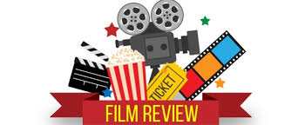
1. Meet in groups of 2-5 to discuss the film. What were the strengths/Weaknesses of the Film? Discuss acting, cinematography, writing, directing, sets, costume, dialogue, etc.

2. Rate the film and justify it; listen to group mates.

3. Come up with a “Hook” & get feedback from the group.

1. Start with a compelling hook (controversial statement, quote, metaphor, comparison, interesting background info). Make the reader want to keep reading!

2. Rate it right away! Stars / out of 10 / out of 100 / Thumbs up or down. Be clear right away.

*Great Movie: The Red Baron is the rare movie that succeeds on almost every level, where each character, scene, costume, and joke fire on all cylinders to make a film worth repeated viewings."
*Bad Movie: "It doesn't matter how much you enjoy kung-fu and karate films: with 47 Ronin, you're better off saving your money, the calories you’d put on with the overpriced popcorn, and your time."
*Okay Movie: "I loved the wildly uneven Interstellar far more than I should have, but that doesn't mean it is perfect. Ultimately, the utter awe and spectacle of space swept me through the corn-maze of complicated plot at stilted dialogue reminiscent of an 8th grader trying to ask a crush out on a date.

3. Give specific and direct references/examples to back up your statements.

*Great: "Michael B. Jordan and Octavia Spencer's chemistry would carry Fruitvale Station even if the script wasn't so good. The mid-movie prison scene in particular, where the camera never leaves their faces, shows how much they can convey with nothing but their eyelids, the flashing tension of neck muscles, and a barely cracking voice."
*Bad: "Jurassic World's biggest flaw, a complete lack of relatable female characters, is only further underscored by a laughably unrealistic shot of our heroine running away from a dinosaur -- in heels."

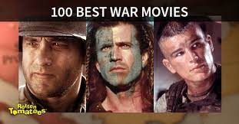
4. Discuss many facets of the film: Cinematography, acting, dialogue, writing, characters, costume, lighting, musical score, choice of sets, etc.

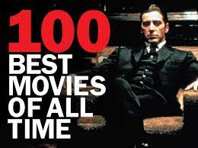
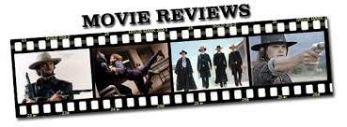
5. Clincher – end with a bang. Much like your hook, end with something that makes the reader say “wow” or fully support your view.

*Many sections borrowed from Wikihow: https://www.wikihow.com/Write-a-Movie-Review#
Stylistic Techniques for the Creative Writing Process
(Submit this sheet with checkmarks in boxes when complete)

1. Circle all banned words and replace them with a higher level word. (Ie: Slang, cool, sad, like, any IM terminology.)

2. HOOK: Look at your beginning. Is it engaging? Does it inspire to keep reading?

3. Sentence variety: A. Do any of your sentences begin with the same sddddddddddddddddd word? If so, change them.
Sentence # | Length
1 | 8
2 | 12
3 | 15
4 | 3
5 | 5

B. Do you have variety in the length and types of d sentences that you are using?
C. Count the number of sentences + words in each sentence and create a chart.

D. Did you back up your statements with rich examples?
4. Is your writing in the present tense?

5. Eliminate any use of the second person (you) unless for a stylistic purpose.

6. Find an image or situation in your paragraph. Think of something that is similar to it and create a thoughtful metaphor or simile to enhance that section of your review.

7. Circle at least three verbs per paragraph and replace them with one (or two) appropriate verbs from the thesaurus (the best word is not always the biggest).

8. Highlight any similes, metaphors, or allusions.

9. Underline at least three nouns. Think of at least one (preferably two) adjectives and use them. Join the adjectives with a comma + and, but, even, yet.

10. Put adverbs in front of at least three of your verbs.
11. Is the conclusion wrapped up with a satisfying ending. Is it a great clincher?

12. Rate the film.

*Dual Verbs: Some types of dual verbs are like running and jumping or skipping and falling. It is two verbs put together to make a more drastic effect in writing!

**Dual Adjectives: He was a tall, tanned, attractive, rich and outdoorsy.

