Socials 9
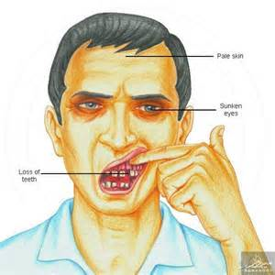
Hook: We will discuss the romanticized view of explorers by watching a segment of Indiana Jones (Raiders of Lost Arc). Then, we will read a handout on the “Reality of an Explorers Life.”

Preamble: Early explorers in New France (Canada) used rudimentary maps and the help of local indigenous peoples.

Task: Today you have become an explorer and will face some of the challenges they felt in your search for gold. Remember, maps were often incomplete and explorers had to add to them to be able to find their way back to a place.
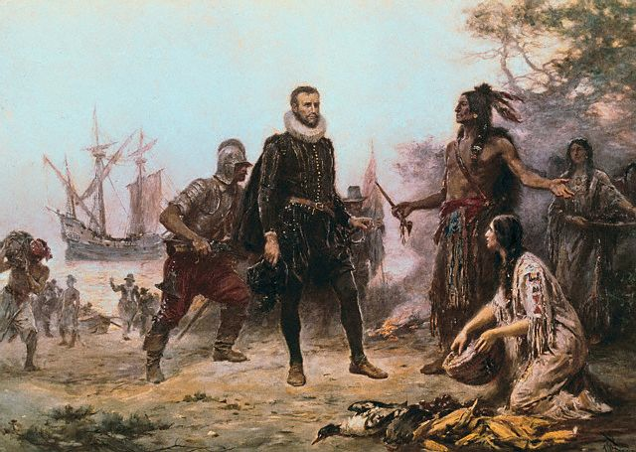
Directions:

1. First, You will be given a relatively easy map to follow. See the back of this sheet for a satellite map of the school. In your group, find the “X” which marks the location of your first piece of treasure – another more rudimentary map that would offer you a more realistic view of the types of maps that explorers were used to using.

You are extremely lucky to have the help of First Nations experts to help guide you on the journey. First peoples often used rudimentary mental maps drawn in snow, in sand or on trees, which were meant to be discarded after use.

Instructions: When you find the second more basic map you will have to do the following:

1. Follow the clue on the rear of the map to the next clue.

2. When you get to the first location where the clue has directed you, put an X on the map where you arrive.

3. Draw and label a minimum of two landmarks around the clue that an explorer ten years from now could use to orient themselves (ie a memorable tree, house etc).

4. Follow the next clue to the area where the treasure is located. When you arrive, search for the treasure, but you must also draw three landmarks on the map to indicate to future explorers where the treasure was located.

5. Back in class, we will discuss three ways that you think that this activity relates to the explorers in Early Canada

Go to the place where the great green and blue squares converge with the nets that catch no fish and are surrounded by the great metal beasts that link arms and stand three heads taller than I.

Go to the place where the boundaries converge of our territory and where the great grey net towers three heads taller than I.

Go to our animal friends that stand tall in guardianship of our empire.

Clue: Go to the place where the elders gather with their steeds and play games where they toss their mustang shoes back and forth. Between where the elders gather and the southern most main trading post of our empire lies the enchanted forest where you will find the treasure.

Now take your treasure and go back to classroom.

Sorry, another explorer beat you to the treasure, go back to the classroom with your head hung low

GROUP 1

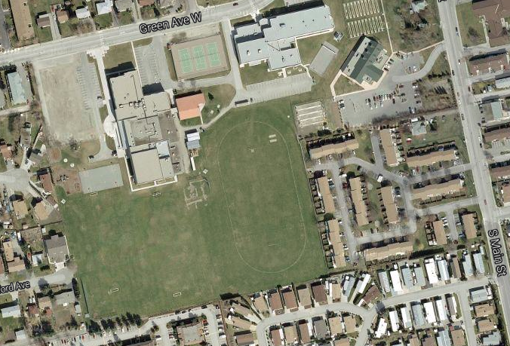

GROUP 2

GROUP 3

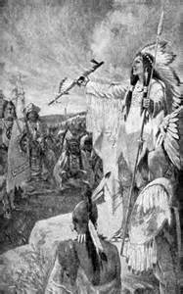
Now take your treasure and go back to classroom.

Go to the place where the great green and blue squares converge with the nets that catch no fish and are surrounded by the great metal beasts that link arms and stand three heads taller than I.

Go to the place where the boundaries converge on the south-west corner of our territory and where the great grey net towers three heads taller than I. A net used to catch swift moving objects

Go to our animal friends that stand tall in guardianship of our empire.

Go to the place where the elders gather with their steeds and play games where they toss their mustang shoes back and forth. Between where the elders gather and the southern most main trading post of our empire lies the enchanted forest where you will find the treasure.

Sorry, another Explorer beat you to the treasure. Go back to the classroom with your head hung low.

