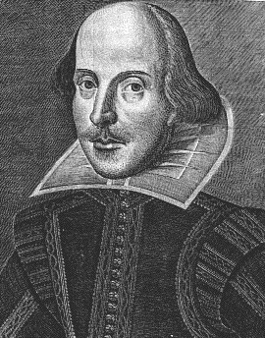 English 9 – Let the Good Times Roll Mr. Fitton 6
“Read, read, read. Read everything – trash, classics, good and bad, and see how they do it. Just like a carpenter who works as an apprentice and studies the master.” -Faulkner

Introduction: English 9 is a skills based course that aims to sharpen student’s minds and to provide pupils with strategies to become better readers, writers and connoisseurs of literature.

Course Objectives: Students will develop the ability to:

*Develop confidence in reading, writing and speaking *Recognize literary devices in writing
*Read actively by taking notes, questioning & annotating *Develop proficient speaking and presentation skills
*Write expository, descriptive and narrative paragraphs as well as a basic essay
*Read and reflect upon reading via discussion/writing/creative projects *Have FUN with literature!

Curriculum Organizers. Learning Outcomes (Students will learn to:)

1. Oral Language Communicate effectively through public speaking, acting, sharing opinions,
(Speaking and listening) debating and working in groups. Learn techniques to persuade/critique/engage others. Students will also learn how to become active listeners

2. Reading and Viewing. Read and view to comprehend the deeper meaning of a variety of fiction and nonfiction. We will also sharpen critical analytical skills through constant practice with a variety of texts and mediums.

3. Writing & representing. Express ideas meaningfully, clearly and creatively. Apply a range of strategies to improve writing by assessing their own work and others.

Assessment and Evaluation
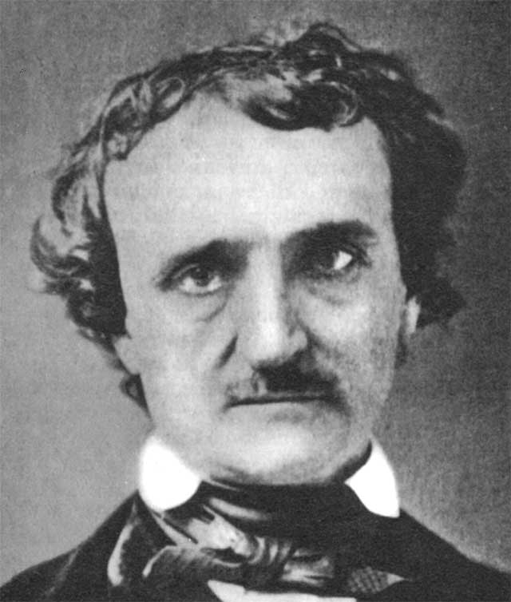 -Conducted on an ongoing basis.
-Criterion referenced (students know in advance how they will be marked)
-Quizzes, Projects, thoughtful analysis of literature, written assignments, discussions, simulations, creative projects.
Mark Breakdown
80% of the School Mark will be based on Assignments
20% of the School Mark will be based on Quizzes/Tests/Oral Language.
The pen is mightier than the sword!
-E. Bulwer-Lytton
Terms 1 & 2 = 80% Exam = 20%
Materials – Bring EVERY day: Binder w/dividers; Paper; Pencil; Texts
Label Dividers: *Helpful Handouts *Notes *Assignments

Late Policy – Assignments must be turned in at the beginning of class. If you have late assignments you will be kept in at lunch. Plagiarism = referral to administration and redo assignment at lunch/afterschool.

Attendance: Regular attendance is the most important predictor of success in this course.
Arrive on time and prepared. If you must miss class, inform me in advance to receive the
material missed. If you are late, enter quietly and you will make up time after class.
Chronic lates / absences = referral to administration and a conference with parents. Students and parents
Can also e-mail me @ jfitton@summer.com about attendance, grades or any other concerns.

No electronic devices used in class; drinks in a closed container are acceptable
English 9 - We few, we happy few, we band of brothers!

“Books are the carriers of civilization. Without books, history is silent, literature dumb,
science crippled, thought and speculation at a standstill.” – Barbara W. Tuchman
Unit 1: September – -Death, Destruction and one Happy Day (AKA Short Stories) We will be interacting with stories and participating in various activities to help connect to the plot and the main ideas.
Stories include: “Mountain Journey,” “Monkey’s Paw,” “Toyland,” and “Adulthood.”

Unit 2: October Stargirl speaks up at the Stone Bear Lottery:
You will be given a choice of four novels about bullying. Various activities will be given for the books to help you achieve a deeper understanding.
Novel choices: Speak, Touching Spirit Bear, The Lottery, Star Girl, Men of Stone

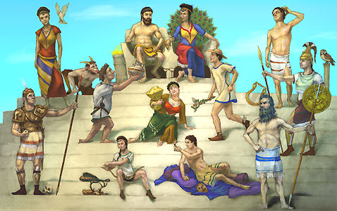Unit 3: Oct-Nov - Marvelous Men and Malignant Monsters
We will study an assortment of Greek mythology, the King Arthur myths and creation myths. You will have a variety options to reveal understanding.
Myths for Study: Creation myths, Greek Gods, “Deadelus and Icarus,” Greek Myth of Choice, King Arthur Myths, The Mighty
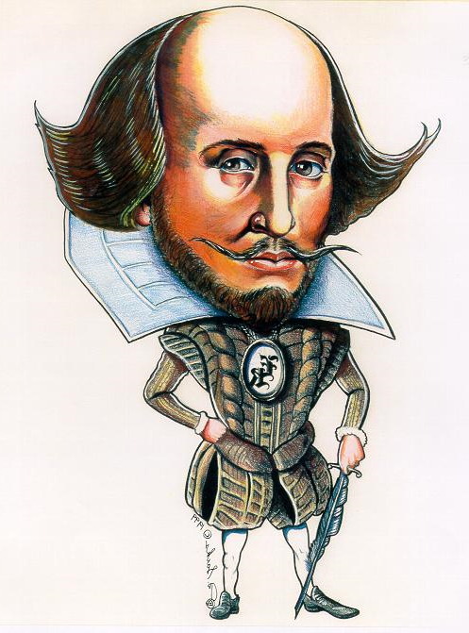
Unit 4: Nov-Dec Study thy play thou foul pestilent foot licker
We will study Shakespeare’s A Midsummer Night’s Dream. Get ready for some fun reading of the play out loud in class! We will make Shakespeare come alive while learning about his life and times. The movie will be shown. Disclaimer: Pepto-Bismol may be required on the last day of the unit

Unit 5: December Modern Poetics. We will use a combination of written, performance & musical poetry to learn the elements of a poem, including poetic devices (metaphor, simile, etc)
Poetry to Study: “The Shark,” “Ironic,” “Richard Cory,” “Boulevard of Broken Dreams,” “Beautiful Day,” and poems that students will select.

Unit 6: January - Nonfiction Texts
In this unit we will explore texts such as directions and articles. Emphasis will be placed on reading strategies, understanding the texts and even writing your own instructions!
Texts: “The Demon in the Freezer,” “Wither Amelia Erhardt,” “Paper Airplanes,” “When Ninja’s Attack,” and “The Sutter Boys.”

Unit 7: Dec-Jan Lovely Literature and Dandy Discussions
Again you will be given a choice of novels and we will do a variety of fun activities to increase your understanding of your text.* (See next page for more details)
Choices include: Boy Who Couldn’t Die, Monster, Hunger Games, Ender’s Game, The Pearl, Acceleration, and multiple others.

Congratulations, you are now an English genius!

*Literature Circles allows students to choose a novel of their choice. They will study the novel in groups using roles and small group projects as a basis for discussion and as an avenue to discover the meaning of their novel.

*A primary goal within School district 67 is to improve student literacy by fostering independent reading for all students. The success of the Literature circle program is dependent upon offering current and relevant novels that will engage students. Therefore, some novels may contain realistic and mature themes. Student will be briefed on the style and content of each text prior to making their individual selections. Parents with an interest in Literature Circles are encouraged to contact the classroom teacher.

Please review this outline with your parents and have them sign it and include their email address and phone number and hand it back to me no later than Friday Feb 11th. Email
will be my primary mode of contact. My email address is: jfitton@summer.com. Please do not hesitate to email me if you (or your parents) have any questions. I am also available by phone at 770-7750.

---------------------------------------------------------------------------------------------------------

Student Name: _________________________________________________________

Parent(s) Name(s): _____________________________________________________

Signature: ____________________________________________________________

Email and phone number: (Phone) ____________________________________________
(E-mail)____________________________________________

Student Email address: _________________________________________________

