English 12 Name:
Date:

“A hero is no braver than an ordinary man, but he is braver five minutes longer.”
-Ralph Waldo Emerson
“Morality is based on a consideration of circumstances-not principles”
~ Rudyard Kipling
“Good? Bad?. I’m the one with the gun.

~ Bruce Campbell

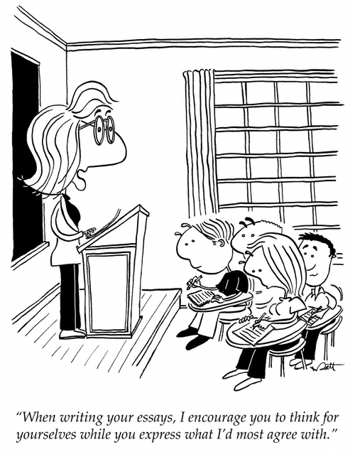
Instructions: Write a 250-350 word analytical paragraph on the topic below:

TOPIC: In the short story Eli, which character is most ethically responsible for the story’s events? Discuss with specific details and references to the story.

Criteria:
*At Least 250 words *Double Spaced & in Ink
*Interesting title *Clear Topic Sentences
*Integrates quotes effectively *Avoids Wordiness
*No 1st person viewpoint *Strong closing sentence *Begins with: In the short story “Eli”…..

Example:
Introduction
Thesis/
Argument
In the short story “Eli” by Vincent Lam, the character most ethically responsible for the events of the story is _______________________ because of ___________________________, ____________________________, and _________________________________.
Blueprint (what will prove your argument.)

Process  Think/Brainstorm 5 Minutes  Find quotations 10 Minutes  Rough Draft 30 Minutes  Edit/Proofread 10 Minutes  Good Copy 20 Minutes  Total: 75 Minutes | Tips for Good Analytical Writing  - Introduction must include thesis, name  of author, title, name of work and blueprint.  -Have clear “signposts” when discussing  a new point. (Examples in class)  - Use direct quotes to support evidence.  -Discuss how quote proves your point.

TRANSITION WORDS YOU MAY WISH TO USE
Consequently Clearly Furthermore Additionally Indeed Moreover
Because Also However Nevertheless Yet On the contrary
Certainly Undoubtedly Unequivocally First, Second, Third Consequently Finally

TOPIC: In the short story “Eli,” which character is most ethically responsible for the events in the story? Discuss with specific details and references to the story.
Introduction, Thesis Statement, and blueprint (items you will discuss)_________________________
____________________________________________________________________________________
____________________________________________________________________________________
____________________________________________________________________________________
____________________________________________________________________________________
Begin by researching a few quotes that prove that each character was responsible.

Page # | The quote(s) that support your viewpoint and the explanation of how the information proves your thesis.
 | POLICE
 | ELI
 | DOCTOR

