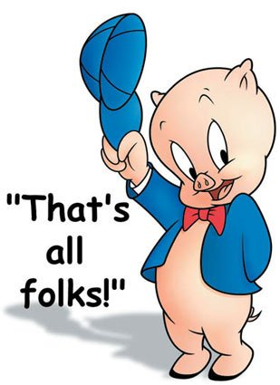
Mr. Fitton Name:
(Capitalist Pig)
/50 MARKS
History 12 Date:

Tests are only one way to measure student success. Only a certain percentage of students are “good test writers.” Indeed, research indicates that students can find more success in education if they are given alternatives to traditional assessment. Accordingly, for the Russian Revolution unit, you will reveal your cumulative knowledge of this time period in any one of a variety of ways. Moreover, due to the broad scope of this unit, a project will provide you with a deeper understanding of the history of the time.
DUE DATE: The completed project is due on ________________________________.

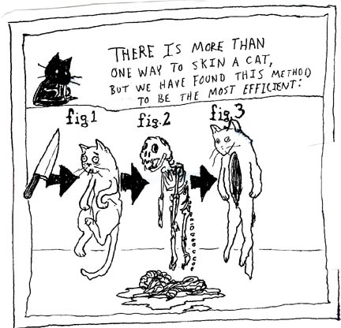
You must be half done and show Mr. Fitton on _______________
If you have not made substantial headway at this point, you will be required to work with Mr. Fitton at lunch.

The Project: The project aims to determine your understanding of concepts and vocabulary germane to the Russian Revolution from 1917-1920s. You may need to delve into prior history or move beyond the suggested date. In each option, you must show reveal a sophisticated understanding of key course concepts and vocabulary words

Suggested Project Ideas:
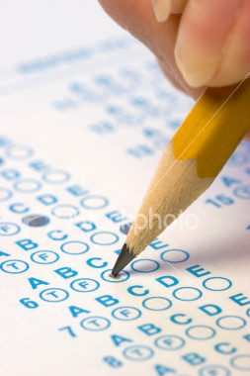
Create A UNIT Exam
-30 multiple choice questions that cover all chapter studied. (Using Blooms taxonomy)
-10 matching/ true-false
-3-5 written (higher level questions)
- Choice of 2 Essay topics (must be thematic)
-Answer key (essay/written should be in point form and incredibly detailed.)
-Should look like a real Unit Test

Unit Mind Map / Pictorial Matrix
-Draw a unit Matrix
-Include Key terms and points
-Necessary Vocabulary
-Pictures or Drawings
-Leave blank spaces for students to put answers (on separate sheet, provide answers.
-Use unit vocab outline and separate matrix into key ideas/segments and sections.

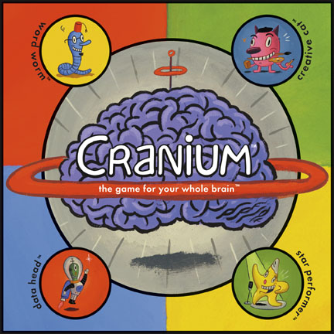
Diary of A Bolshevik
-Start by becoming the persona of a Soldie with Bolshevik ideals in the war.
-Weave the history of the revolution throughout your narrative as you trace your character’s life throughout the revolution.
-Make specific and detailed references to the history and vocabulary of the time.

Video-Log of a Bolshevik
-Using Video, become a character from the Russian Revolution and weave unit vocabulary and key concepts into your narrative.
-Re-enact the history in costume and character with voiceovers, video clips and pictures.
-OR Epic Rap Battles of History

Comic
-Create a comic book or artistic rendition of the revolution using key concepts and unit vocabulary.
-Use key vocabulary from text
-Cover the breadth of the unit

Documentary
-Using film or pictures gathered from the internet, create a documentary with an overdub that explains the revolution.
-Post to youtube for final evaluation.
-You may download and show archival footage or re-enact key scenes yourself.

ASSESSMENT PAGE:

These are only six suggestions. You may show your learning in an alternate fashion (ie. police report, radio show, “Most Interesting Man in the World” parody, Rick Mercer Rant, Epic Rap Battle of History, Draw my life or any idea you have, but consult with me first and I will be happy to discuss the viability of your idea. Also, you may need to submit an outline sheet to ensure that you are on the right track.
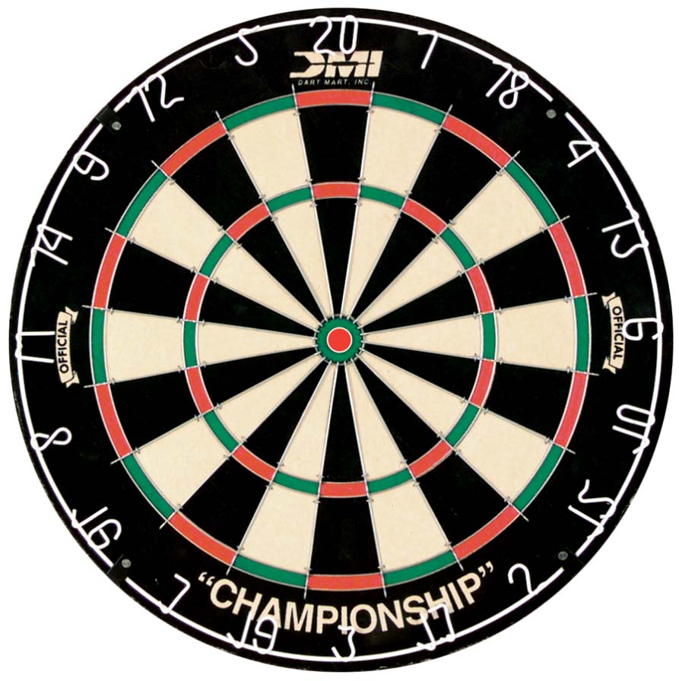
Major themes of the Russian Revolution Unit:
*Change occurs over time * What causes citizens to overthrow gov’t
*Revolutions devour their children * Power of the People
*History is unkind to those who rush it. * Effects of Tyranny on a populace

Important Terms, Characters and Events. Your project must contain an evident understanding of at least 20 terms to receive an “A.” Moreover, the project must also demonstrate a superior understanding of the historical timeline and cause and effect (this should not be a shotgun of random vocabulary defined). Use this as a checklist while working on your project. Before you hand your project in, you must check off the terms below that you have covered.

Karl Marx Proletariat Bourgeoise Bolshevik
Menshevik Nicholas II Rasputin Lenin
“Bloody Sunday” 1905 October Manifesto Duma Collectivization
Soviet Autocracy Marxism Leninism
Provisional Government April Theses Alexander Kerensky
Order No. 1 July Offensive Kornilov Affair Allied Intervention
Russian Civil War Cheka War Communism Kronstadt Mutiny
New Economic Policy Russo-Polish War Treaty of Riga Russo-Japanese War
Treaty of Rapallo Comintern Trotsky Stalin
White Army Sovnarkom March Revolution Treaty of Brest-Litovsk
Peace/Bread/Land November Revolution

TEXTS TO USE FOR RESEARCH:
Howarth: Chapter 3 pp. 13-15 Chapter 7 pp. 31-34 Chapter 13 pp. 54-57 Chapter 14 pp. 59-60

DeMarco: Chapter 1 pp. 17-18 Chapter 3 pp. 37-55

Assessment: Highlight in bold on your project the terms you have used (then, please self-evaluate by circling or highlighting where you think your project falls and include this sheet with your project when you hand it in):
Category | 5 | 4 | 3 | 2 | 1
1. Terms, Events  and Characters  _____ X5 =______ | 20 or more of  The vocabulary  included and used  correctly. Significance  included. | 16-20 of the vocabulary  Included and used  correctly. Significance  included. | 10-15 of  The vocabulary  Included and used  Correctly. May forget  Significance. | 5-9 of the vocab  included and used  correctly. Significance  largely absent. | Less than 5 of  the vocabulary  Included and used  correctly
2. Historical  Accuracy  _____X4 =______ | All details accurately  demonstrate superior  understanding of history  & connections are made. | Most details  demonstrate very  good understanding of  the history with some  Connections made. | Many details  accurately reflect an  understanding of the  history. | some of the details  accurately reflect an  understanding of the  history | Major flaws in  understanding of the  history are evident.
3. Grammar/  Spelling  _____X1 = ______ | Very few grammar/  spelling errors present  does not detract. | Very few grammar/  Spelling errors.  A bit noticeable. | Grammar and Spelling  errors present and at  times cause confusion | Grammar and spelling  errors cause confusion  & detract from work | Riddled with gr/sp  errors. Copy submitted  is of poor draft quality
Teacher Comments: /50

Planning Sheet: Group Members: ____________________

____________________

Page number &  Text used | Characteristic/What they  Will say or do in video and the  Historical data OR statement | Historical Significance/ How it helps readers better  understand history. You need to be detailed here &  show the importance of the event/person/statement
Ie:  P. 70 - Demarco | Mussolini will say:  “I don’t always set up a dictatorship, but when I do,  move cautiously and pass the Acerbo Law first.” | In 1923, Mussolini passed the “Acerbo Law” which gave the party  With the most votes a 2/3 majority in government. Blackshirts  Attacked the opposition, making them look weak. Fascists won  65% of the votes as a result, essentially giving Mussolini full power.
*Please note, depending on the project you choose, you may hand this sheet in for assessment.
Criterion A: Knowing & Understanding
Achievement Level | Level Descriptor | Task-Specific Clarification
0 | The student does not reach a standard described by any of the descriptors below. | Add your own expectations here!
1-2 | The student:  - uses limited relevant terminology,  - demonstrates basic knowledge and understanding of content and concepts with minimal descriptions and/or examples.
3-4 | The student:  - uses some terminology accurately and appropriately,  - demonstrates adequate knowledge and understanding of content and concepts through satisfactory descriptions, explanations and examples.
5-6 | The student:  - uses a range of terminology accurately and appropriately,  - demonstrates substantial knowledge and understanding of content and concepts through accurate descriptions, explanations and examples.
7-8 | The student:  - consistently uses a wide range of terminology effectively,  - demonstrates detailed knowledge and understanding of content and concepts through thorough accurate descriptions, explanations and examples.

Criterion B: Investigating
Achievement Level | Level Descriptor | Task-Specific Clarification
0 | The student does not reach a standard described by any of the descriptors below. | Add your own expectations here!
1-2 | The student:  - formulates a research question that is clear or focused and describes its relevance,  - formulates a limited action plan to investigate a research question or does not follow a plan,  - collects and records limited information, not always consistent with the research question,  - makes a limited evaluation of the process and results of the investigation.
3-4 | The student:  - formulates a research question that is clear and focused and describes its relevance in detail,  - formulates and somewhat follows a partial action plan to investigate a research question,  - uses a research method(s) to collect and record mostly relevant information,  - evaluates some aspects of the process and results of the investigation.
5-6 | The student:  - formulates a clear and focused research question and explains its relevance,  - formulates and follows a substantial action plan to investigate a research question,  - uses research method(s) to collect and record appropriate relevant information,  - evaluates the process and results of the investigation.
7-8 | The student:  - formulates a clear and focused research question and justifies its relevance,  - formulates and effectively follows a comprehensive action plan to investigate a research question,  - uses research methods to collect and record appropriate, varied and relevant information,  - thoroughly evaluates the investigation process and results.

Criterion C: Communicating
Achievement Level | Level Descriptor | Task-Specific Clarification
0 | The student does not reach a standard described by any of the descriptors below. | Add your own expectations here!
1-2 | The student:  - communicates information and ideas in a limited way, using a style that is limited in its appropriateness to the audience and purpose,  - structures information and ideas according to the specified format in a limited way,  - documents sources of information in a limited way.
3-4 | The student:  - communicates information and ideas satisfactorily by using a style that is somewhat appropriate to the audience and purpose,  - structures information and ideas in a way that is somewhat appropriate to the specified format,  - sometimes documents sources of information using a recognized convention.
5-6 | The student:  - communicates information and ideas accurately by using a style that is mostly appropriate to the audience and purpose,  - structures information and ideas in a way that is mostly appropriate to the specified format,  - often documents sources of information using a recognized convention.
7-8 | The student:  - communicates information and ideas effectively and accurately by using a style that is completely appropriate to the audience and purpose,  - structures information and ideas in a way that is completely appropriate to the specified format,  - consistently documents sources of information using a recognized convention.

Criterion D: Thinking Critically
Achievement Level | Level Descriptor | Task-Specific Clarification
0 | The student does not reach a standard described by any of the descriptors below. | Add your own expectations here!
1-2 | The student:  - analyses concepts, issues, models, visual representation and theories to a limited extent,  - summarizes information to a limited extent to make arguments,  - describes a limited number of sources/data in terms of origin and purpose and recognizes few values and limitation,  - identifies different perspectives and minimal implications.
3-4 | The student:  - analyses concepts, issues, models, visual representation and theories,  - summarizes information to make arguments,  - analyses and/or evaluates sources/data in terms of origin and purpose, recognizing some values and limitations,  - interprets different perspectives and some of their implications.
5-6 | The student:  - discusses concepts, issues, models, visual representation and theories,  - synthesizes information to make valid arguments,  - effectively analyses and evaluates a range of sources/data in terms of origin and purpose, recognizing values and limitations,  - interprets different perspectives and their implications.
7-8 | The student:  - completes a detailed discussion of concepts, issues, models, visual representation and theories,  - synthesizes information to make valid, well-supported arguments,  - effectively analyses and evaluates a wide range of sources/data in terms of origin and purpose, recognizing values and limitations,  - thoroughly interprets a range of different perspectives and their implications.

