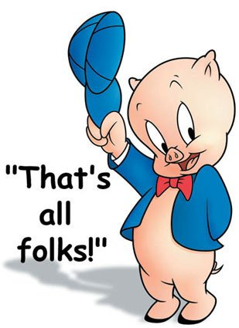
Mr. Fitton Name:
(Capitalist Pig)
/50 MARKS
History 12 Date:

Tests are only one way to measure student success. Only a certain percentage of students are “good test writers.” Indeed, research indicates that students can find more success in education if they are given alternatives to traditional assessment. Accordingly, for the Russian Revolution unit, you will reveal your cumulative knowledge of this time period in any one of a variety of ways. Moreover, due to the broad scope of this unit, a project will provide you with a deeper understanding of the history of the time.
DUE DATE: The completed project is due on ________________________________.

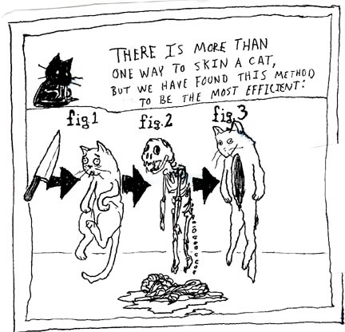
You must be half done and show Mr. Fitton on _______________
If you have not made substantial headway at this point, you will be required to work with Mr. Fitton at lunch.

The Project: The project aims to determine your understanding of concepts and vocabulary germane to the Russian Revolution from 1917-1920s. You may need to delve into prior history or move beyond the suggested date. In each option, you must show reveal a sophisticated understanding of key course concepts and vocabulary words

Suggested Project Ideas:
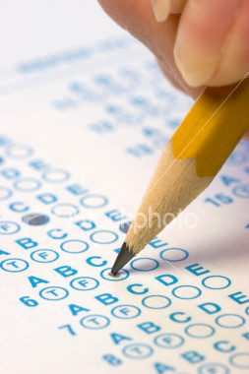
Create A UNIT Exam
-30 multiple choice questions that cover all chapter studied. (Using Blooms taxonomy)
-10 matching/ true-false
-3-5 written (higher level questions)
- Choice of 2 Essay topics (must be thematic)
-Answer key (essay/written should be in point form and incredibly detailed.)
-Should look like a real Unit Test

Unit Mind Map / Pictorial Matrix
-Draw a unit Matrix
-Include Key terms and points
-Necessary Vocabulary
-Pictures or Drawings
-Leave blank spaces for students to put answers (on separate sheet, provide answers.
-Use unit vocab outline and separate matrix into key ideas/segments and sections.

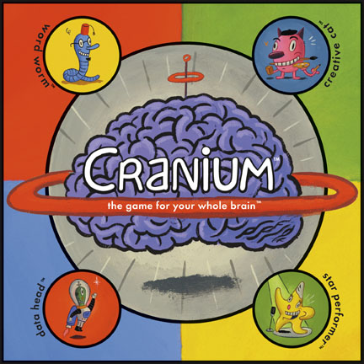
Diary of A Bolshevik
-Start by becoming the persona of a Soldie with Bolshevik ideals in the war.
-Weave the history of the revolution throughout your narrative as you trace your character’s life throughout the revolution.
-Make specific and detailed references to the history and vocabulary of the time.

Video-Log of a Bolshevik
-Using Video, become a character from the Russian Revolution and weave unit vocabulary and key concepts into your narrative.
-Re-enact the history in costume and character with voiceovers, video clips and pictures.
-OR Epic Rap Battles of History

Comic
-Create a comic book or artistic rendition of the revolution using key concepts and unit vocabulary.
-Use key vocabulary from text
-Cover the breadth of the unit

Documentary
-Using film or pictures gathered from the internet, create a documentary with an overdub that explains the revolution.
-Post to youtube for final evaluation.
-You may download and show archival footage or re-enact key scenes yourself.

ASSESSMENT PAGE:

These are only six suggestions. You may show your learning in an alternate fashion (ie. police report, radio show, “Most Interesting Man in the World” parody, Rick Mercer Rant, Epic Rap Battle of History or any idea you have, but consult with me first and I will be happy to discuss the viability of your idea. Also, depending on the project, you may need to submit an outline sheet to ensure that you are on the right track.
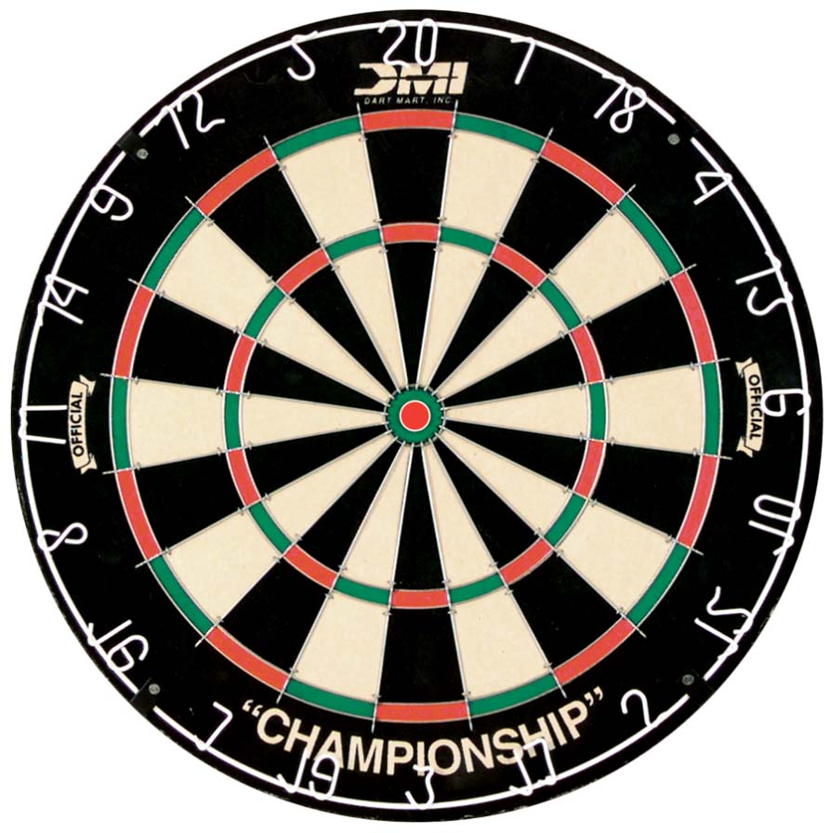
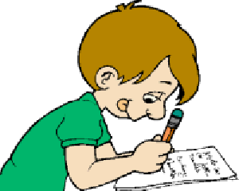
Major themes of the Russian Revolution Unit:
*Change occurs over time * The Great Man Theory of History
*Revolutions devour their children * Power of the People
*History is unkind to those who rush it. * Effects of Tyranny

Important Terms, Characters and Events. Your project must contain an evident understanding of at least 25 terms to receive an “A.” Moreover, the project must also demonstrate a superior understanding of the historical timeline and cause and effect (this should not be a shotgun of random vocabulary defined). Use this as a checklist while working on your project. Before you hand your project in, you must check off the terms below that you have covered.

Karl Marx Proletariat Bourgeoise Bolshevik
Menshevik Nicholas II Rasputin Lenin
“Bloody Sunday” 1905 October Manifesto Duma Collectivization
Soviet Autocracy Marxism Leninism
Provisional Government April Theses Alexander Kerensky
Order No. 1 July Offensive Kornilov Affair Allied Intervention
Russian Civil War Cheka War Communism Kronstadt Mutiny
New Economic Policy Russo-Polish War Treaty of Riga Russo-Japanese War
Treaty of Rapallo Comintern Trotsky Stalin
White Army Sovnarkom March Revolution Treaty of Brest-Litovsk
Peace/Bread/Land November Revolution

TEXTS TO USE FOR RESEARCH:
Howarth: Chapter 3 pp. 13-15 Chapter 7 pp. 31-34 Chapter 13 pp. 54-57 Chapter 14 pp. 59-60

DeMarco: Chapter 1 pp. 17-18 Chapter 3 pp. 37-55

Assessment: Highlight in bold on your project the terms you have used (then, please self-evaluate by circling or highlighting where you think your project falls and include this sheet with your project when you hand it in):
Category | 5 | 4 | 3 | 2 | 1
1. Terms, Events  and Characters  _____ X5 =______ | 25 or more of  The vocabulary  included and used  correctly. Significance  included. | 20-24 of the vocabulary  Included and used  correctly. Significance  included. | 15-20 of  The vocabulary  Included and used  Correctly. May forget  Significance. | 5-14 of the vocab  included and used  correctly. Significance  largely absent. | Less than 5 of  the vocabulary  Included and used  correctly
2. Historical  Accuracy  _____X4 =______ | All details accurately  demonstrate superior  understanding of history  & connections are made. | Most details  demonstrate very  good understanding of  the history with some  Connections made. | Many details  accurately reflect an  understanding of the  history. | some of the details  accurately reflect an  understanding of the  history | Major flaws in  understanding of the  history are evident.
3. Grammar/  Spelling  _____X1 = ______ | Very few grammar/  spelling errors present  does not detract. | Very few grammar/  Spelling errors.  A bit noticeable. | Grammar and Spelling  errors present and at  times cause confusion | Grammar and spelling  errors cause confusion  & detract from work | Riddled with gr/sp  errors. Copy submitted  is of poor draft quality
Teacher Comments: /50

