Descriptive Paragraph Assignment Fundamentals English Name: __________________

Task: Using powerful, precise word, detailed images and comparisons, respond to the following topic:

Topics: 1. The Joys of Living in Penticton
2. The best part of Living in Penticton.
3. Your most vivid memory of Living in Penticton
4. A person who makes Penticton great
Idea | Specific way to approach it
Memory | What is one specific event that you can describe in detail; or something that your memory tells you IS Penticton.
Person | Parent, friend, grandparent, teacher, role model in Penticton
Object | Local object, special object, symbol
Activity | Shopping, game, hobby, volunteer work, job, vacation activity
Location (think small part of it, not whole thing) | Outdoors, indoors, permanent item or itinerant item.
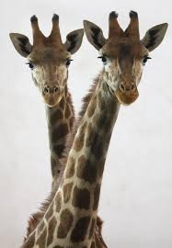
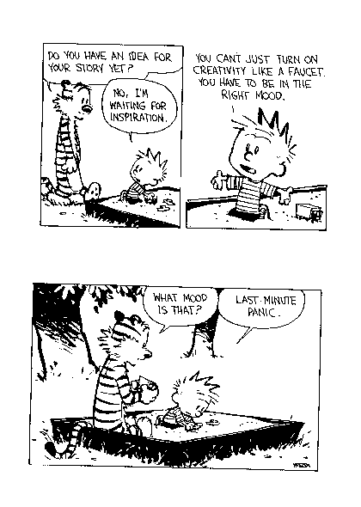

Must include:
1. Topic Sentence that establishes the focus for your paragraph (where are you or what are you describing) and pulls the reader in (start in the middle of the action, not “In this paragraph I will describe”)

2. Body Language must be sensory language

3. Conclusion

Reminder: A Descriptive paragraph if build around ONE MAIN
IMPRESSION OR IDEA about a person, scene or object. It presents a word picture with vivid and precise sensory words and phrases and poetic devices (onomatopoeia, simile, metaphor, personification, hyperbole and alliteration)

Length: 150-300 words (at least 1 ½ pages), double spaced, typed or in ink

Worth: 16 Marks (see attached marking rubric as editing checklist)

Brainstorm:
Idea: _________________________________________________

Image that appeals to: | Sight | Sound | Taste | Touch | Smell

Descriptive Paragraph Criteria

Criteria

Content
-Strong, forceful,
detailed descriptions of item that result in
‘imagery’
-Ideas clearly described
Form
-A distinct paragraph
-Introduction and
concluding sentence
-Clear transitions
Conventions
-Sentence Structure
- Spelling
- Punctuation
Personal Checklist
- Content – I have used strong, forceful, detailed descriptions which provide a single, clear picture of a person, place, thing, or idea.

- Form – I have written an organized paragraph with topic sentence, supporting details, and a concluding sentence complete with transitions between ideas.

- Conventions- I have proofread and have few spelling or sentence errors. Any errors that I have do not interfere with the meaning of my paragraph

Aspect | Not Yet Within Expectations  (1) | Meets Expectations  (Minimal)  (2) | Fully Meets Expectations  (3) | Exceeds Expectations  (4)
Content | - No descriptions provided (may be a simple list or discussion) | - Descriptions lose focus.  - Descriptions are vague | - Descriptions are clear.  - Attempts at creativity made. | - Descriptions are vivid  - Descriptions are creative  - Descriptions create ‘images’ in readers mind
Form | - Introduction is missing  - Supporting details missing or off topic  - No transitions  - Conclusion missing | - Topic sentence is there but is weak  - Supporting details are vague or unconnected to topic sentence  - Weak transitions  - Weak conclusion | - Topic sentence  - Supporting Details  - Transitions  - Concluding Sentence | -Topic sentence is engaging ‘hook’  -Powerful supporting details  -Transitions are creative and strong  -Powerful conclusion
Conventions | -Many errors in spelling in structure interfere with meaning | -Errors in simple words and structures noticeable but don’t interfere with meaning | - Some errors in some difficult passages but meaning is clear | -Few errors in spelling, sentence structure punctuations or grammar

Must haves Score Total

- On topic Content _______ X 2=_____
- Clear Effort Form _______ X 1=_____ /16
- You are Proud of it Conventions______ X 1=_____

