History 12 /30 Name:

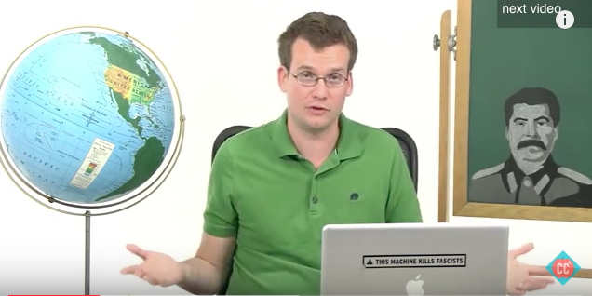
Crash Course in History Assignment

In order to cover a great deal of material to complete the course, you will conduct a self-study of ONE major unit of study.

Watch ONE crash course video and respond to the questions below. The items below are suggestions. You may choose another Crash Course that we have not viewed in class.

Due on _________________________________________. The assignment is worth 30 marks. SEE OPTIONS BELOW:
*Islam and Politics Crash Course 216 (ISIS) https://www.youtube.com/watch?v=ka8csjsmX6I
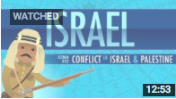
*Conflict in Israel and Palestine: Crash Course History 223 https://www.youtube.com/watch?v=1wo2TLlMhiw

*Cold War in Asia:
https://www.youtube.com/watch?v=Y2IcmLkuhG0

*Nonviolence and Peace Movements: Crash Course History 228
https://www.youtube.com/watch?v=eP-mv5IjFzY
*Decolonization and Nationalism (Gandhi; Indonesia, Congo, Vietnam, Cambodia)
https://www.youtube.com/watch?v=T_sGTspaF4Y

*Communists, Nationalists, and China's Revolutions: Crash Course World History #37
https://www.youtube.com/watch?v=UUCEeC4f6ts

Preamble: Crash Course in History is a quick and thoughtful jaunt through major historical time periods. John Green’s quick style mimics the speed of university/college course content. Be prepared to write furiously as Professors impart their knowledge principally through lectures. Here’s your chance to practice.

Most of John Green’s Crash Course in History follow a format. He has an introduction, a thought bubble, a post-thought bubble lesson, a mystery compartment, important quotations, references to historians, and a thoughtful concluding statement. Throughout his narrative he also usually includes key historical figures, events and trends. He often includes Social, Political, Economic, Cultural & Military History. In the crash course video that you watch, please respond to the questions below.

EPISODE OF CRASH COURSE – TITLE: _____________________________________________________________

1. Intro: In his introduction, he lists what he will discuss and includes some big historical ideas. List 5 key points (5 Marks)

2. Thought Bubble OR whole Video – He often lists a key concept. What is the key concept? Provide two quotes/statements from the episode that support what you believe is the key concept. (3 Marks)

Key Concept:

Supporting Quote 1:

Supporting Quote 2:

3. In Crash Course, the writers often include a quote about the era or from a person who lived during the time. Rewrite one quote he chooses to include. Include the name of the person quoted. Then list why you think it was included (it must be important if he chose that quote over millions of others from that era). (4 Marks)

Quote + Name of Speaker (2)

Why was it included/Why was it important to understand the era/concept? (2)

4. Post thought bubble:

List 6 key points (must include at least: 2 key people; 2 key conflicts 2 additional key points). Be specific, list the event, some details about it and why it was significant (6 marks)

5. How does he conclude? What idea does he leave you with – his goal is to make you think. (1)

6. After viewing the video, create a timeline of 10 key dates/events/points using the line below. You need not create a true timeline measured with exact intervals, but need to simply choose the key events, list the date and the event with details on a line in order. Title your timeline (10)

_________________________________________________________________________________________________________________________

7. List 1 neat thing you learned and did not know. This should be a serious historical new learning. (1)

/30

