History 12 Name:

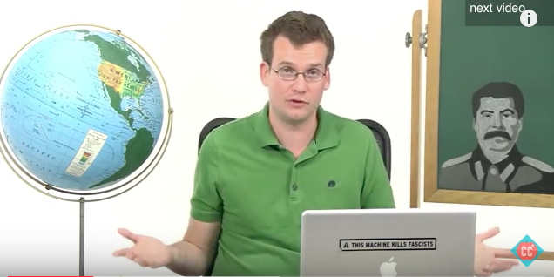
Crash Course in History Assignment

In order to cover a great deal of material to complete the course, you will conduct a self-study of two major units of study of your choice. See the 5 options below .

“Islam,” “Israeli-Palestine Conflict,” “Cold War in Asia,” “Non-Violence Movements” or “Decolonization & Nationalism.”

Watch two of the videos below in class and on your own time and respond to the questions below.
Due on _________________________________________. The assignment is worth 60 marks.

Options
*Islam and Politics Crash Course 216 (ISIS) https://www.youtube.com/watch?v=ka8csjsmX6I
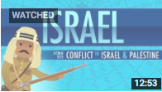
*Conflict in Israel and Palestine: Crash Course History 223 https://www.youtube.com/watch?v=1wo2TLlMhiw

*Cold War in Asia:
https://www.youtube.com/watch?v=Y2IcmLkuhG0

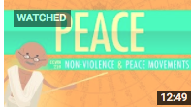
*Nonviolence and Peace Movements: Crash Course History 228
https://www.youtube.com/watch?v=eP-mv5IjFzY

*Decolonization and Nationalism (Gandhi; Indonesia, Congo, Vietnam, Cambodia)
https://www.youtube.com/watch?v=T_sGTspaF4Y

Preamble: Crash Course in History is a quick and thoughtful jaunt through major historical time periods. John Green’s quick style mimics the speed of university/college course content. Be prepared to write furiously as Professors impart their knowledge principally through fast speaking. Here’s your chance to practice.

Most of John Green’s Crash Course in History follow a format. He has an introduction, a thought bubble, a post-thought bubble lesson, a mystery compartment, important quotations, references to historians, and a thoughtful concluding statement. Throughout his narrative he also usually includes key historical figures, events and trends. He often includes Social, Political, Economic, Cultural & Military History. In the two crash course videos that you watch, please respond to the questions below.

FIRST EPISODE OF CRASH COURSE – TITLE: _____________________________________________________________

1. Intro: In his introduction, he lists what he will discuss and includes some big historical ideas. List 5 key points (5 Marks)

2. Thought Bubble – He often lists a key concept to know. What is the key concept he is trying to teach? Provide two quotes from his speech that support what you believe is the key concept. (3 Marks)

Key Concept:

Supporting Quote 1:

Supporting Quote 2:

3. In Crash Course, the writers often include a quote about the era or from a person who lived during the time. Rewrite one quote he chooses to include. Include the name of the person quoted. Then list why you think it was included (it must be important if he chose that quote over millions of others from that era). (4 Marks)

Quote + Name of Speaker (2)

Why was it included/Why was it important to understand the era/concept? (2)

4. Post thought bubble:

List 6 key points (must include at least: 2 key people; 2 key conflicts 2 additional key points). Be specific, list the event, some details about it and why it was significant (6 marks)

5. How does he conclude? What idea does he leave you with – his goal is to make you think. (1)

6. After viewing the video, create a timeline of 10 key dates/events/points using the line below. You need not create a true timeline measured with exact intervals, but need to simply choose the key events, list the date and the event on a line in order. Title your timeline (10)

_________________________________________________________________________________________________________________________

7. List 1 neat thing you learned and did not know. This should be a serious historical new learning. (1)

/30

SECOND EPISODE OF CRASH COURSE – TITLE: _____________________________________________________________

1. Intro: In his introduction, he lists what he will discuss and includes some big historical ideas. List 5 key points (5 Marks)

2. Thought Bubble – He often lists a key concept to know. What is the key concept he is trying to teach? Provide two quotes from his speech that support what you believe is the key concept. (3 Marks)

Key Concept:

Supporting Quote 1:

Supporting Quote 2:

3. In Crash Course, the writers often include a quote about the era or from a person who lived during the time. Rewrite one quote he chooses to include. Include the name of the person quoted. Then list why you think it was included (it must be important if he chose that quote over millions of others from that era). (4 Marks)

Quote + Name of Speaker (2)

Why was it included/Why was it important to understand the era/concept? (2)

4. Post thought bubble:

List 6 key points (must include at least: 2 key people; 2 key conflicts 2 additional key points). Be specific, list the event, some details about it and why it was significant (6 marks)

5. How does he conclude? What idea does he leave you with – his goal is to make you think. (1)

6. After viewing the video, create a timeline of 10 key dates/events/points using the line below. You need not create a true timeline measured with exact intervals, but need to simply choose the key events, list the date and the event on a line in order. Title your timeline (10)

_________________________________________________________________________________________________________________________

7. List 1 neat thing you learned and did not know. This should be a serious historical new learning. (1)

