Name: ___________________

Judge Judy Notes Sheet

Trial Details (FOR CIVIL COURT)

What were the main charges?_________________________________________________________

Name of Plaintiff:_________________________________________

Name of Defendant:_______________________________________

Main Events of the Case
Judge Judy either starts by summarizing the main points of the case. Write these down below.
-
-
-
-
The plaintiff’s story:
-
-
-
-

The defendant’s story:
-
-
-
-

What evidence is submitted to Judge Judy for this case? For the plaintiff? For the defendant?

What was my final decision on this case? Who was awarded for damages?
Write in the space to the right ->

Which side of the case do you favour? The plaintiff’s? The defendant’s? Why? Use the other side of the page for more room.

Court Watching Sheet NAME:

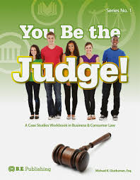
Trial Details (CRIMINAL COURT)

What were the main charges?_______________________________

Name of Accused:_________________________________________

Name of a Witness:_______________________________________

Main Events of the Case
As you watch, what are some of the key pieces of evidence or details presented.
-
-
-
-

The Accused (or a witness’s key points)
-
-
-
-

The Co-Accused (or another witnesses key points)
-
-
-
-

What evidence is submitted to the Judge or Jury for this case?

What do you think is the Crown’s Strategy | What do you think is the Defence’s Strategy

Which side of the case do you favour? The Crown? The Defence? Why?

What questions do you still have?

