Mr. Fitton Social Studies 9

“History will be kind to me for I intend to write it” Winston Churchill

Expectations

1. I will endeavor to keep homework to a minimum. Most assignments will be done in class. In return, I expect that all students will make every effort to attend each class on time. Parents will be contacted when students have unexcused absences or excessive lates. If you must be absent from a class, it is your responsibility to pick up the assignments you missed, preferably before class.

2. Come to class on time, prepared and ready to work. Treat everyone with respect.

3.Catch up on missing assignments in a timely manner. Students with missing assignments will be asked to stay in at lunch or attend homework room.

4. During class discussions leave all electronics in your bag. During independent work you may use an ipod, but please do not use your cell phone in class.

5. If you don’t understand something, please ask. There is a lot information in this fast-paced course and a challenging provincial exam (that counts for scholarships) at the end. I am available for help at lunch and afterschool until 4. I also have a prep block in 1-1 if you have a spare then.

6. Keep all of the unit overviews/vocabulary and ASRs, they will be invaluable in studying for the provincial exam

7. Have a good semester; you will get out of this course as much as you are willing to put in.

Social Studies 11 - History Unit: A Nation Forged In Blood…

“Those who don't know history are destined to repeat it.” ~ Edmund Burke.

The Social Studies 11 History unit will familiarize students with Canada’s intriguing past. The focus of the course is on Canada’s role on the world stage in the 20th century as well as the nation’s journey towards independence from Britain in 1982.

UNIT 1 & 2 – 20th Century + World War One
Week of Topic Goals Assessment
March 31 – April 4th Intro to 20th century Canada Notion of Canadian Identity Notes
Vocabulary
April 7 -11th World War 1 Identify/Explain Causes; Political Mud/Rats/Death
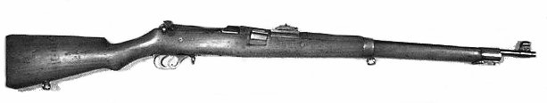
Economic, Social Issues Quizzes/ Map
Paragraph
April 14 - 17th Role Play/Historical Empathy Tr. Versailles Sim
Unit test

Unit 3 – Flappers and Hooch!
Week of Topic Goals Assessment
April 22-25 Roaring 20s Identify/Explain Political, Cartoon Analysis
Social, Economic issues Essay
Is Canada more independent? Quiz; Police Report

Unit 4 – The Great Depression
Week of Topic Goals Assessment
April 28-May 2 Great Depression and Identify/explain Pol/Soc/Econ Newspaper project
Totalitarianism Factors. ideologies Annotation
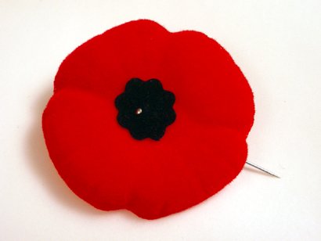
May 5-9th Rise of Fascism Ideology. How much should govn’t Quiz + Unit Test
be involved in the economy? Paragraph/Mind Map

Unit 5 –WAR
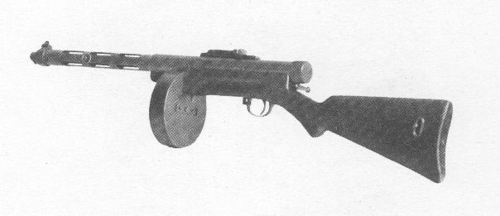
Week of Topic Goals Assessment
May 12-16th Canada and World War 2 Identify strategies/tactics used in WW2 Student projectt.
(possibly longer) Canada’s Pol/Soc/Econ involvement Film/Vocab; DBQs
Moral issues of Holocaust and WMDs Propaganda.
Unit Test

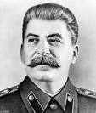
Unit 6/7 – The Cold War
Week of Topic Goals Assessment
May 19-23rd The Cold War Era Explain Canada’s role in Cold War Gallery Walk
Analyze Canada’s Post-War relationship Essay/ test
with the US and Developing world. Spy vs. Spy
May 26-30th United Nations -Identify/explain cultural trends Prime Minister Timeline

Unit 8 – Canadian Identity
Week of Topic Goals Assessment
June 2-6th Canadian Explain how Fr./Eng. Relations shaped Quiz; Pamphlet
Identity Post WW2 Era. Analyze constitutional Scrapbook
Change of 80s and 90s. Aboriginal issues. Matrix Chart
Timeline Mind Map
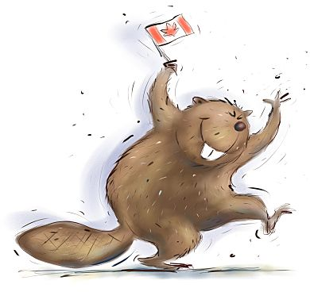

FINAL EXAM: Thursday June 19, 2014 1-4pm

Contact Information

Email:

efitton@summer.com

Website:

www.efitton.weebly.com

