Wellness 11/12 CLOSE READING ASSIGNMENT Student Name:
Excerpt  May be slightly different than your printed edition | Your Annotations  Make sure to highlight text, too!
 | Thought/Question
 | Thought/Question
 | Thought/Question
 | Thought/Question
Epiphany — What is the Significance of This Excerpt to the Broader Text? [5+ sentences]

Most Important Line and Impact. Use Quotation Marks. Cite if you want to prep for post secondary:

Context. If someone had not read the article, what would they need to know to get the most important line?

Text Name: Author Name: Date Read:

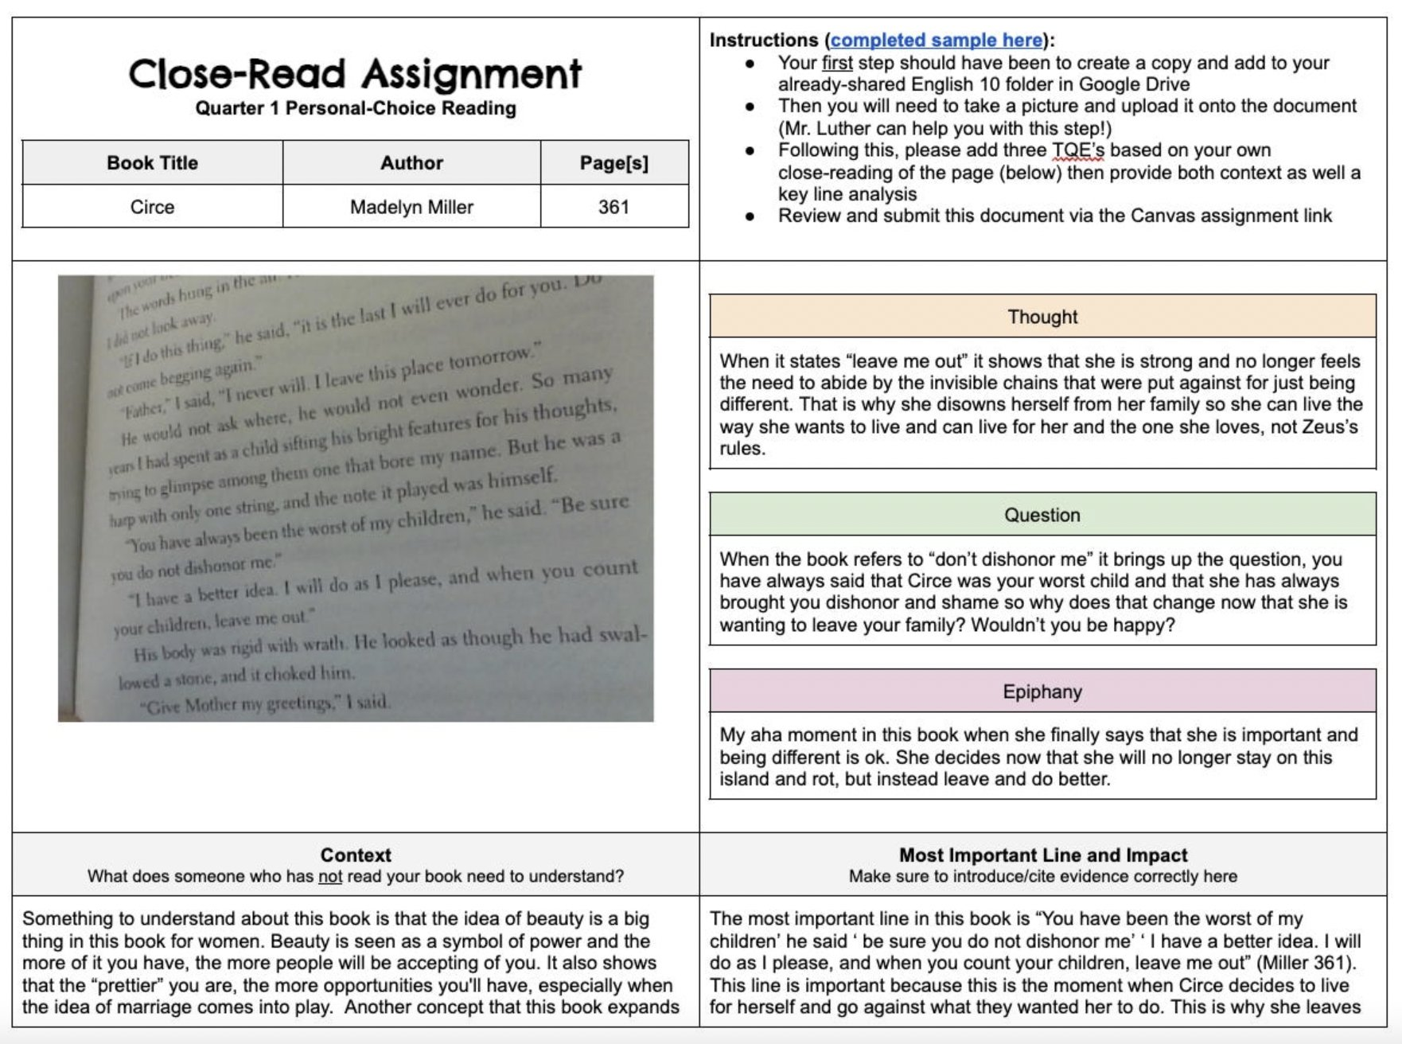
Sample – Thanks to Marcus Luther for Inspiring this amazing assignment. @MarcusLuther6 on X.

Graded Holistically on a 6 point scale. Then out of 12.

Teacher Comments:

/12

