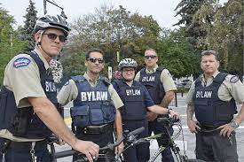
Law 12 Name:
Context: The city of Penticton is engaging in an emergency services review. Researchers are trying to determine how Police, Fire, Bylaw and Community Safety Personel are being used, and are seeking to create a plan to most efficiently and effectively keep our community safe.

Your Job: You have been hired as a University Criminologist to review Bylaw/CSO, Fire and Police in Penticton – using the data, videos, infographics provide, and your own knowledge, develop some answers to the following:

1. If you were coming to Penticton to conduct a review of Bylaw, Fire and Police, what information would you want to know? (What questions would you have? Who would you want to talk to? What data would you collect?)

2. If you were coming to Penticton to conduct a safety services review, what questions would you ask focus groups of Bylaw, Fire, Police and community members?

Some Stats and General info
City of Penticton Budget 2022 Protective Services  Bylaw services $1,793,500  Fire Services $7,924,935  RCMP $12,825,000 | City of Penticton Budget 2026 Protective Services  Bylaw services $1,860,514 (4% increase 2022-2026)  Fire Services $8,318,722 (5% increase 2020-2026)  RCMP $15,320,861 (19% increase 2022-2026)

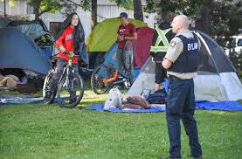
Bylaw: Officers proactively and reactively investigate bylaw violations. Officers have daily public contact with a focus on community safety and social issues. Focus on community safety, livability, and cleanliness (homeless issues, panhandling, nuisances in public places, etc.). Conduct regular foot and bike patrol of parks, trails, beaches and other public spaces to educate and enforce bylaws and be a visible presence downtown working in all-weather conditions and in various terrains. Through proactive patrols, identify persons in medical distress and contact appropriate agency. Identify individuals at most acutely elevated risk in the community and bring individual's information to the CAST- Community Active Support Table for a collaborative intervention.
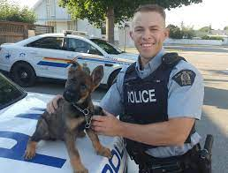
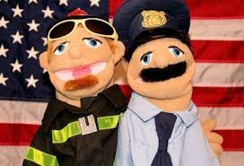
Police: Enforce Criminal Code and multiple other types of offences. Create safe communities and reduce fear of crime and disorder. Most of you are familiar with police responsibilities.
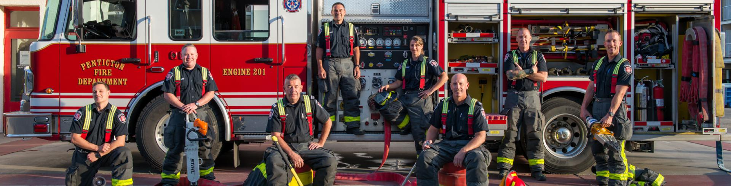
Fire: The Penticton Fire Department is a composite department including 37 career members and up to 40 auxiliary members providing a range of emergency and non-emergency services. Our team attends to the public's safety, which can include responding to structure fires, grass and urban/interface fires and other emergency incidents such as flooding and natural gas pipeline breaks. Career Firefighters: Respond to all calls including medical emergencies, motor vehicle accidents and fire alarm activations. They are trained to high technical standards, including rescue techniques for confined spaces, high angles, and water and ice rescue.
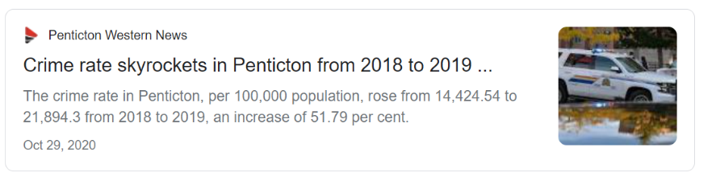
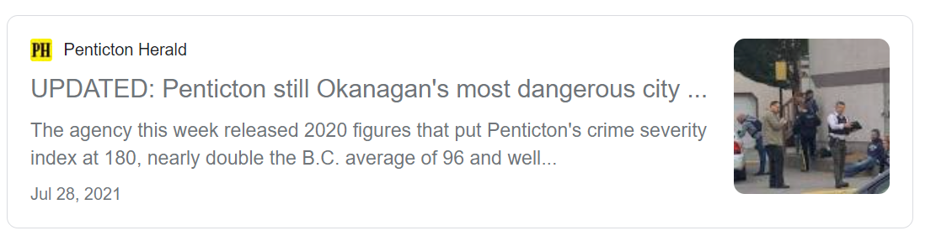

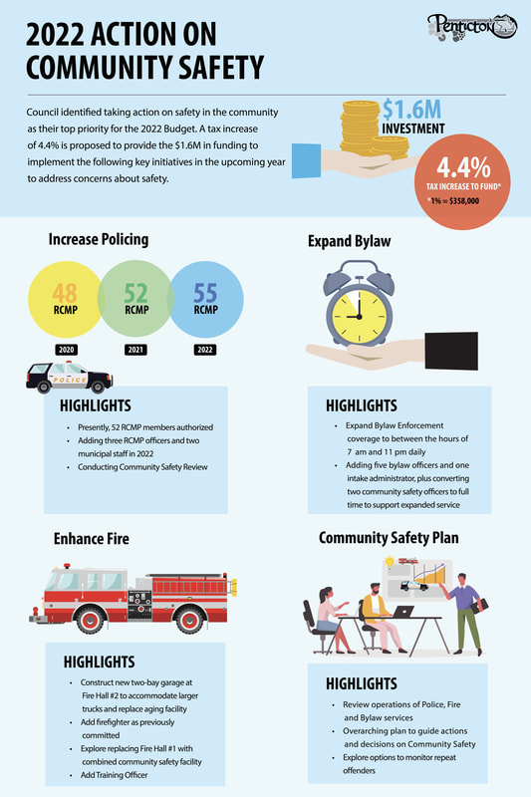

To Consider:
A. Are we getting the best bang for our buck? How do we know? What metrics would we use to determine this?
B. How do we measure effectiveness of each service? What are the indicators that they are “doing a good job?”
C. What suggestions would you have to make Penticton Safer? (Remember, you can only suggest things the municipality can do)
D. After reading the job descriptions of each service provided in class – come up with some ways you would measure if each service was being successful?
E. What would Penticton and each service look like in 5 years, if they were doing their job optimally?
F. How do we tell whether police and fire are effective and efficient and provide a good return on investment? How can they be made more effective? Will tossing in 5 more Mounties make a difference?

