Communications 12 Name: __________________
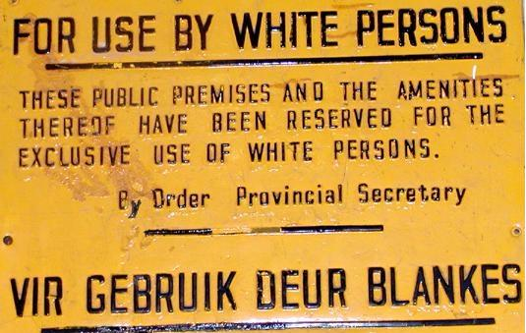
Apartheid
1652 – ____________ ___________ arrive in South Africa and settle there.
-become known as ____________ or ___________. See themselves as racially superior to the native _____________ African population.
-19th century: _________________ government develops interest in South Africa because of discovery gold and diamonds
-1899-1902 ________________War British fight Dutch for control of South Africa and win.
-created world’s first ________________ camps. 26 000 Boers die, so do 14 000 Africans.
-Boers angry at British rule, but British basically let them run government.
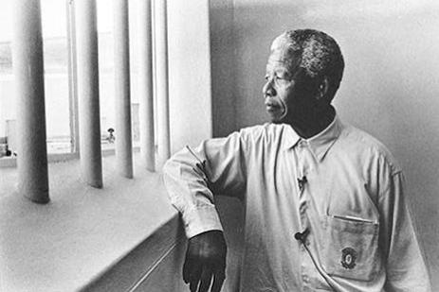
-Population 99% Black, but government made up of 30% British and 70% Dutch Afrikaners.
-British integrate some _______________ laws, but Boers really push for them and have control of government to get them accepted as law.
-by 1948, ____________________ fully in effect (means apartness in Afrikaans)
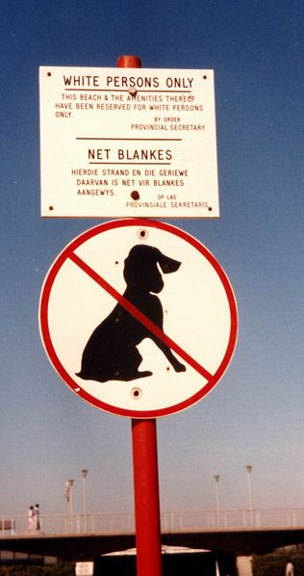
-Separate ____________________ (water fountain, different sections of city (99% of population, but live in 13% of land), restaurants, buses, etc have 9pm curfew can’t vote, no inter-marriage)
-Boers always oppose everything British support (for example, they support Hitler in World War II)
-Blacks want ________________ in English to be able to move up in the world
-English education becomes illegal
-law enforced with ___________________.
-in place until _____________ ______________, through peaceful resistance, brought it down in 1994.
-The violence continues today, one of highest crime rates in world

Apartheid - KEY
1652 – DUTCH SETTLERS arrive in South Africa and settle there.
-become known as AFRIKANERS or BOERS. See themselves as racially superior to the native BLACK African population.
-19th century: BRITISH government develops interest in South Africa because of discovery gold and diamonds
-1899-1902 BOER War: British fight Dutch for control of South Africa and win.
-created world’s first Concentration camps. 26 000 Boers die, so do 14 000 Africans.
-Boers angry at British rule, but British basically let them run government.
-Population 99% Black, but government made up of 30% British and 70% Dutch Afrikaners.
-British integrate some SEGREGATION laws, but Boers really push for them and have control of government to get them accepted as law.
-by 1948, APARTHEID fully in effect (means apartness in Afrikaans)
-Separate “BUT EQUAL” (water fountain, different sections of city (99% of population, but live in 13% of land), restaurants, buses, etc have 9pm curfew can’t vote, no inter-marriage)
-Boers always oppose everything British support (for example, they support Hitler in World War II)
-Blacks want SCHOOL in English to be able to move up in the world
-English education becomes illegal
-law enforced with BRUTAL FORCE.
-in place until NELSON MANDELA, through peaceful resistance, brought it down in 1994.
-The violence continues today, one of highest crime rates in world

Communications 12 Name: ________________
A Child Called It and The Power of One

Directions: Brainstorm as many personality traits as you can think of that allow both David and PK to survive horrific childhoods. Then, choose you 3 best traits and write a 150 word paragraph on the following topic:

Both PK and David have very difficult childhoods; however, both characters are ultimately able to put their pasts behind them to become very successful adults. What traits do both PK and David possess which allow them to overcome adversity? Explain your answer with specific examples from BOTH The Power of One and A Child Called It

Character Traits | A Child Called It | The Power of One

1.The Outline:

2. Write a rough draft

3. Edit
Content | Format | Conventions
3 ideas ___ | Topic Sentence _____ | Grammar ______
Supported with evidence (example, quote etc.) ___ | Transition words _____ | Spelling ______
All thoroughly explained (how they support T.S) ___ | Conclusion _____ | All sentences make sense when read aloud ______

4. Write a good copy

Aspect | Not Yet Within Expectations  (1) | Meets Expectations (minimal)  (2) | Fully Meets Expectations  (3) | Exceeds Expectations  (4)
Content | - 1. The paragraph does not describe David and PK’s Character traits  - 2. No references from the movie are provided, or references chosen do not support the traits given. | - 1. PK and David’s personality is described but it is vague or very general and simplistic, or less than 3 traits are provided  - 2. References provided from the story are present, but may be very general, or one piece of evidence is missing | - 1. David and PK’s personalities are described with three accurate traits/examples for each story  - 2. Evidence from each of the stories is provided to support each of the traits given, or three examples are given to support | - 1. At least three traits that fit David and PK is clearly described with; clear and convincing evidence from both stories are provided  - 2. Three clear , specific and possibly subtle pieces of evidence from the story are included to support the character traits described
Form | - 1. No clear topic sentence or statement of main ideas  - 2. Details have no logical order or connection, no transition words used  - 3. No specific evidence supports ideas in topic sentence  - 4. Conclusion is missing | - 1. Topic sentence exists but key ideas are vague or there are less than 3  - 2. Details are vague or unconnected, few transition words used  - 3. Evidence is limited or only vaguely connected to the ideas in the topic sentence  - 4. Weak conclusion | - 1. Topic sentence states main idea, and summarizes 3 key points but may be awkward or too in-depth  - 2. Transitions are there, and details are logically connected, transition words used for each new idea, but may be awkward  - 3. Accurate evidence provided for each idea in topic sentence, may be out of sequence  - 4. Concluding sentence accurately summarizes paragraph | - 1. Topic sentence states main idea and smoothly and briefly summarizes 3 key ideas  - 2. Transition words are used smoothly and effectively for each new idea  - 3. Three pieces of specific evidence are provided that directly link to the topic sentence  - 4. Concluding sentence summarizes main ideas in new words and ends in an interesting way
Conventions | - 1. Many errors in spelling and sentence structure interfere with meaning  - 2. Many errors in verb tense and point of view  Vocabulary used to describe the character is simple and basic | - 1. Errors in simple words and structures are noticeable but don’t interfere with meaning  - 2. Some errors in verb tense and point of view, but meaning is clear  - Vocabulary words used are simple with one or two exceptions | - 1. One or two grammar and spelling errors in some difficult passages but meaning is clear  - 2. One or two errors in verb tense and point of view  - Vocabulary words are consistently strong and effective | - 1. No errors in spelling, sentence structure, punctuation or grammar  - 2. Paragraph is written completely in 3rd person and present tense  - Vocabulary words are high level, challenging and very descriptive
Character Sketch/theme Paragraph Criteria
Content X1= /4
Form X2= /8 Total: /16
Conventions X1= /4

