LAW 12 Charter Project NAME:

Essential Questions: Why is the charter important? How does it guarantee the rights of Canadians? Which sections are crucial? When are rights breached?

Assignment: Using page 559-563 of Law In Action (the pages of each section are listed below for your convenience), Your own Internet Search, Any of the notes provided in class and your own notes, demonstrate an understanding of a key section of the Charter of Rights and Freedoms. Groups of 1-2

Goals: Learn to summarize, analyze, condense, use examples and create own examples while learning about the Charter.

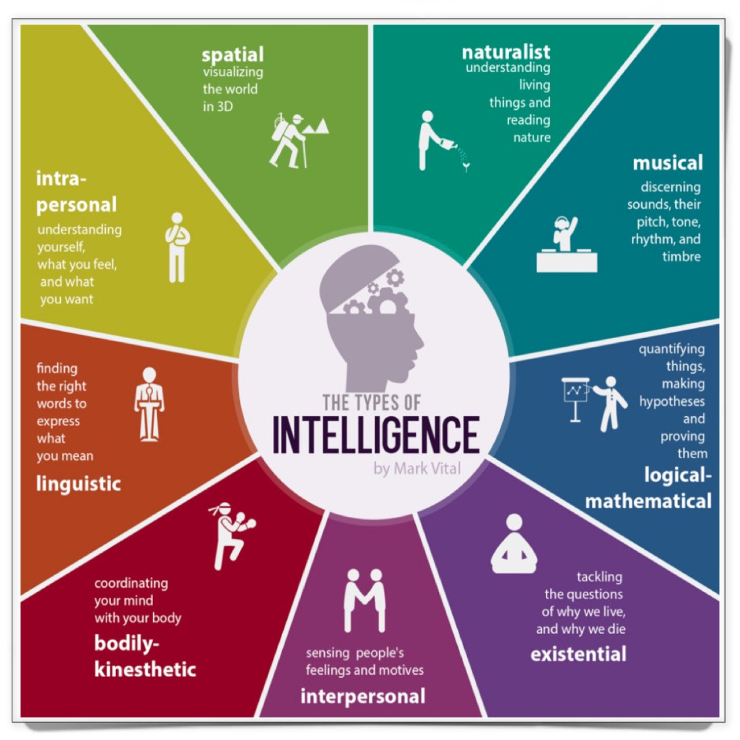
Ways to show your learning: For this project, you may choose to demonstrate your learning in any way that you are passionate about. Some potential options

Draw my life Video Podcast Animation
Website Children’s Book Live Skit Interview
App of some sort Your Choice.

Criteria: 1. Students will choose a section of the charter; 2. describe it in student friendly language; 3. Provide a real life case showing a breach of the Right/Freedom*** 4. create their own example of the right being infringed and 5. explain how it is being infringed.

***Provide a real-life case demonstrating a breach of the right or freedom. Be sure to include:
    - A description of the case, in your own words.
    - Who won, and why.
    - How this case demonstrates its importance to Canadian society and/or to your life

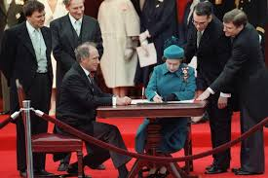
OPTIONS TO CHOOSE FOR THE PROJECT: Only one group per section.

Section 1 - Reasonable Limits Clause (P. 100)

Section 33 – Notwithstanding Clause (P.101)

Fundamental Freedoms

Freedom of Conscience and Religion (P. 102)

Freedom of Thought and Expression (P.104)

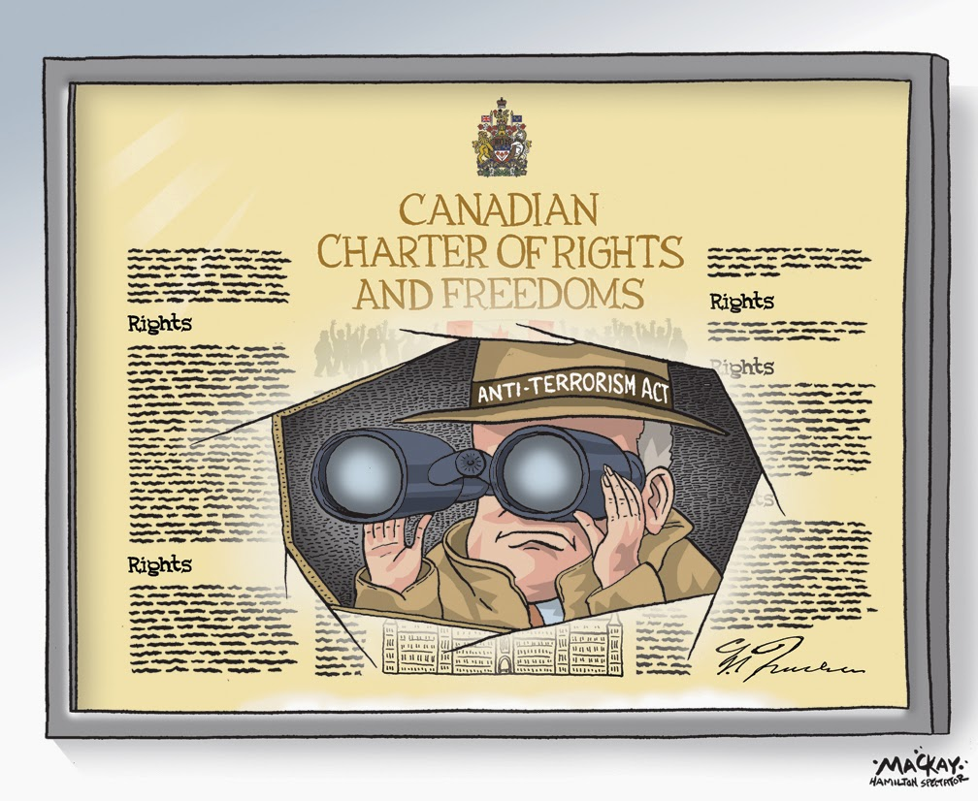
Freedom of Peaceful Assembly & Association
(p. 104-105)

Democratic Rights (P. 108)

Mobility Rights (P. 109)

Legal Rights

Life, Liberty and Security of Person (110-111)

Unreasonable Search and Seizure (P.111-112)

Arbitrary Detention and Imprisonment (P.112)

Rights when arrested (P.112-113, 114)

Rights when Charged (P. 113, 114)

Cruel and Unusual Punishment (P.113, 115)

Rights of Witness (P.115)

Equality Rights (P. 116, 117)

Language Rights/ Language Education Rights
(P. 118-119)

General Rights (Aboriginal, Multicultural, Gender)

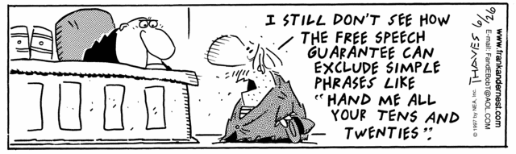

 | 1  Not Yet Meeting | 2  Minimally Meeting | 3  Meeting | 4  Exceeding
Understanding  &  Application of Knowledge  /8 | Does not demonstrate an understanding of content while inadequately applying it to the project and its expectations.  Demonstrates little to no critical thinking. | Demonstrates a basic understanding of content while satisfactorily applying it to the project and its expectations.  Demonstrates limited critical thinking. | Demonstrates an understanding of content while applying it to the project and its expectations.  Demonstrates critical thinking. | Demonstrates an exceptional understanding of content while effectively applying it  to the project  and its expectations.  Demonstrates spectacular critical thinking.
Research Skills  &  Relevance of Information  /8 | Evidence of research and research skills is unclear or not present.  Information is not current. Information is not relevant. | Evidence of research and research skills is minimal, but present.  Information is mostly current.  Information is questionably relevant. | Evidence of research and research skills is apparent.  Information is current.  Information is relevant. | Evidence of research and research skills is unmistakable and clear.  Information is current.  Information is relevant and significant.
Organization, Grammar,  Spelling  & Clarity  /4 | Information is not organized or clear.  Grammar and spelling often interfere with intent and meaning. | Information is somewhat organized and clear.  Grammar and spelling sometimes interfere with intent and meaning. | Information is organized and clear.  Grammar and spelling issues do not interfere with intent and meaning. | Information is effectively organized and clear.  Grammar and spelling issues do not interfere with intent and meaning.
Completion  /4 | The project is mostly incomplete. | This project is missing substantial portions | This project has met most of the criteria for completion. | The project is complete as it includes all necessary applicable criteria
PROJECT RUBRIC

TOTAL: _____/24
STUDENT NAME(S)____________________________________________________

TEACHER COMMENTS:

