|  |  |  |  |  |  |
| --- | --- | --- | --- | --- | --- |
|  | Communism | Socialism | Liberalism | Conservatism | Fascism |
| Major  Thinkers/  Books |  |  |  |  |  |
| View of  Human  Nature |  |  |  |  |  |
| Political  Beliefs |  |  |  |  |  |
| Economic  Beliefs |  |  |  |  |  |
| Political  Party  Examples |  |  |  |  |  |

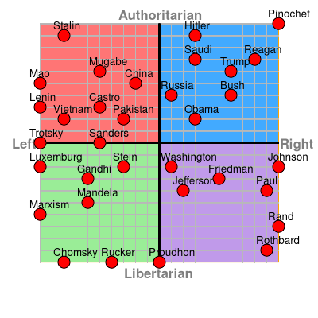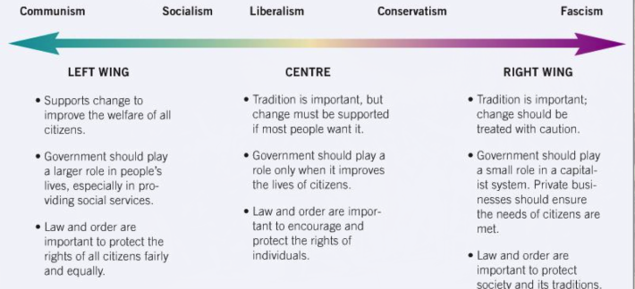

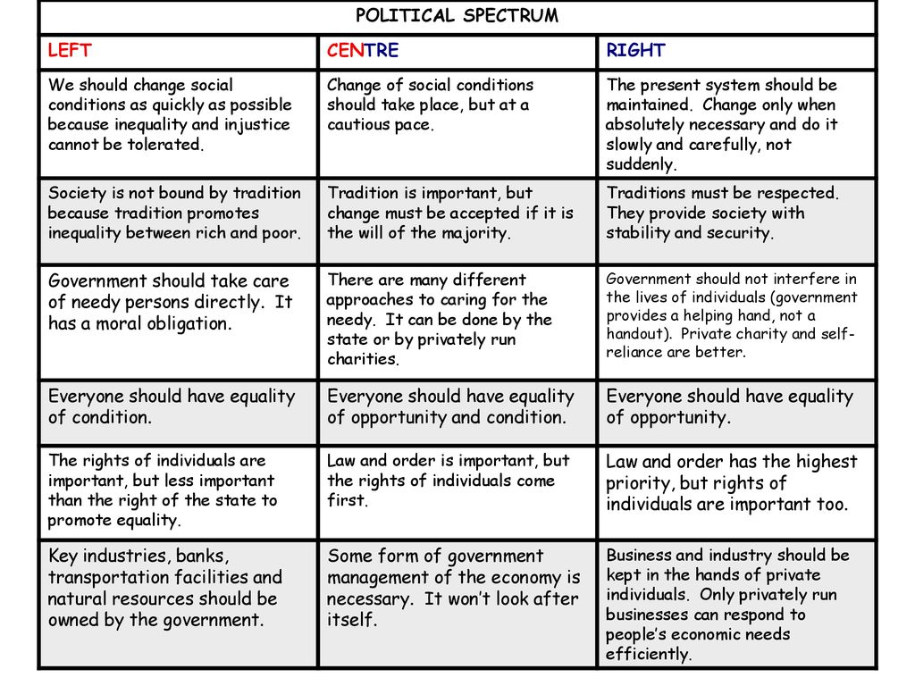

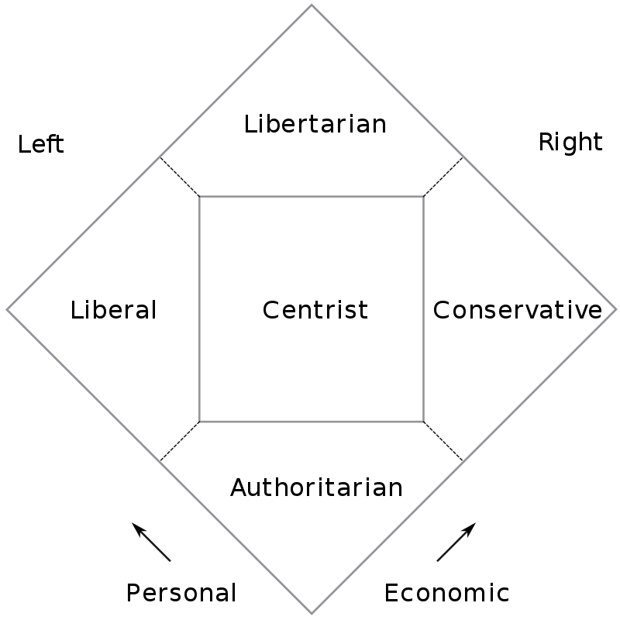

**Edmund Burke**[[edit](http://en.wikipedia.org/w/index.php?title=Traditionalist_conservatism&action=edit&section=12)]

Rt. Hon. Edmund Burke

Traditionalist conservatism began with the thought of Anglo-Irish [Whig](http://en.wikipedia.org/wiki/British_Whig_Party) statesman and philosopher [Edmund Burke](http://en.wikipedia.org/wiki/Edmund_Burke), whose political principles were rooted in moral natural law and the Western tradition. Burke believed in prescriptive rights and that those rights were "God-given". He also defended what he referred to as "ordered liberty" (best reflected in the unwritten law of the British constitutional monarchy). Burke also advocated for those transcendent values that found support in such institutions as the church, the family, and the state.[3] He was a fierce critic of the principles behind the [French Revolution](http://en.wikipedia.org/wiki/French_Revolution), and in 1790 his observations on its excesses and radicalism were collected in [*Reflections on the Revolution in France*](http://en.wikipedia.org/wiki/Reflections_on_the_Revolution_in_France).

|  |  |  |  |  |  |
| --- | --- | --- | --- | --- | --- |
|  | Communism | Socialism | Liberalism | Conservatism | Fascism |
| Major  Thinkers/  Books | Karl Marx, Friedrich Engels “Das Kapital” | Marx, Engels | Locke, Voltaire,  Adam Smith | Edmund Burke | Hitler, Mussolini,  Mein Kampf |
| View of  Humans | Equality for all, “each according to their ability, each according to their needs” | Equality, but some measure of state control to ensure it | Humans are logical beings | State may need to correct human nature; | -People are subservient to the glory of the state |
| Political  Beliefs | Dictatorship of the proleteriat until no longer needed; no government | All individuals should have access to basics of consumption | Individual rights over all else | Individuals rights and freedoms; based on traditions | State above all else; do not respect other nations; ultra nationalists; gain glory through constant war |
| Economic  Beliefs | No money, public ownership of all means of production | Profit distributed amongst populace; some private ownership; key industries nationalized (means of production socially owned | Adam Smith – the invisible hand; Laissez Faire Capitalism | Laissez-faire; charity is responsibility of people, not government | -autarky – self sufficiency  -glorify the state with money |
| Political  Party  Examples | Communist, Bolshevik, Marxist-Leninist | NDP | Liberal Party | Republicans, | Nazi, Fascist, Falange |