Mr. Fitton Name:
Humanities 10 Date:
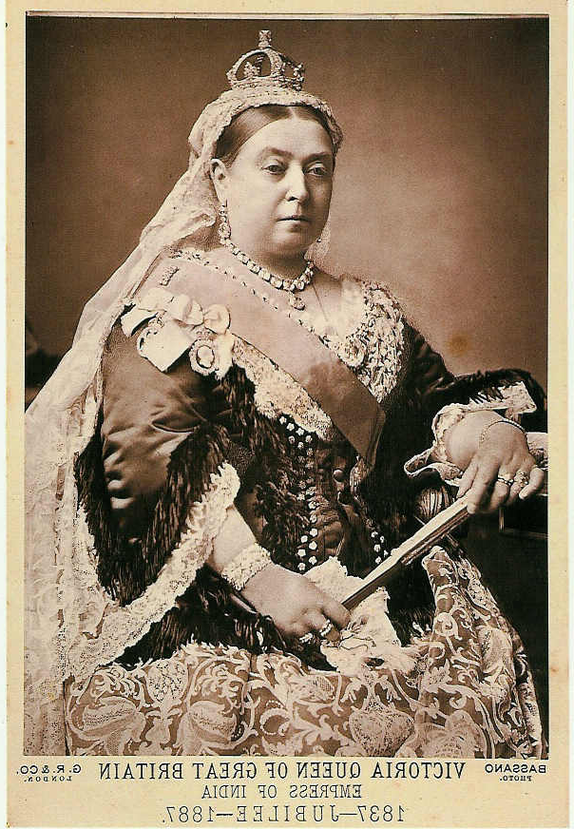
Victorian Era: The Victorian era spanned from 1837 -1901 and was marked by an increase in prosperity, scientific progress and morality. Immigrants continued to come to Canada and worked hard to survive, but life was better than the pain & lack of social mobility that faced them in Europe.

Aboriginals: Governments forced aboriginals onto reserves; as white settlement encroached, the government took back the land or bought the best land from impoverished natives. Aboriginals found this unfair and made land claims; issues surrounding land claims exist today. The ultimate goal of whites was assimilation.
Attitudes and Values
-British were superior
-To be born British was to win the lottery of life.
-British would help civilize the world.
-Morality and family values paramount.
-Any man could rise above circumstance.

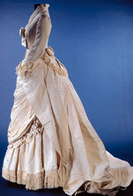
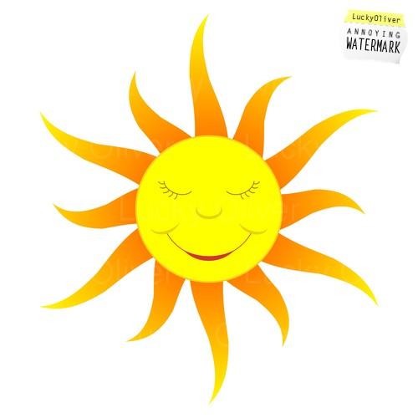
The sense of British supremacy owed to the fact that their navy was beyond challenge, their industry was the most advanced on earth & their empire was extensive. At this time, “the sun never set on the British Empire.”
-Hard Work Ethic
-Christianity. (Anglican, Catholic, Methodist and Presbyterian churches in most major cities)
-Innovation and Inventiveness (crystal palace)
-Self-made men are appreciated.

Fashion and décor: Victorians flaunted their wealth. Architecture was ostentatious and excessive. Clothing was similarly flamboyant. Women’s dresses were long, flowing and puffy with high collars, to avoid the sun because tans were seen as “lower class.” Men dressed in shirts, ties and long jackets, similar to today.


Science and medicine: The x-ray, aspirin, antibiotics, antiseptics vitamins, and the concept of medical hygiene were developed in the era. These advancements saved countless lives. Perhaps the most important discovery was the vaccination which helped young children survive smallpox and other childhood diseases.

Leisure: Victorians amused themselves by visiting fairs and circuses and hosting parties. In the countryside they played parlour games like “kissing the thumb” and attended barn dances. They also enjoyed “blood sports” like Bear-Baiting, Bare-Knuckle Boxing, Dog Fights and Dog-and-Bull Fights. Boxing soon became less bloody with the introduction of the Marquess of Queensbury rules which limited rounds and created a standard set of rules.

Travel: The invention of the steam engine heralded a new era in travel. Steamships crossed the Atlantic in two weeks and trains contributed to the infrastructure and growth of Canada. The 1st Canadian railway was the Champlain-St-Lawrence railway and its strict timetables meant consistency for passengers and a lack of accidents.

Newspapers.: A rise in literacy and urbanization meant that by 1873 Canada had 47 daily newspapers. The in Canada was the Halifax Gazette in 1752. They differed from modern papers in that there were no sports, comics, advice columns and horoscopes. Newspapers were crammed with information, news, helpful hints and crime reports. There was no sense of privacy and Victorians enjoyed reading about their neighbours.
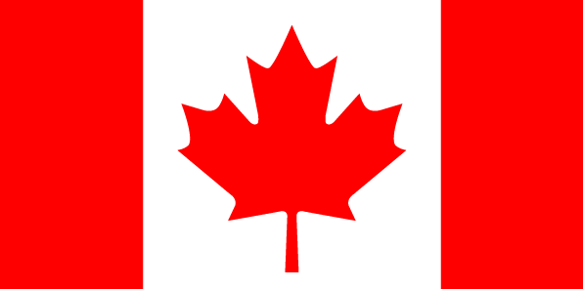
Building a Nation: After the union of the Canada’s, some politicians began to dream of a “Confederation” or union of Britain’s North American colonies. The union would be create a centralized government where Canada would have power over its own matters.

1840 –Canada Unites 1864 – Quebec Conference
1846 – Britain repeals Corn Laws and converts to Free-Trade 1861-65 – USA Civil War (Threatens Canada)
1849 – Canada is given responsible Government 1865 – Fenians Raid Canada
-Rebellion Losses bill is signed. 1867 - July 1st – BNA Act signed. Canada
1849-1864 – Political Impasse/Canada in Debt. becomes a nation.
1864- Charlottetown Conference

UNIT VOCABULARY
Define and explain the historical significance for each of the following terms from Chapter 2. They are testable.

Victorian Era _________________________________________________________________________________
_____________________________________________________________________________________________
Queen Victoria________________________________________________________________________________
_____________________________________________________________________________________________
Bear Baiting__________________________________________________________________________________
_____________________________________________________________________________________________
Responsible Government________________________________________________________________________
_____________________________________________________________________________________________
Mercantilism / Corn Laws_______________________________________________________________________
_____________________________________________________________________________________________
Lord Elgin____________________________________________________________________________________
_____________________________________________________________________________________________
Rebellion Losses Bill___________________________________________________________________________
_____________________________________________________________________________________________
Burning of Parliament___________________________________________________________________________
_____________________________________________________________________________________________
Manifest Destiny ______________________________________________________________________________
_____________________________________________________________________________________________
American Civil War____________________________________________________________________________
_____________________________________________________________________________________________
John A. Macdonald / Tories______________________________________________________________________
_____________________________________________________________________________________________
Double Majority_______________________________________________________________________________
_____________________________________________________________________________________________
Fenian Raids__________________________________________________________________________________
_____________________________________________________________________________________________
Charlottetown Conference_______________________________________________________________________
_____________________________________________________________________________________________
Quebec Conference_____________________________________________________________________________
_____________________________________________________________________________________________
BNA Act_____________________________________________________________________________________
_____________________________________________________________________________________________
Confederation_________________________________________________________________________________
_____________________________________________________________________________________________

