Comm 11/12 Names:
Mindshift Intro Assignment

Lesson:
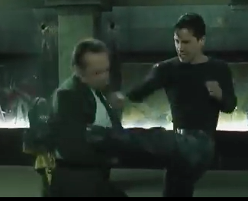
1. Watch the Matrix Fight Scene (https://youtu.be/Wh7h-wSLz9I) as a director, not as a moviegoer. Look at the number of shots and types of angles used. A director and cameraman are VERY purposeful in which angles/shots they use. Like you will in your next assignment.

2. View the teacher slideshow on Camera angles/shots

3. Watch the youtube video on basic film angles/shots.
https://www.youtube.com/watch?v=ICcE72RwEyc
(This is film related – we will also watch one on photography)

Mini Assignment:

1. You are no longer students, you are Photographers. In groups of 2-4 students, please go out and take several photos in which you try to use at least 6 different camera Shots or Angles.

2. Circle the Shots/Angles/ that you used once you have completed it. (On pictures below)

3. The shots can be still, have action, include humans or you can choose to have a prop. Your creativity is the limit.

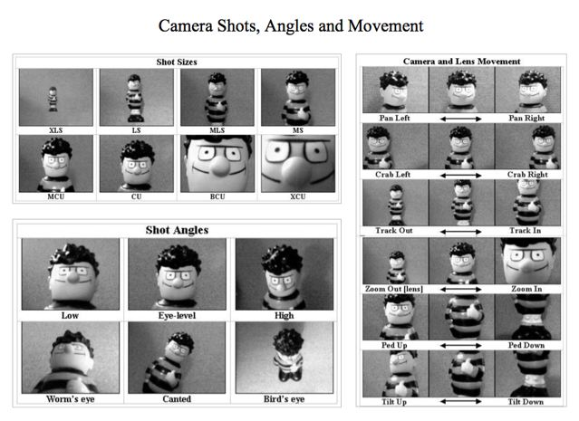
4. You have 20 minutes. Remember, the goal is just to TRY OUT camera angles for our big project.

