HTF 12 Names:
Cinematography 101

Lesson:
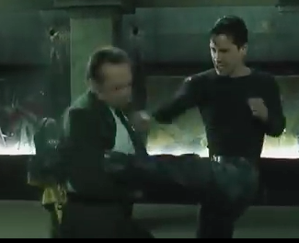
1. Watch the Matrix Fight Scene (https://www.youtube.com/watch?v=7GSgWzmR_-c ) as a director, not as a moviegoer. Look at the number of shots and types of angles used. A director and cameraman are VERY purposeful in which angles/shots they use.

2. View the teacher slideshow on Camera angles/shots

3. Watch the youtube video on basic film angles/shots.
https://www.youtube.com/watch?v=ICcE72RwEyc
(Or youtube a video on angles/shots)

Mini Assignment:

1. You are no longer students, you are filmmakers. In groups of 2-4 students, please go out and film a small video in which you try to use at least 6 different camera Shots, Angles or Movement.

2. Circle the Shots/Angles/Movement Type that you used once you have completed it. (On pictures below)

3. The film can have dialogue, or be silent; it can have action or none. Its up to you! Your creativity is the limit.

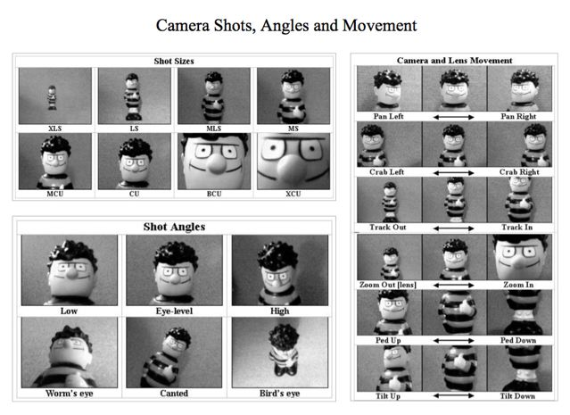
4. You have 40 minutes. Remember, the goal is just to TRY OUT camera angles for our big project.

