Blue Zones: 4-Corners Debate Activity

Looking for a vibrant activity that involves movement, discussion and controversy? Try a 4-Corners debate/discussion with your class!

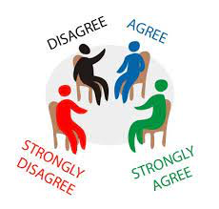
Low Prep – Set up four corners with Strongly Agree (SA); Agree (A); Disagree (D) or Strongly Disagree (SD).; read the controversial statements below and have students stand where their beliefs lay. Have students justify and debate.

Medium Prep – Have students fill out the sheet below prior to the debate; then conduct the four-corners debate by reading each statement and having kids debate/discuss standing in their corner.

High Prep – Have students read the handout, write out their initial thoughts; read an article/do some online research about each issue/statement, then engage in the debate above while standing where their beliefs lay.

The prompt statements below represent issues relating to “Live to 100 – Secrets of the Blue Zones.” Read the statements in the column on the left and select whether you Strongly Agree (SA); Agree (A); Disagree (D) or Strongly Disagree (SD). Justify your statement and prepare to hear from others.

When the teacher reads out each statement, stand in the corner of the room that corresponds to your beliefs. Often the teacher will have whiteboards or paper with Strongly Agree, Agree, Disagree or Strongly Disagree in each corner. Debate and defend your views.

*If someone makes a point that encourages you to rethink your position, feel free to move to a new location*.

Statement Your Opinion
1. Lifespan vs. Lifestyle: "Living to an old age, as seen in the Blue Zones, should not be a primary goal if it means sacrificing modern comforts and conveniences." | SA A D SD (Circle)  Explain:
2. Dietary Changes: "Governments should impose regulations to shift national diets closer to those observed in Blue Zones to combat rising health issues." | SA A D SD (Circle)  Explain:
3. Technology and Health: "The increasing dependence on technology is a major barrier to achieving the kind of wellness and longevity seen in Blue Zones." | SA A D SD (Circle)  Explain:
4. Cultural Preservation vs. Globalization: "The lifestyles in Blue Zones should be preserved at all costs, even if it means limiting the influence of globalization and modernization in these areas." | SA A D SD (Circle)  Explain:

Statement Your Opinion
5. Education System Reform: "School curriculums should be radically reformed to include more focus on lifestyle and wellness practices similar to those in Blue Zones." | SA A D SD (Circle)  Explain:
6. Healthcare Priorities: "Healthcare systems should prioritize lifestyle medicine and natural remedies over pharmaceutical interventions, following the example of Blue Zones." | SA A D SD (Circle)  Explain:
7. Individual vs. Collective Responsibility: "Individuals are solely responsible for their health and longevity, and it's not the role of the community or society to influence personal lifestyle choices." | SA A D SD (Circle)  Explain:
8. Economic Growth vs. Wellness: "Economic growth and technological advancement should be prioritized even if they potentially shorten life spans or reduce the quality of life as seen in Blue Zones." | SA A D SD (Circle)  Explain:

“After all, the purpose of learning isn’t to affirm our beliefs; it’s to evolve our beliefs.”
― Adam M. Grant, Think Again: The Power of Knowing What You Don't Know

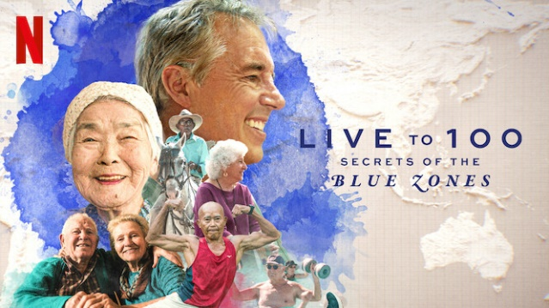

Possible other debate topics:
- Global Implementation of Blue Zone Principles: "The principles and lifestyles of Blue Zones should be universally adopted as a global standard for health and wellness."
- Youth Lifestyle Choices: "Today's youth are too entrenched in technology and fast-paced lifestyles to adopt the principles seen in Blue Zones."
- Economic Implications: "Adopting Blue Zone lifestyles could negatively impact economic growth, as these lifestyles often involve reduced consumption and slower-paced living."
- Mandatory Health Education: "Education about lifestyles like those in Blue Zones should be mandatory in schools to combat the rising trend of lifestyle-related diseases."
- Individual Freedom vs. Public Health: "Governments should have the authority to enforce lifestyle changes on their citizens for the sake of public health, similar to the practices in Blue Zones."
- Cultural Diversity and Adaptation: "It is unrealistic and culturally insensitive to expect people from diverse backgrounds to adopt the specific lifestyles of Blue Zones."
- Longevity vs. Quality of Life: "The pursuit of a longer life, as exemplified by Blue Zones, is overvalued; what matters more is the quality of life, regardless of its length."
- Healthcare Focus: "The healthcare industry should shift its focus from treating illness to promoting the wellness and preventative lifestyle practices seen in Blue Zones."
- Urban Planning and Development: "Modern cities should be redesigned to emulate the physical layout and community aspects of Blue Zones to promote healthier living."
- Dietary Restrictions and Freedom: "Promoting a plant-based diet, as common in Blue Zones, infringes on personal freedom and cultural dietary preferences."

