“BATTLESHIP REVIEW” GAME INSTRUCTIONS

1. Place your 5 square long battleship on the chart on “Your Grid”; and your 3 square cruiser
2. The opposing team will ask you a question. If you get it right, you get to launch a torpedo. Guess where the battleship is located (ie: 1, A)
3. The team will let you know if you hit or missed. The goal is to sink the battleship by hitting it correctly five times.
4. Teams alternate asking questions and taking shots.

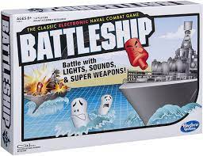
YOUR GRID

 | 1 | 2 | 3 | 4 | 5
A

B

C
D
E

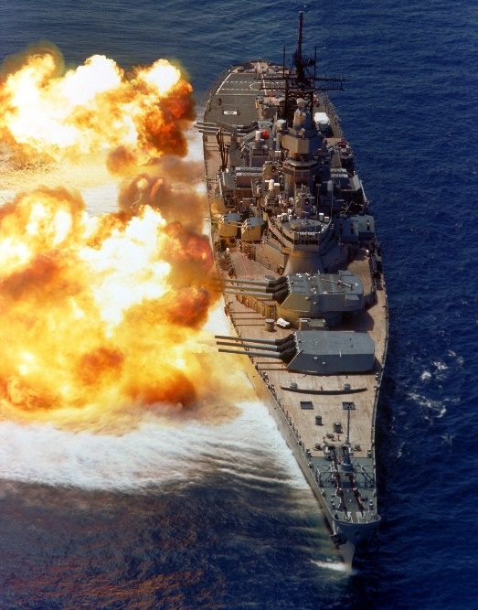

ENEMY GRID
 | 1 | 2 | 3 | 4 | 5
A

B

C
D
E

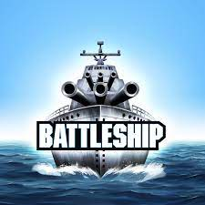

“BATTLESHIP REVIEW” GAME INSTRUCTIONS

1. 1. Place your 5 square long battleship on the chart on “Your Grid”; and your 3 square cruiser
2. The opposing team will ask you a question. If you get it right, you get to launch a torpedo. Guess where the battleship is located (ie: 1, A)
3. The team will let you know if you hit or missed. The goal is to sink the battleship by hitting it correctly five times.
4. Teams alternate asking questions and taking shots.

YOUR GRID
 | 1 | 2 | 3 | 4 | 5
A

B

C
D
E

ENEMY GRID
 | 1 | 2 | 3 | 4 | 5
A

B

C
D
E

