SS9 Names:_____________________________________
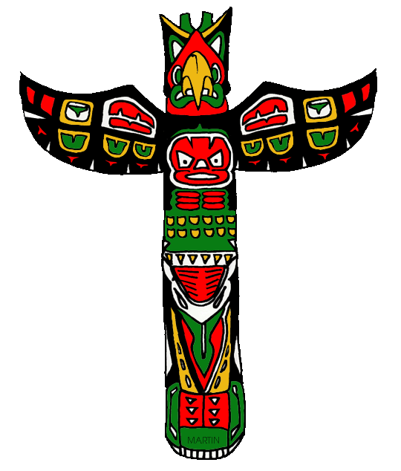
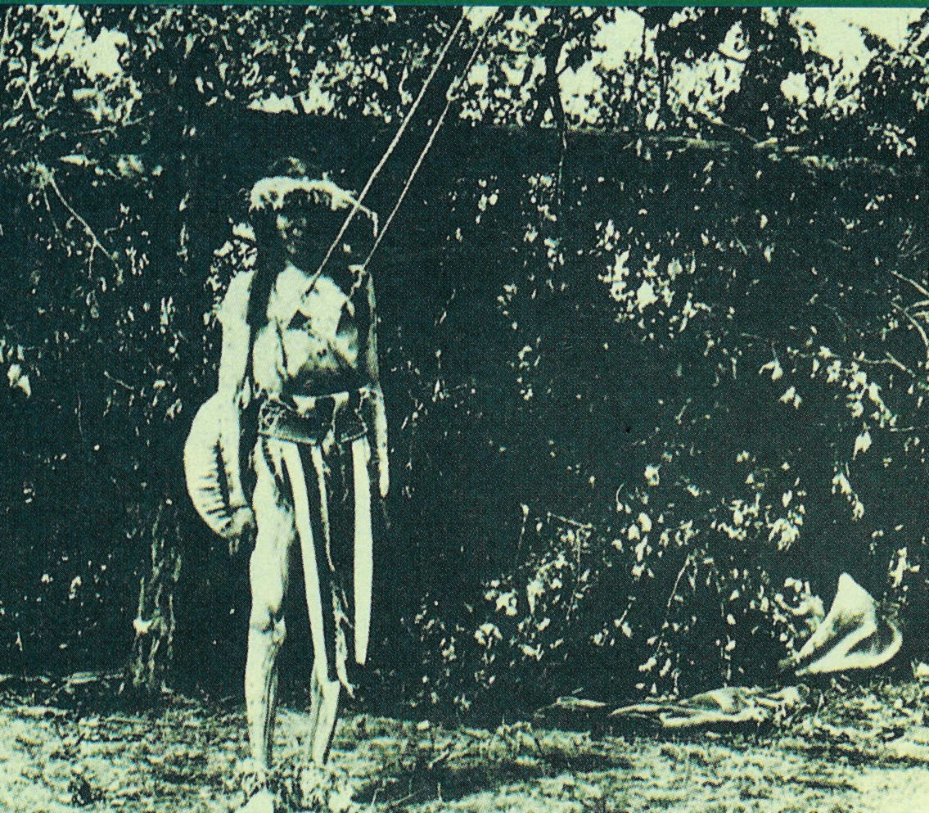
Aboriginals in Early Canada

In groups of 4-5:

1. Chose one of the Aboriginal groups we took notes on (Inuit, Plains, Plateau, Northwest Coast, Beothuk, Iroquois)

2. Highlight 5-6 key details from your notes. (Think of things you could see being on a test when you try to think what is important). Do this part together as a group.
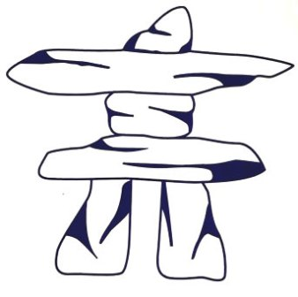
Example of important details for the explorer Jacques Cartier:

-Represented France
-came to Canada in 1534
-looking for passage to Asia
-ended up trading for furs with Aboriginals
-claimed Canada for France
-kidnapped some aboriginals and brought them to France.

3. Read your creation story together (one person could read aloud, or take turns reading sections).

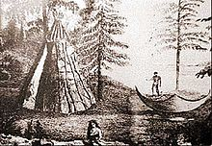
4. Half of your group will use the information you highlighted to write a 5 sentence (max.) paragraph highlighting the key information about your chosen group. Record this on your chart paper.

Jacques Cartier was a French Explorer who came to Canada in 1534 to look for a passage to Asia. After several attempts and visiting Newfoundland, Nova Scotia and Quebec, he realized a passage to Asia was not in the area he was looking and he was forced to come on land as his crew was ill prepared and dying of scurvy. Once on land, he met some Iroquois Indigenous people and began trading with them in exchange for aid, guiding and furs. He even kidnapped a few an brought them to France to be studied, killing most due to a lack of immunity to European diseases He soon realized Canada would be a useful colony and claimed it for France.

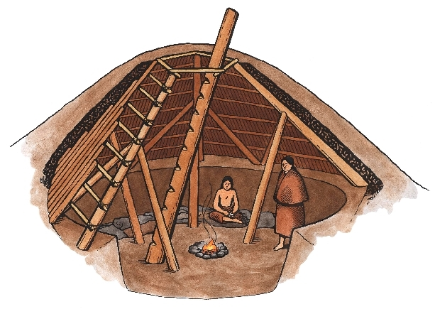
5. The other half will read a creation story for your chosen group and recreate it in a matrix (combination of drawings (simple) and minimal words). Do this on a separate piece of chart paper.

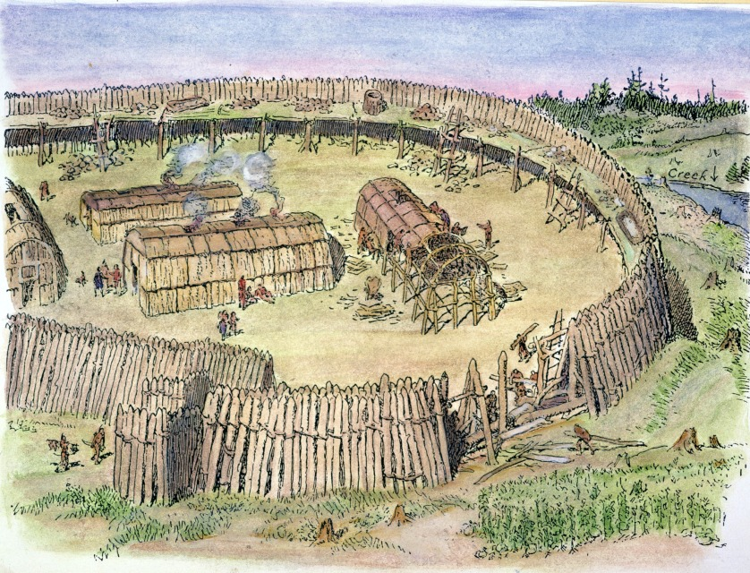
6. Each group member will be responsible for presenting a part of your chart paper.

Worth: 12 marks

Summary | Not yet within Expectations  *Covers 3 or less details. *Not in paragraph form (possibly a list).  *Many errors in spelling or grammar.  *No topic sentences. *Covers insignificant details. | Minimally meets Expectations  *Covers some details, but not 5/6.  *In paragraph form, but it is awkward,  *May not have a topic sentence  *Has several errors in spelling/grammar.  *Some details are not key ones.  *May have some insignificant details. | Fully Meets Expectations  *Covers 5 or 6 details *Paragraph form (may be a little long or short)  *may be a bit awkward or *Have a spelling or grammar mistake.  *Uses only key details | Exceeds Expectations  *Covers 5 or 6 details in 5 sentence paragraph. *Details are the key information. *Paragraph covers in the information in a clear and concise way. *Paragraph has a topic sentence  *Free of spelling and grammar mistakes
Matrix | *Misses key ideas in the story.  *Is either all words or all pictures. | *Has too many words and possibly not enough pictures. *Covers some of the main ideas but misses a few. | *Has necessary words and almost all of the key ideas.  *Has pictures for the main events. | *Has effective, key words. *Has impactful pictures for every main event.  *Covers all of the main ideas of the story
Presentation | *Only one group member presents. *Hard to hear  /understand | *Most members present and are usually (but not always) easy to hear/understand | *All members present and are mostly easy to hear/  understand | *All Members Present and presenters, are effective and easy to hear/ understand

/12

