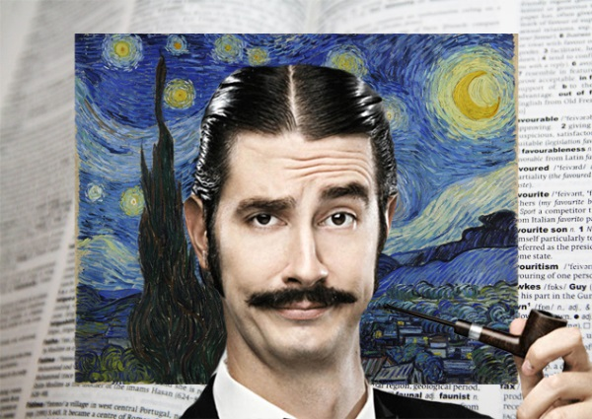
Mr. Fitton
2019-04-26

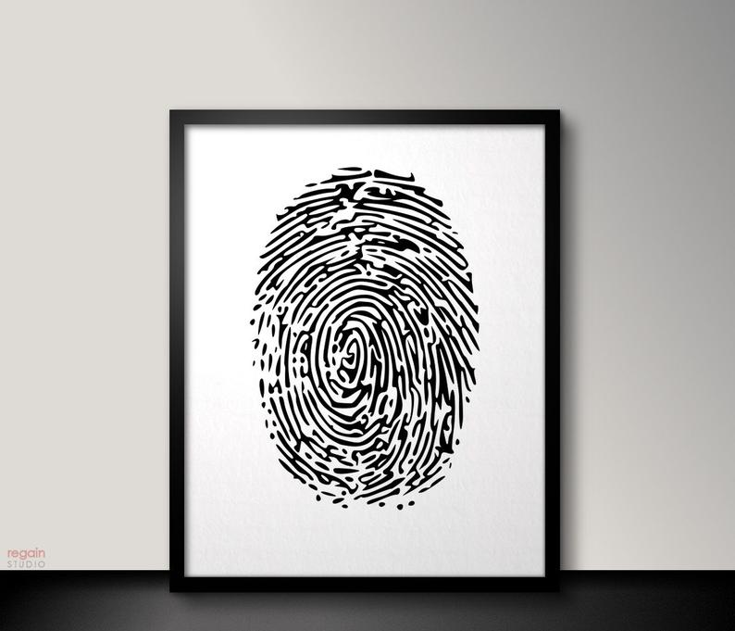
Sample Assignment – Art Critique
Hamilton Standish Aimsley III, is the foremost conceptual artist of this generation. His avant-garde ink on paper designs capture the tumultuous nature of society and the frenetic pace of modern existence. He credits growing up in the complex modern technological metropolis of Penticton as inspiration for his anxiety ridden drawings which conceptualize modern man’s slavery to perpetual work. He resides in Penticton with his 6 cats, 2 bichon-frise puppies and a wife and kids.

“Modern Prisons” is an elegantly complex amalgam of black ink on purposely pristine white paper. The central figure of the enigmatic, entrancing maze represented by a forcefully applied human fingerprint is highly evocative. Ultimately, this piece is meant to capture man’s feelings of imprisonment by modern society. However, simultaneously, this picture serves as a triumphant reminder of a person’s vibrant originality. Aimsley’s art grabs the viewer by the shoulders and shakes them to the core; he screams at them to remember that although they are prisoned within the confines of societies’ black box of lines, it is in fact a prison they built. His statement is reinforced by the fact that the fingerprint is as black as the bars that encase it. However, the dark and highly intricate fingerprint presents majestically and forcefully in the center of a sea of white; this purposeful position reminds us of the power of our own individuality. The black print fights conformity with the white and provides a stunning contrast which serves as a reminder not to simply accept social norms. Indeed, Aimsley destroys our apathy and exhorts humanity to violently tear away our shackles and demonstrate our vibrant plumage like a magnificent peacock. Be brave; shine your light, “Modern Prisons” expostulates through a megaphone to the astute observer. The painting is a great reminder to fight the power of institutions with our individuality and to never fade into the white abyss; indeed, “shine brightly,” Aimsley’s work yells. Finally, the artist’s purposeful use of the swirl of a maze draws our attention to the chaos inherent in the human experience. However, the ink on canvas reminds us that we should not restrict ourselves to one path and that life is deliciously fraught with important side roads. As one of the prophetic voices of our distraught, angst-ridden generations, Aimsley acts as a beacon of life, reflecting both truth and hope on a despairing populace. His art is like a warm cup of coffee with undulating steam, offering temporary reprieve and joy from the unrelenting stress of chilly modern day Canadian life. Essentially, “Modern Prisons” re-affirms the preciousness of our existence and does so with splendor, grandeur and elegant simplicity.

