Mr. Fitton Name
English SATIRICAL ART CRITIQUE Date

If you can write a creative (and satirical) art critique of a child’s art, you can do anything!

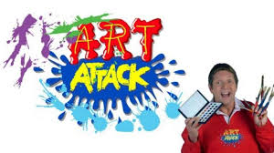
Goal: To demonstrate your art critique skills as a way to practice creative non-fiction writing (to sharpen your descriptive/vocabulary skills)
Role: You are a highly intellectual elite art critic (alternative, you may take on a persona – famous actor / snooty art critic / anyone with distinctive voice)
Audience: The local art community
Situation: You are lecturing or writing an art critique at a local gallery
Product: An official written art critique (Slideshow, Speech, Newspaper Article) include “about the author”
Standard: “A- Analyzing” and “C – Producing Text”

The most recent art piece by “Riley” The Artist: “Riley”
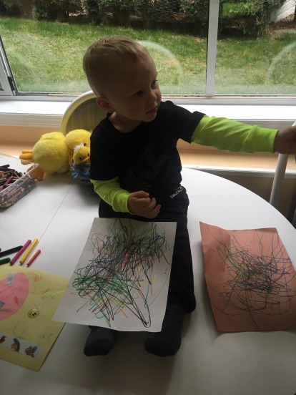
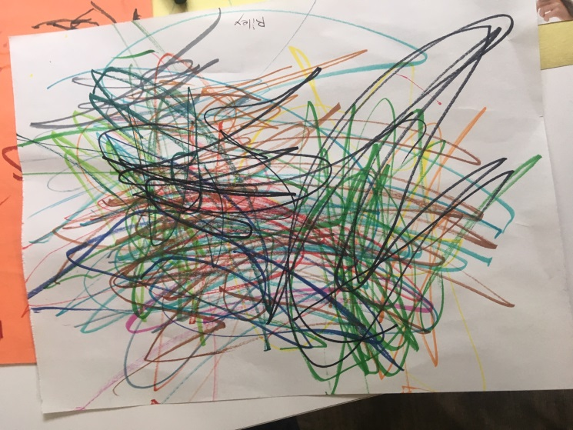

Assignment: Please examine the abstract art piece above, written by renowned Penticton Artist “Riley.” His artistic representations have come to represent the spirit and anxieties of our era. Please prepare an art critique accordingly.

You should have 4 phases to your critique. Remember to use vibrant and specific language. Refer to facets of the art piece directly.

1. Look at the Obvious: For example, what's the name of the piece? (Make it up). What country is the artist from? What medium did the artist use, such as paint, clay, film, or other type of material?

2. Analyze the Work: Describe the subject matter, color, and style. What do you see? Describe the color palette and spectrum; Do you see pastels, or do you see bright colors? Maybe you see more muted tones. Look at the style. Style refers to a particular type of movement, such as Art Nouveau or Cubism. What is the era?

3. Interpret the Work: What does it all mean? What you think is going on in the painting. Sometimes your interpretation may be more straightforward; other times, you'll be calling attention to a hidden meaning. How does it represent society or the era it was created in? Provide social context and Historical Context (what is occurring in society or history that influenced the art piece).

4. Make a Judgment Call: Is the work was successful. Did it convey the message the artist intended? Was the composition, color, and line quality successful in representing the art type it belongs to? In art criticism, judgment is never personal; it is about interpreting the art and whether the art communicates a message to the audience.

5. About the Author: Include biographical details, favorite medium, and pertinent artist information (could include generalizations about his work).

For Fun Here is an “Art Critique Random Phrase Generator:” http://www.pixmaven.com/phrase_generator.html
Online Resources to use:
1. https://study.com/academy/lesson/art-criticism-definition-steps-example.html (Simple steps to Critique Art)
2. https://m.wikihow.com/Critique-Artwork (WikiHow – more detailed way to look at art)
3. https://www.goshen.edu/art/ed/critiqueform.html (Scaffolding Sheet for Art)
4. https://www.goshen.edu/art/ed/rubric3.html (Rubric by Art Teacher)

Stylistic Techniques for Writing – Rework your Draft

1. Have an engaging hook
2. Eliminate Banned Words
3. Verbs (and *dual Verbs)
4. Adjectives (and **dual adjectives)
5. Adverbs
6. Figures of Speech (simile, metaphor)
7. Sentence variety and NTSSTSW

(Check off as you complete)
1. Have an engaging hook. Grab the reader’s attention (controversial statement, start with action, begin with unexpected or strong statement.

2. Circle all banned words and replace them with a higher level word. (Ie: Slang, cool, sad, like, any IM terminology.)

3. Circle at least one verb per sentence and replace it with one (or two) verbs from the thesaurus.

4. Underline all nouns. Think of at least one (preferably two) adjectives and use them. Join the adjectives with a comma + and, but, even, yet.

5. Put adverbs in front of all of your verbs. (See adverb list).

6. Find an image or situation in your paragraph. Think of something that is similar to it and create a thoughtful metaphor or simile to enhance that section of your writing.

7. Sentence variety & No two sentences start the same way. Short and long sentences and ensure you begin every sentence differently.

*Dual Verbs: Some types of dual verbs are like running and jumping or skipping and falling. It is two verbs put together to make a more drastic effect on a project, school work, or just everyday writing!

**Dual Adjectives: He was a tall, tanned, attractive, rich and outdoorsy.

Criterion C: Producing Text
Level | Level Descriptor | Task-Specific Clarification
0 | The student does not reach a standard described by any of the descriptors below. | Add your own expectations here!
1-2 | The student produces texts that:  - demonstrate limited personal engagement with the creative process; demonstrates a limited degree of insight, imagination or sensitivity and minimal exploration of and critical reflection on new perspectives and ideas,  - makes minimal stylistic choices in terms of linguistic, literary and visual devices, demonstrating limited awareness of impact on an audience,  - selects few relevant details and examples to develop ideas.
3-4 | The student produces texts that:  - demonstrate adequate personal engagement with the creative process; demonstrates some insight, imagination or sensitivity and some exploration of and critical reflection on new perspectives and ideas,  - makes some stylistic choices in terms of linguistic, literary and visual devices, demonstrating adequate awareness of impact on an audience,  - selects some relevant details and examples to develop ideas.
5-6 | The student produces texts that:  - demonstrate considerable personal engagement with the creative process; demonstrates considerable insight, imagination or sensitivity and substantial exploration of and critical reflection on new perspectives and ideas,  - makes thoughtful stylistic choices in terms of linguistic, literary and visual devices, demonstrating good awareness of impact on an audience,  - selects sufficient relevant details and examples to develop ideas.
7-8 | The student produces texts that:  - demonstrate a high degree of personal engagement with the creative process; demonstrates a high degree of insight, imagination or sensitivity and perceptive exploration of and critical reflection on new perspectives and ideas,  - makes perceptive stylistic choices in terms of linguistic, literary and visual devices, demonstrating good awareness of impact on an audience,  - selects extensive relevant details and examples to develop ideas with precision.

Criterion A: Analyzing
Level | Level Descriptor | Task-Specific Clarification
0 | The student does not reach a standard described by any of the descriptors below. | Add your own expectations here!
1-2 | The student:  - provides limited analysis of the content, context, language, structure, technique and style of text(s) and the relationship among texts,  - provides limited analysis of the effects of the creator’s choices on an audience,  - rarely justifies opinions and ideas with examples or explanations; uses little or no terminology,  - evaluates few similarities and differences by making minimal connections in features across and within genres and texts.
3-4 | The student:  - provides adequate analysis of the content, context, language, structure, technique and style of text(s) and the relationship among texts,  - provides adequate analysis of the effects of the creator’s choices on an audience,  - justifies opinions and ideas with some examples and explanations, though this may not be consistent; uses some terminology,  - evaluates some similarities and differences by making adequate connections in features across and within genres and texts.
5-6 | The student:  - competently analyses the content, context, language, structure, technique, style of text(s) and the relationship among texts,  - competently analyses the effects of the creator’s choices on an audience,  - sufficiently justifies opinions and ideas with examples and explanations; uses accurate terminology,  - evaluates similarities and differences by making substantial connections in features across and within genres and texts.
7-8 | The student:  - provides perceptive analysis of the content, context, language, structure, technique, style of text(s) and the relationship among texts,  - perceptively analyses the effects of the creator’s choices on an audience,  - gives detailed justification of opinions and ideas with a range of examples, and thorough explanations; uses accurate terminology,  - perceptively compares and contrasts by making extensive connections in features across and within genres and texts.

