WWI Arms Auction
"The first world war was a horror of gas, industrialized slaughter, fear, and appalling human suffering" -Nick Harkway, Novelist.
Name of Country: ____________________________________________________
Names of Group Members: ___________________________________________________________________
This sheet is to help you keep track of your bidding. Each team starts the game with $100. There are 18 weapons up for sale, so make sure you budget! Check mark on the LEFT if you end up buying it!
Weapon Name: | How useful do you think it will be? (Rate from 1-10) | What is your ceiling bid? (highest you can spend?)  Ceiling bids should not add up to more than $100 total. | What will be your opening bid? (Don’t start with your ceiling bid, you might end up getting it for cheaper!) | At end: What is effectiveness of the weapon? (1-10)
1. Plane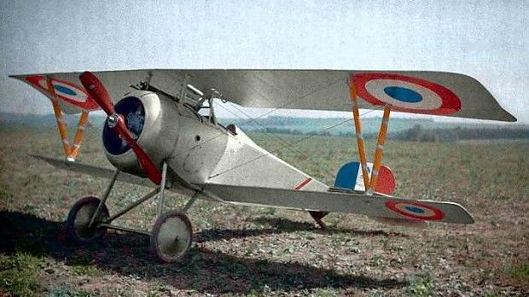 |  |  | How much did you spend: ______
2. Gas  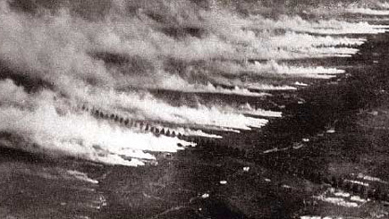 |  |  | How much did you spend: ______
3. U-Boat  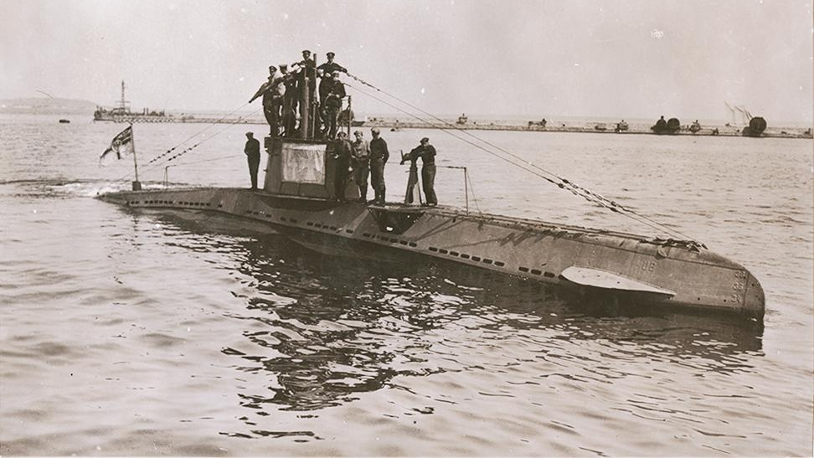 |  |  | How much did you spend: ______
4. Cavalry  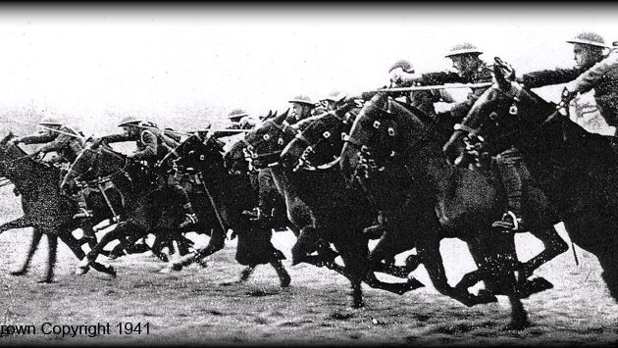 |  |  | How much did you spend: ______
5. Dreadnought  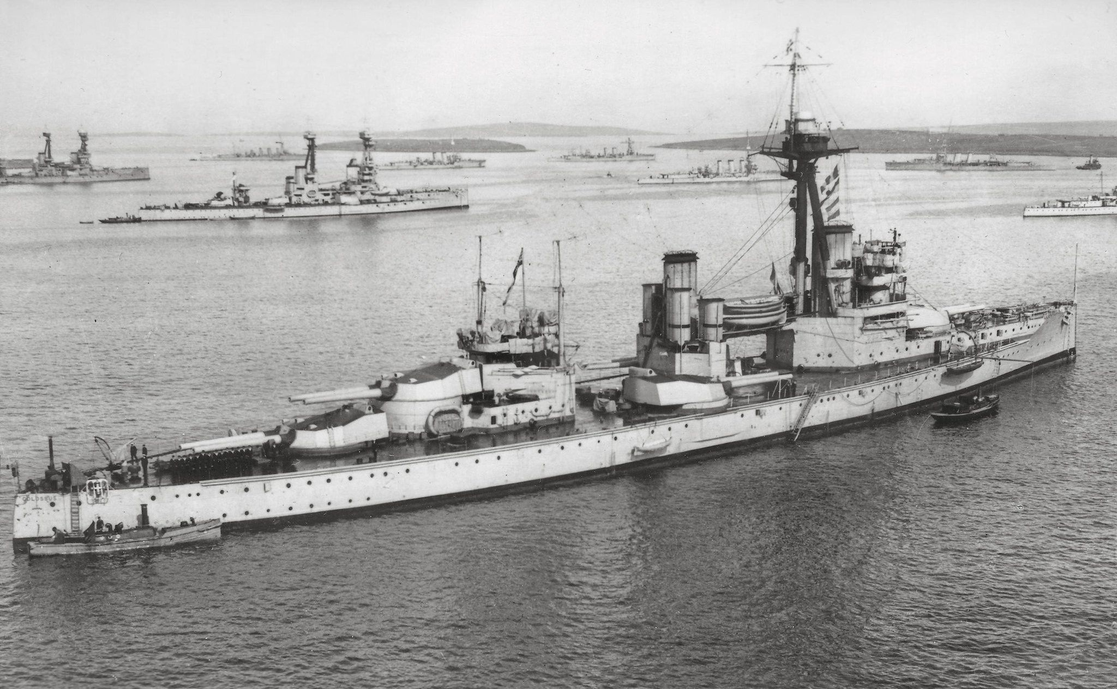 |  |  | How much did you spend: ______
6. Artillery  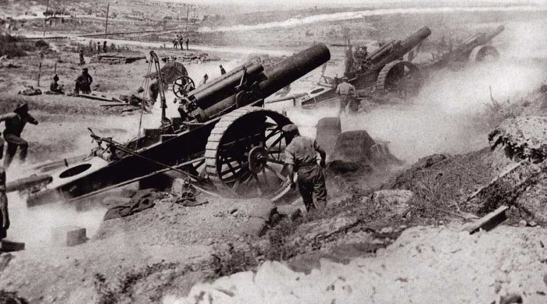 |  |  | How much did you spend: ______
7. Gas Mask  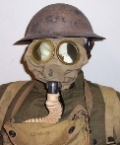 |  |  | How much did you spend: ______
8. Tank  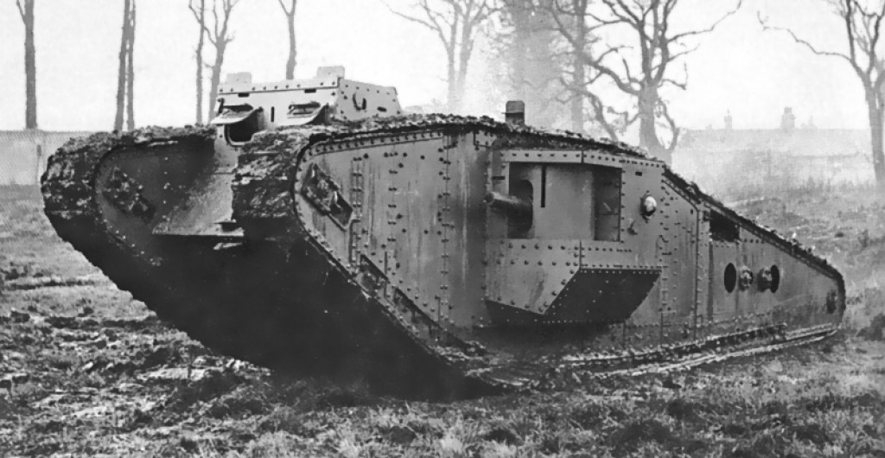 |  |  | How much did you spend: ______
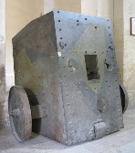  9. Mobile Shield |  |  | How much did you spend: ______
10. Machine Gun  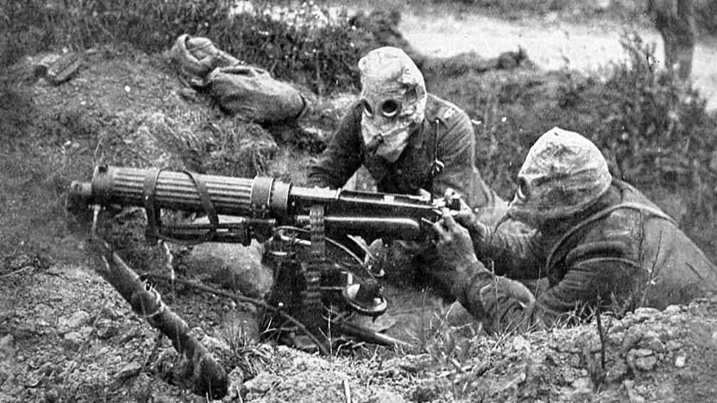 |  |  | How much did you spend: ______
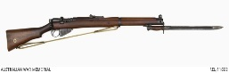  11. Rifle |  |  | How much did you spend: ______
12. Grenade  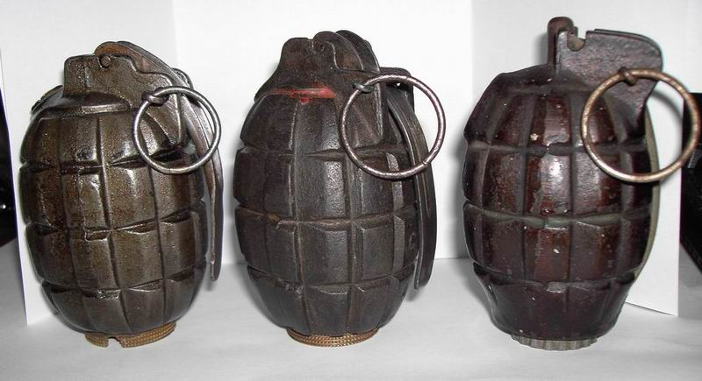 |  |  | How much did you spend: ______
13. Flamethrower |  |  | How much did you spend: ______
14. Zeppelin  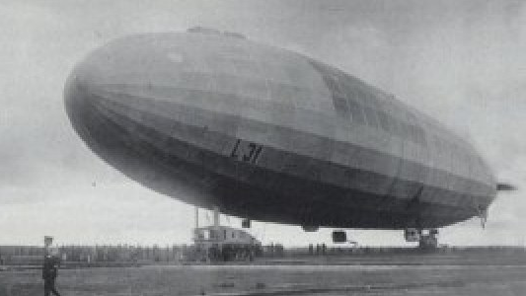 |  |  | How much did you spend: ______
15. Ambulance  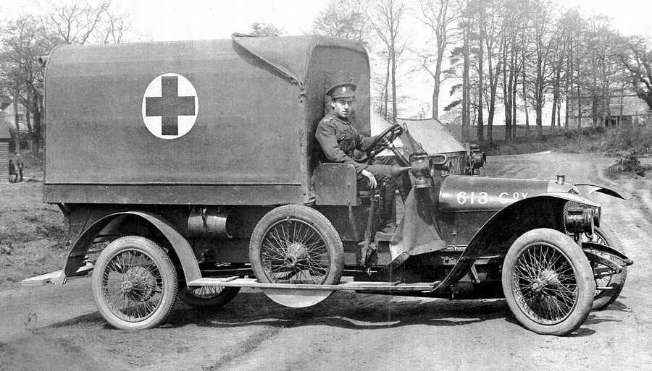 |  |  | How much did you spend: ______
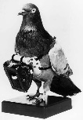  16. Carrier Pigeon |  |  | How much did you spend: ______
17. Grenade Catapult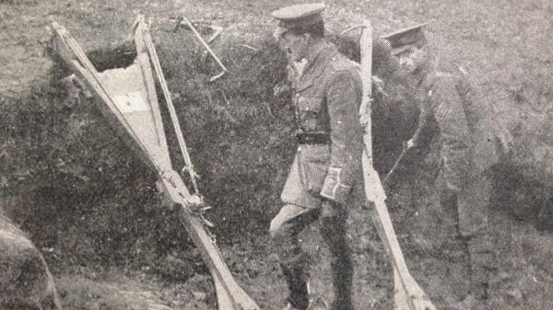 |  |  | How much did you spend: ______
18. Paris Gun  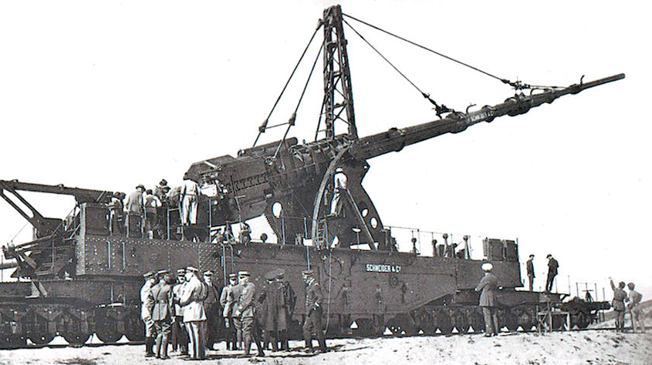 |  |  | How much did you spend: ______
Total Points _______
WWI Arms Auction - EFFECTIVENESS KEY
"The first world war was a horror of gas, industrialized slaughter, fear, and appalling human suffering" -Nick Harkway, Novelist.
Name of Country: ____________________________________________________
Names of Group Members: ___________________________________________________________________
This sheet is to help you keep track of your bidding. Each team starts the game with $100. There are 18 weapons up for sale, so make sure you budget! Check mark on the LEFT if you end up buying it!
Weapon Name: | How useful do you think it will be? (Rate from 1-10) | What is your ceiling bid? (highest you can spend?)  Ceiling bids should not add up to more than $100 total. | What will be your opening bid? (Don’t start with your ceiling bid, you might end up getting it for cheaper!) | At end: What is effectiveness of the weapon? (1-10)
1. Plane |  |  | How much did you spend: ______ | 8
2. Gas |  |  | How much did you spend: ______ | 6
3. U-Boat |  |  | How much did you spend: ______ | 9
4. Cavalry |  |  | How much did you spend: ______ | 1
5. Dreadnought |  |  | How much did you spend: ______ | 7
6. Artillery |  |  | How much did you spend: ______ | 10
7. Gas Mask |  |  | How much did you spend: ______ | 6
8. Tank |  |  | How much did you spend: ______ | 7
9. Mobile Shield |  |  | How much did you spend: ______ | 0
10. Machine Gun |  |  | How much did you spend: ______ | 9
11. Rifle |  |  | How much did you spend: ______ | 6
12. Grenade |  |  | How much did you spend: ______ | 5
13. Flamethrower |  |  | How much did you spend: ______ | 2
14. Zeppelin |  |  | How much did you spend: ______ | 4
15. Ambulance |  |  | How much did you spend: ______ | 4
16. Carrier Pigeon |  |  | How much did you spend: ______ | 3
17. Grenade Catapult |  |  | How much did you spend: ______ | 0
18. Paris Gun |  |  | How much did you spend: ______ | 2
Total Points _______

